# 小兔鲜项目

发表于2023-06-18|更新于2023-07-02

阅读量:213

# Vue3入门

## 认识Vue3

### 1. Vue3组合式API体验

通过 Counter 案例 体验Vue3新引入的组合式API

并且需要注意的是Vue3是向下兼容的，也就是说你可以在Vue3的项目中继续写Vue2的代码

**PLAINTEXT**

|  |
| --- |
| <script> export default {  data(){  return {  count:0  }  },  methods:{  addCount(){  this.count++  }  } } </script> |

**PLAINTEXT**

|  |
| --- |
| <script setup> import { ref } from 'vue' const count = ref(0) const addCount = ()=> count.value++ </script> |

特点：

1. 代码量变少
2. 分散式维护变成集中式维护

### 2. Vue3更多的优势

[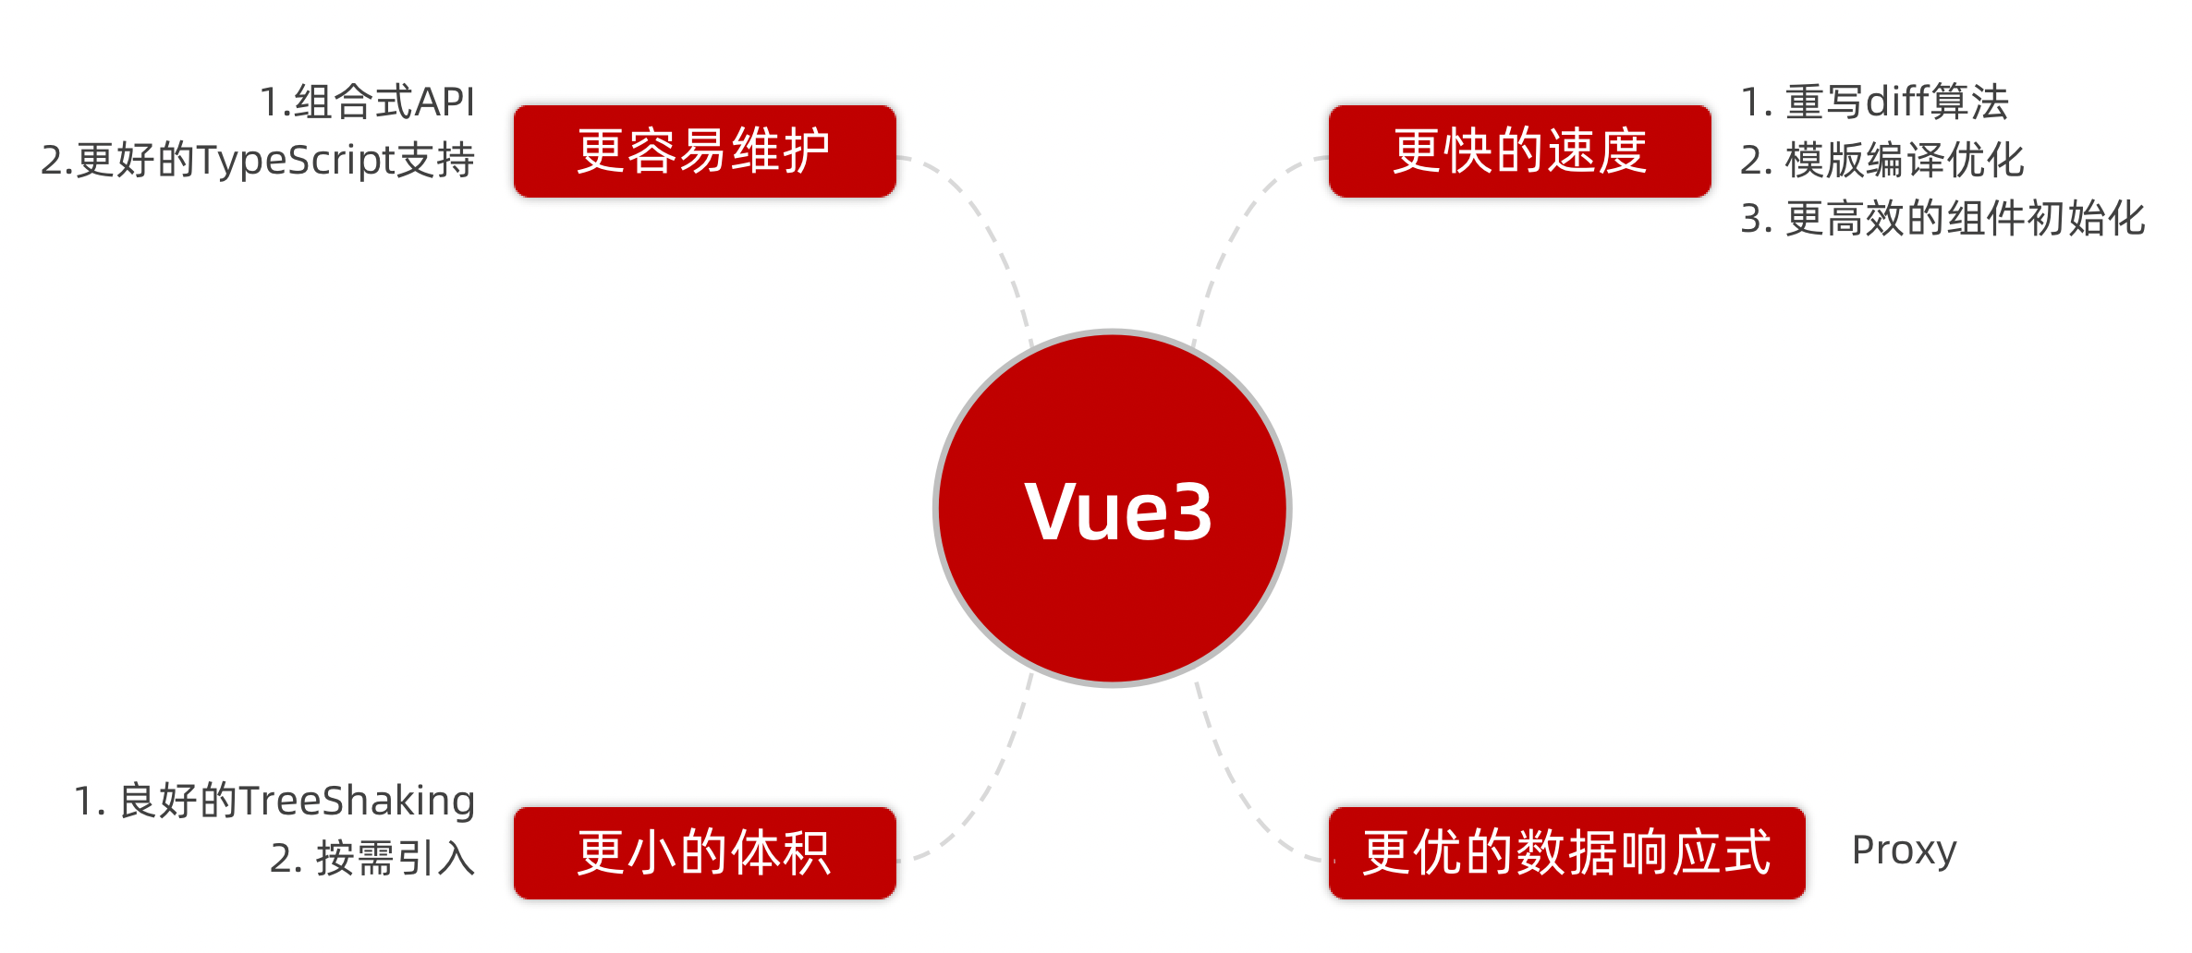](https://xiaobaicai350.github.io/pic/1678178235504-912ad469-1a9a-469d-a8dc-411a55963329.png)

## 使用create-vue搭建Vue3项目

### 1. 认识create-vue

create-vue是Vue官方新的脚手架工具，底层切换到了 vite （下一代前端工具链），为开发提供极速响应

[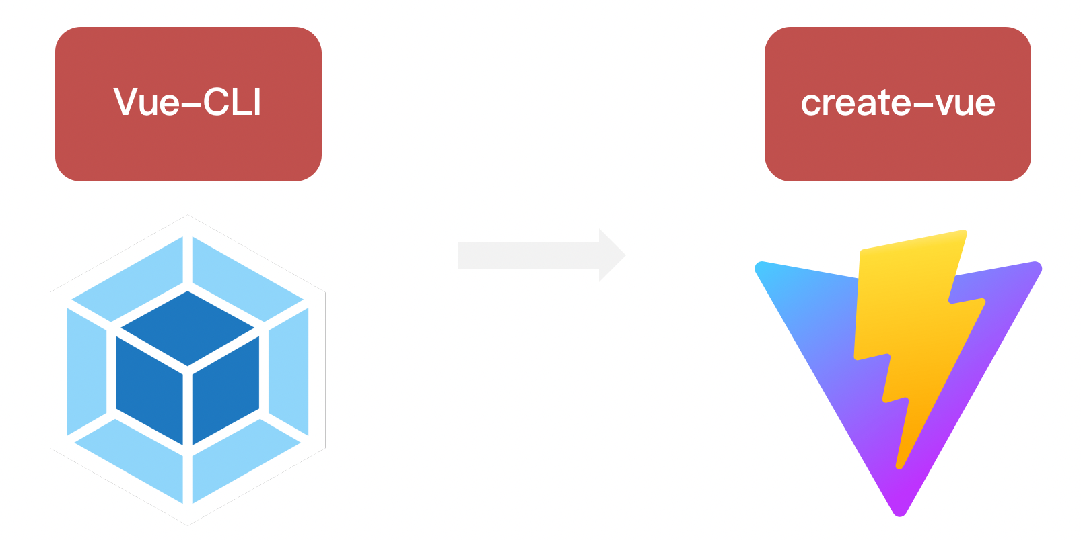](https://xiaobaicai350.github.io/pic/1678178479590-ac164009-4a72-4448-85bf-67dc13f3d0c4.png)

### 2. 使用create-vue创建项目

前置条件 - 已安装16.0或更高版本的Node.js，

C:\Users\Xu>node -v  
v16.16.0

可以看到这里我是16.16版本，希望不会出现依赖冲突

执行如下命令，这一指令将会安装并执行 create-vue

**BASH**

|  |
| --- |
| npm init vue@latest |

[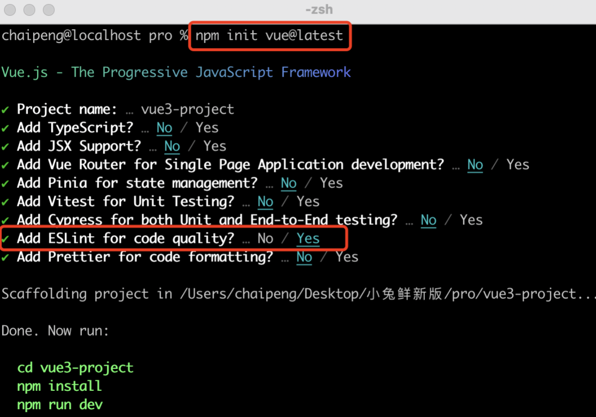](https://xiaobaicai350.github.io/pic/1678178685782-71a3b311-423d-4528-aae9-85e6068db452.png)

我去，这看着比vue2页面高级多了

[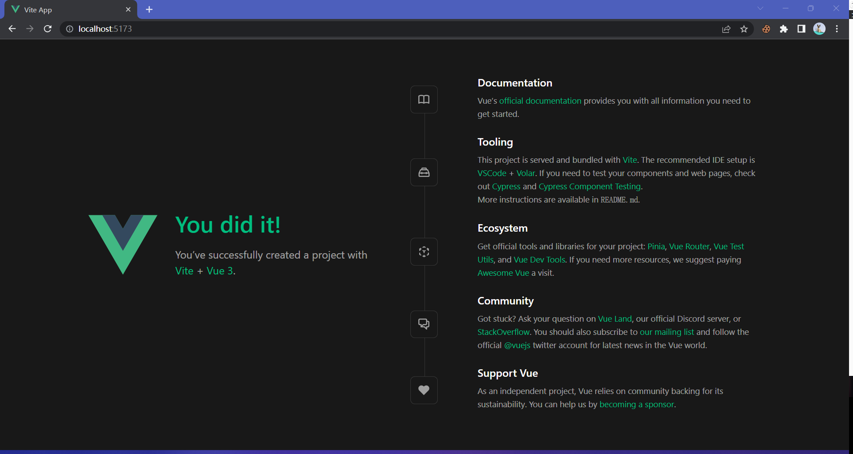](https://xiaobaicai350.github.io/pic/image-20230618181913327.png)

## 熟悉项目和关键文件

[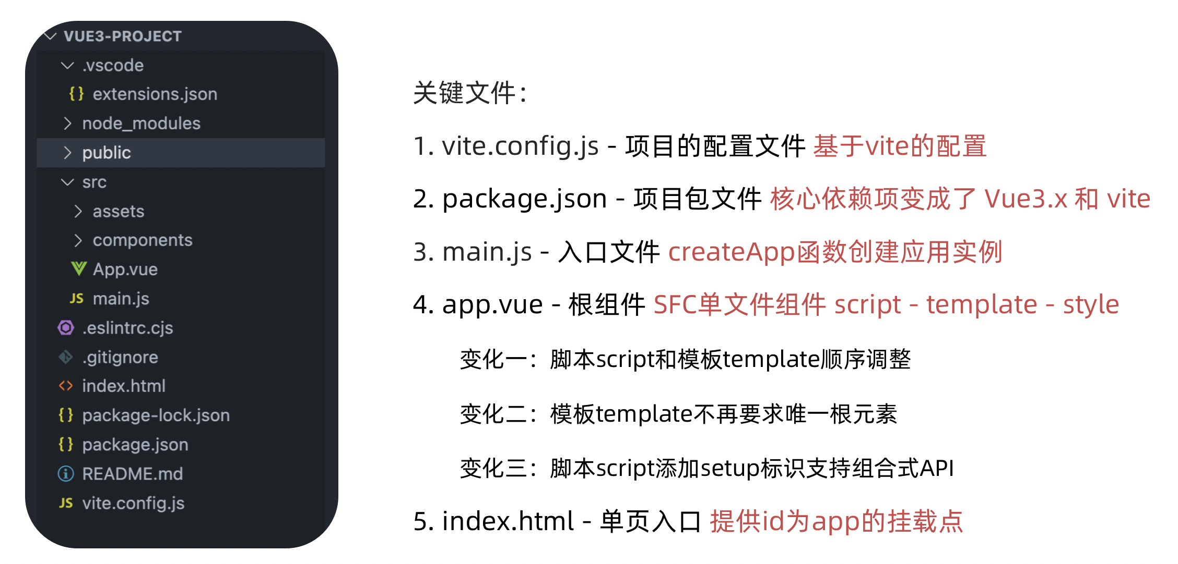](https://xiaobaicai350.github.io/pic/1678178749511-f4a42cbf-987b-46a7-9a01-9cd4f00a5fcf.png)

## 组合式API - setup选项

### 1. setup选项的写法和执行时机

写法

**PLAINTEXT**

|  |
| --- |
| <script>  export default {  setup(){    },  beforeCreate(){    }  } </script> |

执行时机

在beforeCreate钩子之前执行

[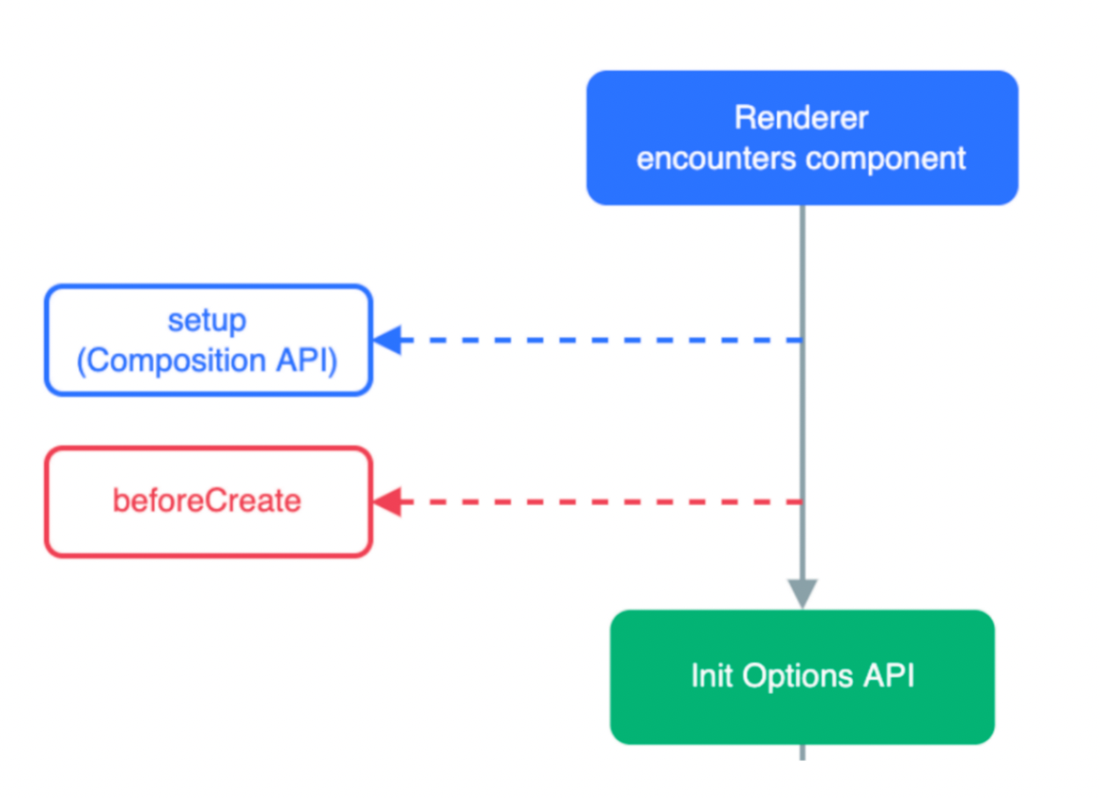](https://xiaobaicai350.github.io/pic/1678179048672-603fdc19-4a41-4542-af55-702776625358.png)

### 2. setup中写代码的特点

在setup函数中写的数据和方法需要在末尾以对象的方式return，才能给模版使用

**PLAINTEXT**

|  |
| --- |
| <script>  export default {  setup(){  const message = 'this is message'  const logMessage = ()=>{  console.log(message)  }  // 必须return才可以  return {  message,  logMessage  }  }  } </script> |

### 3. <script setup>语法糖

script标签添加 setup标记，不需要再写导出语句，默认会添加导出语句

[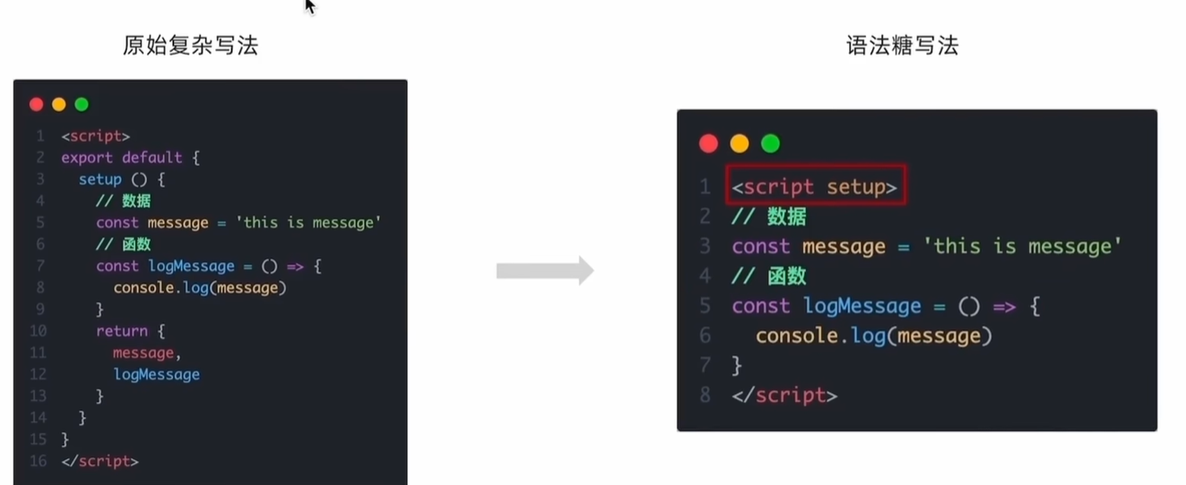](https://xiaobaicai350.github.io/pic/image-20230618193611568.png)

**PLAINTEXT**

|  |
| --- |
| <script setup>  const message = 'this is message'  const logMessage = ()=>{  console.log(message)  } </script> |

需要注意的是。setup中的this已经不指向组件实例啦，指向的undefined。

## 组合式API - reactive和ref函数

### 1. reactive

接受**对象类型数据**的参数传入并返回一个响应式的对象

**PLAINTEXT**

|  |
| --- |
| <script setup>  // 导入  import { reactive } from 'vue'  // 执行函数 传入参数 变量接收  const state = reactive({  msg:'this is msg'  })  const setSate = ()=>{  // 修改数据更新视图  state.msg = 'this is new msg'  } </script>  <template>  {{ state.msg }}  <button @click="setState">change msg</button> </template> |

### 2. ref

接收**简单类型**或者**对象类型**的数据传入并返回一个响应式的对象

**PLAINTEXT**

|  |
| --- |
| <script setup>  // 导入  import { ref } from 'vue'  // 执行函数 传入参数 变量接收  const count = ref(0)  const setCount = ()=>{  // 修改数据更新视图必须加上.value  count.value++  } </script>  <template>  <button @click="setCount">{{count}}</button> </template> |

### 3. reactive 对比 ref

1. 都是用来生成响应式数据
2. 不同点
   1. reactive不能处理简单类型的数据
   2. ref参数类型支持更好，但是必须通过.value做访问修改
   3. ref函数内部的实现依赖于reactive函数
3. 在实际工作中的推荐
   1. 推荐使用ref函数，减少记忆负担，小兔鲜项目都使用**ref**

## 组合式API - computed

计算属性基本思想和Vue2保持一致，组合式API下的计算属性只是修改了API写法

下面这个计算属性会检测原始数据的变化，如果原始数据改变了，那么计算属性也会被调用！

[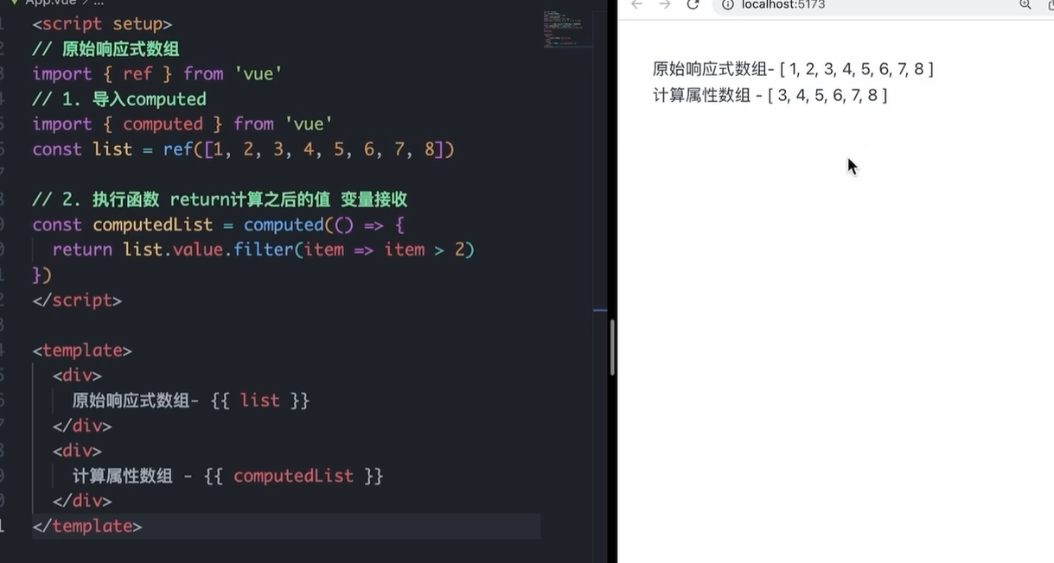](https://xiaobaicai350.github.io/pic/image-20230618195919871.png)

## 组合式API - watch

侦听一个或者多个数据的变化，数据变化时执行回调函数，两个额外参数

* immediate控制立刻执行
* deep开启深度侦听

### 1. 侦听单个数据

**PLAINTEXT**

|  |
| --- |
| <script setup>  // 1. 导入watch  import { ref, watch } from 'vue'  const count = ref(0)  // 2. 调用watch 侦听变化  watch(count, (newValue, oldValue)=>{//一个是变化之前的老值，一个是变化之后的新值  console.log(`count发生了变化，老值为${oldValue},新值为${newValue}`)  }) </script> |

### 2. 侦听多个数据

侦听多个数据，第一个参数可以改写成数组的写法

这两个数据任何一个变化都会引起函数的触发！

**PLAINTEXT**

|  |
| --- |
| <script setup>  // 1. 导入watch  import { ref, watch } from 'vue'  const count = ref(0)  const name = ref('cp')  // 2. 调用watch 侦听变化  watch([count, name], ([newCount, newName],[oldCount,oldName])=>{  console.log(`count或者name变化了，[newCount, newName],[oldCount,oldName])  }) </script> |

### 3. immediate

在侦听器创建时立即触发回调（第一次就执行），响应式数据变化之后继续执行回调

**PLAINTEXT**

|  |
| --- |
| <script setup>  // 1. 导入watch  import { ref, watch } from 'vue'  const count = ref(0)  // 2. 调用watch 侦听变化  watch(count, (newValue, oldValue)=>{  console.log(`count发生了变化，老值为${oldValue},新值为${newValue}`)  },{  immediate: true  }) </script> |

### 4. deep

通过watch监听的ref对象默认是浅层侦听的，直接修改嵌套的对象属性不会触发回调执行，需要开启deep

需要注意的是deep有性能损耗，尽量不要使用deep

**PLAINTEXT**

|  |
| --- |
| <script setup>  // 1. 导入watch  import { ref, watch } from 'vue'  const state = ref({ count: 0 })  // 2. 监听对象state  watch(state, ()=>{  console.log('数据变化了')  })  const changeStateByCount = ()=>{  // 直接修改不会引发回调执行  state.value.count++  } </script> |

添加deep属性就可以触发了

**PLAINTEXT**

|  |
| --- |
| <script setup>  // 1. 导入watch  import { ref, watch } from 'vue'  const state = ref({ count: 0 })  // 2. 监听对象state 并开启deep  watch(state, ()=>{  console.log('数据变化了')  },{deep:true})  const changeStateByCount = ()=>{  // 此时修改可以触发回调  state.value.count++  } </script> |

### 5.精确侦听对象的某个属性

需求：在不开启deep的前提下，侦听age的变化，只有age变化时才执行回调

[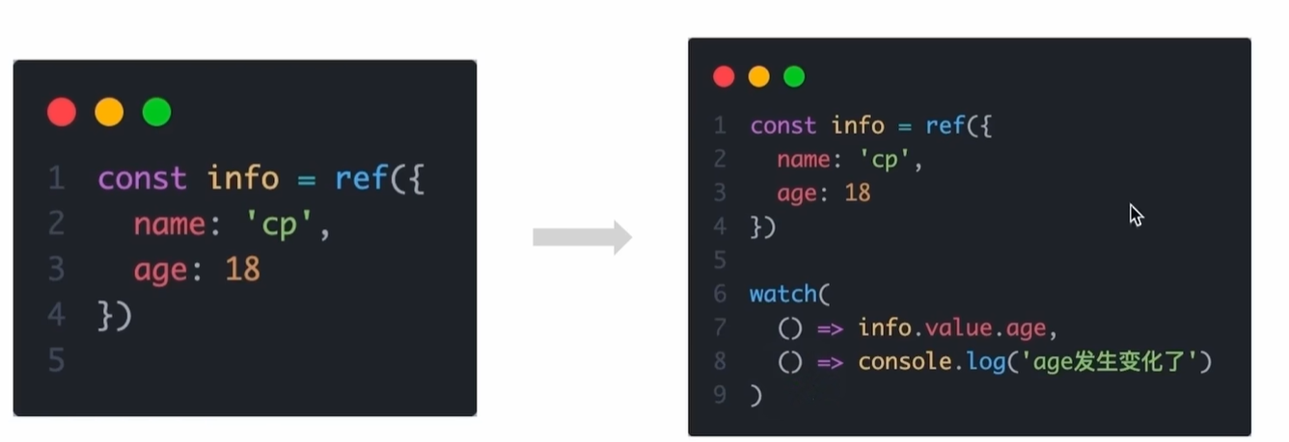](https://xiaobaicai350.github.io/pic/image-20230618212450674.png)

## 组合式API - 生命周期函数

### 1. 选项式对比组合式

[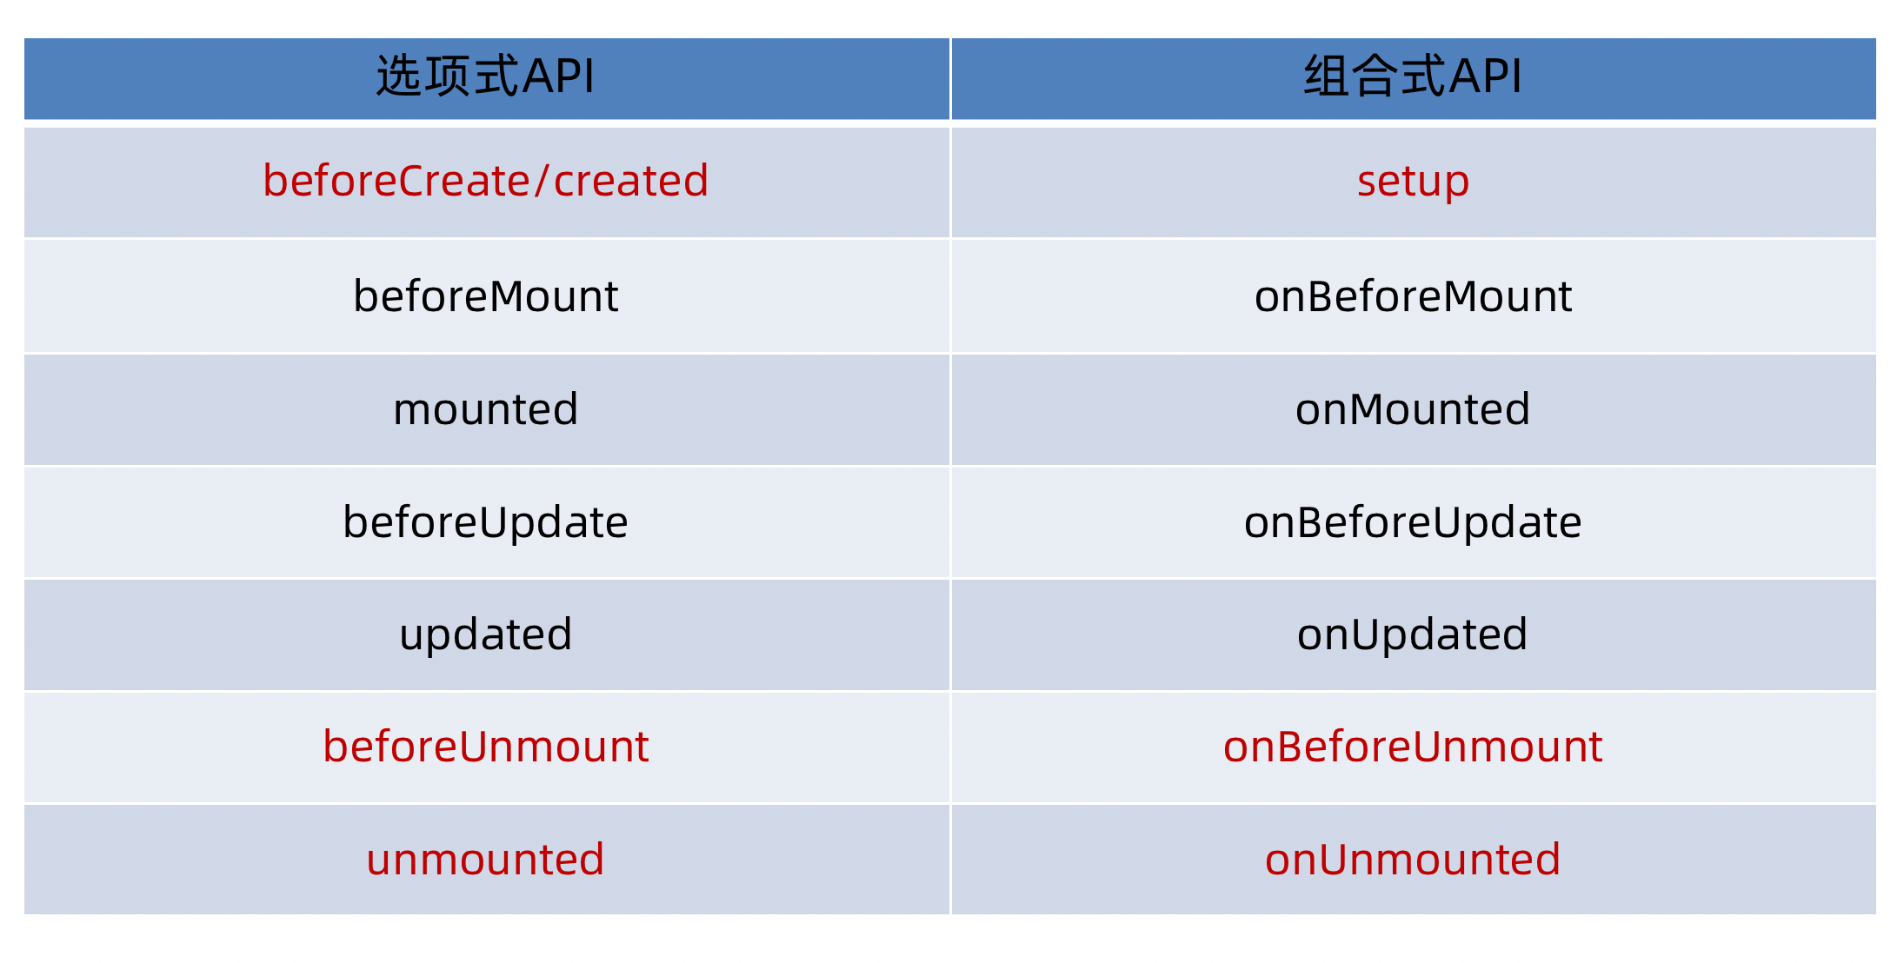](https://xiaobaicai350.github.io/pic/1678183720098-4d40e806-bc0d-4c38-bcbe-9aed440f6b23.png)

### 2. 生命周期函数基本使用

1. 导入生命周期函数
2. 执行生命周期函数，传入回调

**PLAINTEXT**

|  |
| --- |
| <scirpt setup> import { onMounted } from 'vue' onMounted(()=>{  // 自定义逻辑 }) </script> |

### 3. 执行多次

生命周期函数执行多次的时候，会按照顺序依次执行

**PLAINTEXT**

|  |
| --- |
| <scirpt setup> import { onMounted } from 'vue' onMounted(()=>{  // 自定义逻辑 })  onMounted(()=>{  // 自定义逻辑 }) </script> |

## 组合式API - 父子通信

### 1. 父传子

这里注意setup语法糖自动为我们注册了组件，所以我们不用在写components进行注册啦

基本思想

1. 父组件中给子组件绑定属性
2. 子组件内部通过props选项接收数据

### 2. 子传父

基本思想

1. 父组件中给子组件标签通过@绑定事件
2. 子组件内部通过 emit 方法触发事件

## 组合式API - 模版引用

概念：通过 ref标识 获取真实的 dom对象或者组件实例对象

### 1. 基本使用

实现步骤：

1. 调用ref函数生成一个ref对象
2. 通过ref标识绑定ref对象到标签

之后这个dom就被绑定到h1Ref对象身上了，同理也可以得到组件实例对象

[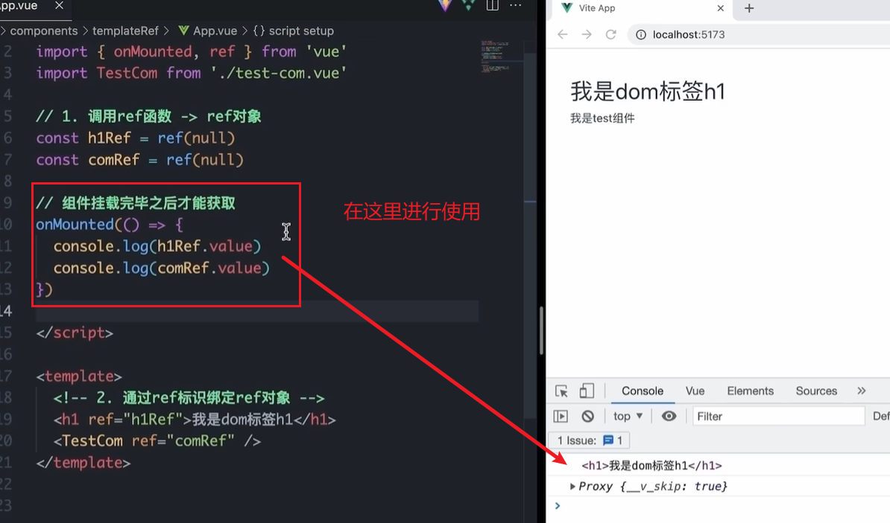](https://xiaobaicai350.github.io/pic/image-20230618214430735.png)

### 2. defineExpose

默认情况下在 <script setup>语法糖下组件内部的属性和方法是不开放给**父组件**(也就是说这个defineExpose是写在子组件里面的)访问的，可以通过defineExpose编译宏指定哪些属性和方法容许访问

说明：下面的代码将子组件里面的testMessage属性暴露出来，使之可以被父组件访问到

## 组合式API - provide和inject

### 1. 作用和场景

顶层组件向任意的底层组件传递数据和方法，实现跨层组件通信

### 2. 跨层传递普通数据

实现步骤

1. 顶层组件通过 provide 函数提供数据
2. 底层组件通过 inject 函数提供数据

[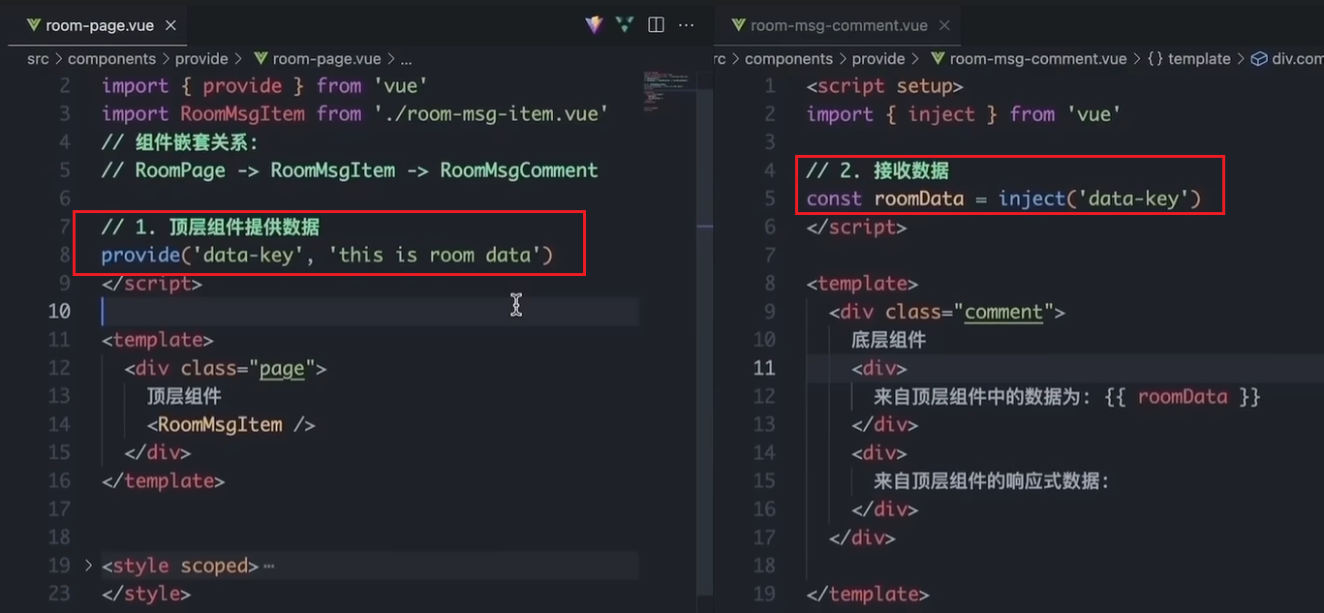](https://xiaobaicai350.github.io/pic/image-20230618215039567.png)

### 3. 跨层传递响应式数据

在调用provide函数时，第二个参数设置为ref对象

### 4. 跨层传递方法

顶层组件可以向底层组件传递方法，底层组件调用方法修改顶层组件的数据

# Pinia入门

## 什么是pinia

Pinia 是 Vue 的专属状态管理库，可以实现跨组件或页面共享状态，是 vuex 状态管理工具的替代品，和 Vuex相比，具备以下优势

1. 提供更加简单的API （去掉了 mutation ）
2. 提供符合组合式API风格的API （和 Vue3 新语法统一）
3. 去掉了modules的概念，每一个store都是一个独立的模块
4. 搭配 TypeScript 一起使用提供可靠的类型推断

## 创建空Vue项目并安装Pinia

### 1. 创建空Vue项目

**BASH**

|  |
| --- |
| npm init vue@latest |

### 2. 安装Pinia并注册

**BASH**

|  |
| --- |
| npm i pinia |

**JAVASCRIPT**

|  |
| --- |
| import { createPinia } from 'pinia'  const app = createApp(App) // 以插件的形式注册 app.use(createPinia()) app.use(router) app.mount('#app') |

## 实现counter

核心步骤：

1. 定义store
2. 组件使用store

1- 定义store

@/stores/counter.js

**JAVASCRIPT**

|  |
| --- |
| import { defineStore } from 'pinia' import { ref } from 'vue'  //这里导出方法。这个方法最好以use开头.... export const useCounterStore = defineStore('counter', ()=>{  // 数据 （state）  const count = ref(0)   // 修改数据的方法 （action,这里既支持同步又支持异步）  const increment = ()=>{  count.value++  }   // 以对象形式返回  return {  count,  increment  } }) |

2- 组件使用store

**PLAINTEXT**

|  |
| --- |
| <script setup>  // 1. 导入use方法  import { useCounterStore } from '@/stores/counter'  // 2. 执行方法得到store， store里有数据和方法  const counterStore = useCounterStore() </script>  <template>  <button @click="counterStore.increment">  {{ counterStore.count }}  </button> </template> |

## 实现getters

getters直接使用计算属性即可实现

**JAVASCRIPT**

|  |
| --- |
| // 数据（state） const count = ref(0) // getter (computed) const doubleCount = computed(() => count.value * 2) |

## 异步action

思想：action函数既支持同步也支持异步，和在组件中发送网络请求写法保持一致  
步骤：

1. store中定义action
2. 组件中触发action

1- store中定义action

**JAVASCRIPT**

|  |
| --- |
| const API_URL = 'http://geek.itheima.net/v1_0/channels'  export const useCounterStore = defineStore('counter', ()=>{  // 数据  const list = ref([])  // 异步action  const loadList = async ()=>{  const res = await axios.get(API_URL)  list.value = res.data.data.channels  }    return {  list,  loadList  } }) |

2- 组件中调用action

**PLAINTEXT**

|  |
| --- |
| <script setup>  import { useCounterStore } from '@/stores/counter'  const counterStore = useCounterStore()  // 调用异步action  counterStore.loadList() </script>  <template>  <ul>  <li v-for="item in counterStore.list" :key="item.id">{{ item.name }}</li>  </ul> </template> |

## storeToRefs保持响应式解构

直接基于store进行解构赋值，响应式数据（state和getter）会丢失响应式特性。

但是我们还是想用解构赋值，那么我们就可以使用storeToRefs辅助保持响应式

**PLAINTEXT**

|  |
| --- |
| <script setup>  import { storeToRefs } from 'pinia'  import { useCounterStore } from '@/stores/counter'  const counterStore = useCounterStore()  // 使用它storeToRefs包裹之后解构保持响应式，  // 注意，这里只能解构赋值数据，不管是对象类型还是基本数据类型都可以，但是不能解构赋值方法  const { count } = storeToRefs(counterStore)  // 如果想要解构赋值方法，使用这种方法解构就好啦  const { increment } = counterStore   </script>  <template>  <button @click="increment">  {{ count }}  </button> </template> |

# 项目起步

## 创建项目并整理目录

**BASH**

|  |
| --- |
| npm init vue@latest |

### src目录调整

[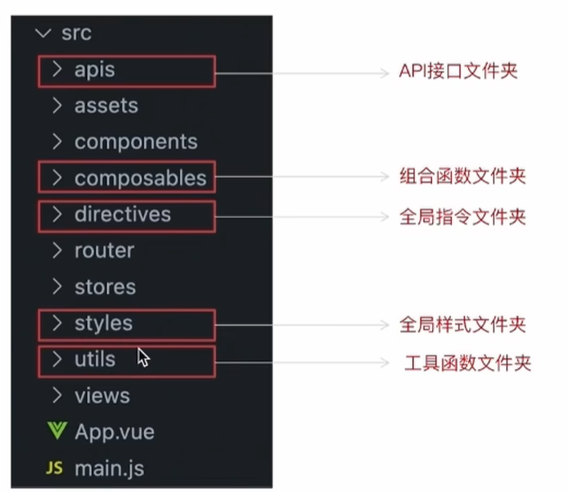](https://xiaobaicai350.github.io/pic/image-20230618222530147.png)

## jsconfig.json配置别名路径

配置别名路径可以在写代码时联想提示路径，也就是说，在编写代码的过程中，一旦输入@/，VSCode会立刻联想出src下的所有子目录和文件，统一文件路径访问不容易出错

不过我下载了插件，这个就不用配置了

[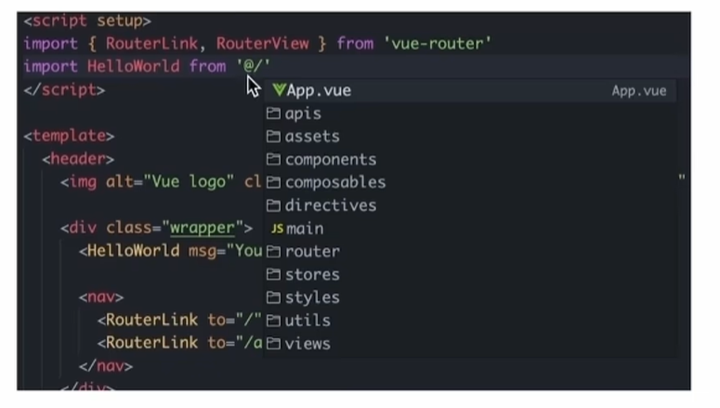](https://xiaobaicai350.github.io/pic/image-20230618222757293.png)

那么如何进行配置呢？

1. 在项目的根目录下新增jsconfig.json文件
2. 添加json格式的配置项，如下：

**JSON**

|  |
| --- |
| {  "compilerOptions" : {  "baseUrl" : "./",  "paths" : {  "@/*":["src/*"]  }  } } |

## elementPlus引入

### 1. 安装elementPlus和自动导入插件

**BASH**

|  |
| --- |
| npm install element-plus --save npm install -D unplugin-vue-components unplugin-auto-import |

### 2. 配置自动按需导入

**JAVASCRIPT**

|  |
| --- |
| // vite.config.ts import { defineConfig } from 'vite' import AutoImport from 'unplugin-auto-import/vite' import Components from 'unplugin-vue-components/vite' import { ElementPlusResolver } from 'unplugin-vue-components/resolvers'  export default defineConfig({  // ...  plugins: [  // ...  AutoImport({  resolvers: [ElementPlusResolver()],  }),  Components({  resolvers: [ElementPlusResolver()],  }),  ], }) |

### 3. 测试组件

**PLAINTEXT**

|  |
| --- |
| <template>  <el-button type="primary">i am button</el-button> </template> |

## 定制elementPlus主题

### 1. 安装sass

基于vite的项目默认不支持css预处理器，需要开发者单独安装

**BASH**

|  |
| --- |
| npm i sass -D |

### 2. 准备定制化的样式文件

styles/element/index.scss

**JAVASCRIPT**

|  |
| --- |
| /* 只需要重写你需要的即可 */ @forward 'element-plus/theme-chalk/src/common/var.scss' with (  $colors: (  'primary': (  // 主色  'base': #27ba9b,  ),  'success': (  // 成功色  'base': #1dc779,  ),  'warning': (  // 警告色  'base': #ffb302,  ),  'danger': (  // 危险色  'base': #e26237,  ),  'error': (  // 错误色  'base': #cf4444,  ),  ) ) |

### 3. 自动导入配置

这里自动导入需要深入到elementPlus的组件中，按照官方的配置文档来

1. 自动导入定制化样式文件进行样式覆盖
2. 按需定制主题配置 （需要安装 unplugin-element-plus）

vite.config.js

**JAVASCRIPT**

|  |
| --- |
| import { fileURLToPath, URL } from "node:url";  import { defineConfig } from "vite"; import vue from "@vitejs/plugin-vue";  import AutoImport from "unplugin-auto-import/vite"; import Components from "unplugin-vue-components/vite"; import { ElementPlusResolver } from "unplugin-vue-components/resolvers";  // https://vitejs.dev/config/ export default defineConfig({  plugins: [  vue(),  AutoImport({  resolvers: [ElementPlusResolver()],  }),  Components({  resolvers: [ElementPlusResolver({ importStyle: "sass" })],  }),  ],  resolve: {  alias: {  "@": fileURLToPath(new URL("./src", import.meta.url)),  },  },  css: {  preprocessorOptions: {  scss: {  // 自动导入定制化样式文件进行样式覆盖  additionalData: `  @use "@/styles/element/index.scss" as *;  `,  },  },  }, }); |

## axios安装并简单封装

### 1. 安装axios

**BASH**

|  |
| --- |
| npm i axios |

### 2. 基础配置

官方文档地址：<https://axios-http.com/zh/docs/intro>  
基础配置通常包括：

1. 实例化 - baseURL + timeout
2. 拦截器 - 携带token 401拦截等

[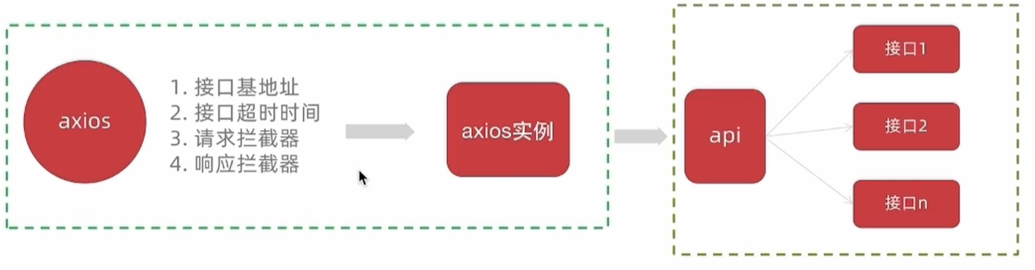](https://xiaobaicai350.github.io/pic/image-20230619091729590.png)

utils/http.js

**JAVASCRIPT**

|  |
| --- |
| import axios from 'axios'  // 创建axios实例 const httpInstance = axios.create({  baseURL: 'http://pcapi-xiaotuxian-front-devtest.itheima.net',  timeout: 5000 })  //目前这两个没啥用，以后再用 // axios请求拦截器 httpInstance.interceptors.request.use(config => {  return config }, e => Promise.reject(e))  // axios响应式拦截器 httpInstance.interceptors.response.use(res => res.data, e => {  return Promise.reject(e) })   export default httpInstance |

### 3. 封装请求函数

apis/testAPI.js

**JAVASCRIPT**

|  |
| --- |
| import httpInstance from '@/utils/http'  export function getCategoryAPI () {  return httpInstance({  url: 'home/category/head'  }) } |

### 4.进行测试

测试在哪进行都可以

**JS**

|  |
| --- |
| import { getCategoryAPI } from "@/apis/testAPI.js";  getCategoryAPI().then((res) => {  console.log(res); }); |

## 添加不在强制组件重命名的配置

这个是对eslint的配置

.eslintrc.cjs

**JS**

|  |
| --- |
| /* eslint-env node */ module.exports = {  root: true,  'extends': [  'plugin:vue/vue3-essential',  'eslint:recommended'  ],  parserOptions: {  ecmaVersion: 'latest'  },  //添加不再强制要求组件重命名的配置  rules:{  'vue/multi-word-component-names':0,  } } |

## 路由整体设计

路由设计原则：找页面的切换方式，如果是**整体切换**，则为一级路由，如果是在一级路由的内部进行的内容切换，则为二级路由

[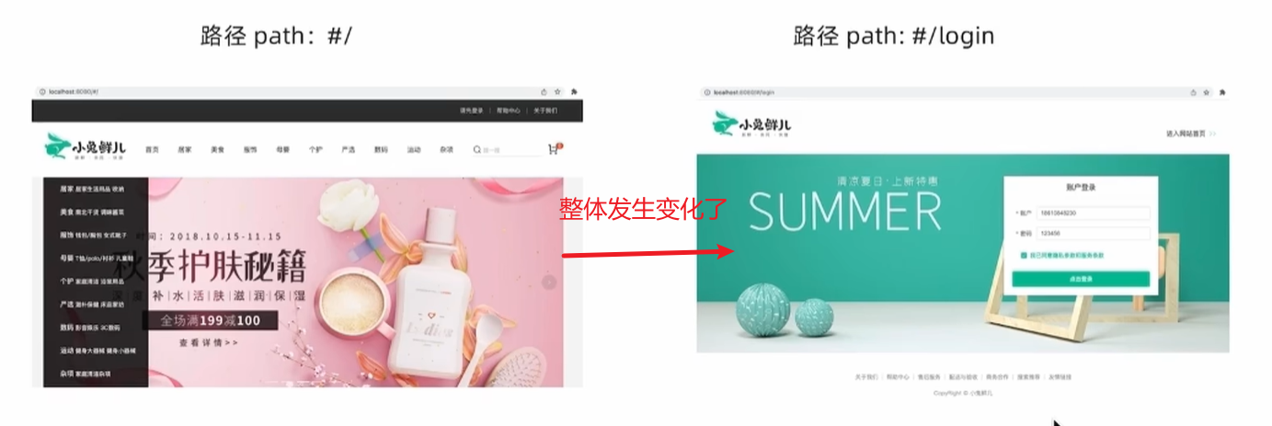](https://xiaobaicai350.github.io/pic/image-20230619094847419.png)

view/Login/index.vue

**HTML**

|  |
| --- |
| <template>  我是Login </template> |

views/Layout/index.vue

**HTML**

|  |
| --- |
| <template>  我是Layout </template> |

二级路由：如果是在一级路由的内部进行的内容切换，则为二级路由

views/Home/index.vue

**HTML**

|  |
| --- |
| <template>  我是home </template> |

views/Category/index.vue

**HTML**

|  |
| --- |
| <template>  我是Category </template> |

router/index.js

**JAVASCRIPT**

|  |
| --- |
| // createRouter：创建router实例对象 // createWebHistory：创建history模式的路由  import { createRouter, createWebHistory } from "vue-router"; import Login from "@/views/Login/index.vue"; import Layout from "@/views/Layout/index.vue"; import Home from "@/views/Home/index.vue"; import Category from "@/views/Category/index.vue";  const router = createRouter({  history: createWebHistory(import.meta.env.BASE_URL),  // path和component对应关系的位置  routes: [  {  path: "/",  component: Layout,  children: [  {  path: "",  component: Home,  },  {  path: "category",  component: Category,  },  ],  },  {  path: "/login",  component: Login,  },  ], });  export default router; |

添加一级路由出口

App.vue

**PLAINTEXT**

|  |
| --- |
| <script setup></script> <template>  <!-- 添加一级路由出口 -->  <router-view></router-view> </template>  <style scoped></style> |

添加二级路由出口

view/Layout/index.vue

**PLAINTEXT**

|  |
| --- |
| <template>  <div>我是layout</div>  <!-- 添加二级路由出口 -->  <router-view /> </template>  <script> export default {}; </script>  <style></style> |

## 静态资源引入和Error Lens安装

### 1. 静态资源引入

1. 图片资源 - 把 images 文件夹放到 assets 目录下
2. 样式资源 - 把 common.scss 文件放到 styles 目录下，然后在main.js中引入[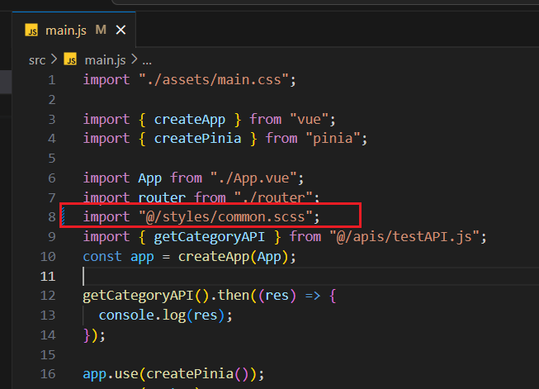](https://xiaobaicai350.github.io/pic/image-20230619104426694.png)

### 2. Error Lens插件安装

error lens是一个试试提供错误警告信息的VSCode插件，方便开发

[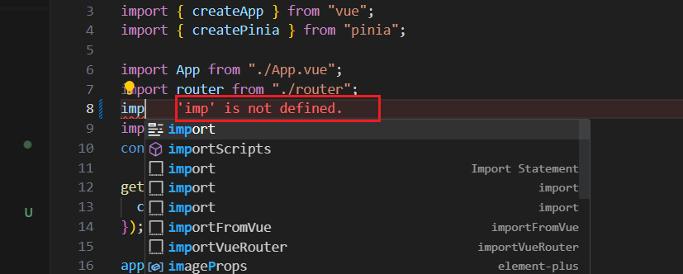](https://xiaobaicai350.github.io/pic/image-20230619104336861.png)

## scss变量自动导入

为什么要自动导入？

在项目里一些组件共享的色值会以scss变量的方式统一放到一个名叫var.scss的文件中，正常组件中使用这些变量的时候，需要先导入var.scss文件。再使用内部的变量，比较繁琐，自动导入可以免去手动导入的步骤，直接使用内部的变量

[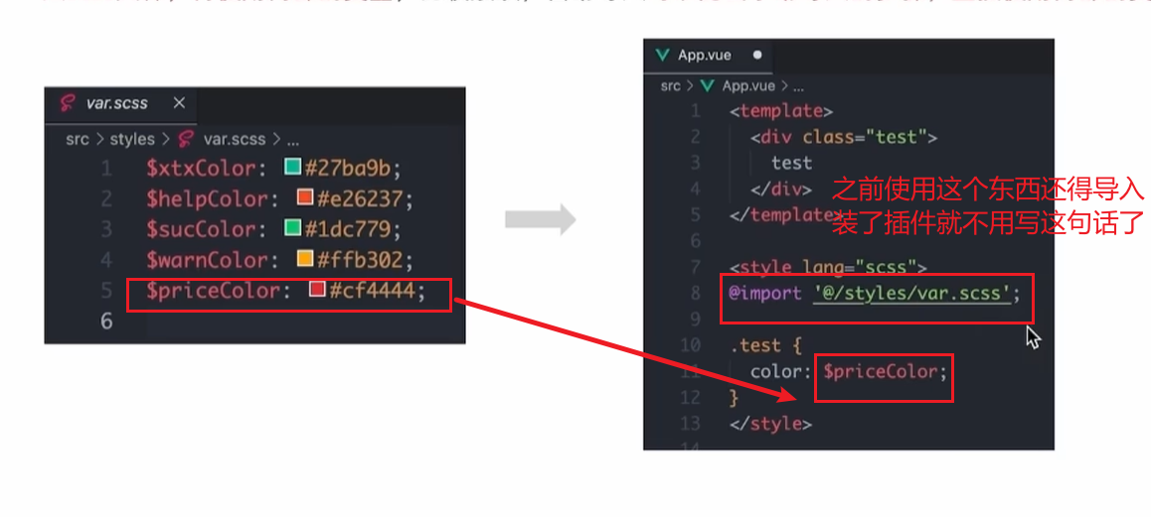](https://xiaobaicai350.github.io/pic/image-20230619104727521.png)

styles/var.scss

**CSS**

|  |
| --- |
| $xtxColor: #27ba9b; $helpColor: #e26237; $sucColor: #1dc779; $warnColor: #ffb302; $priceColor: #cf4444; |

vite.config.js

**JSON**

|  |
| --- |
| css: {  preprocessorOptions: {  scss: {  // 自动导入scss文件  additionalData: `  @use "@/styles/element/index.scss" as *;  @use "@/styles/var.scss" as *;  `,  }  } } |

测试：

**PLAINTEXT**

|  |
| --- |
| <template>  <div class="test">我是layout</div>  <!-- 添加二级路由出口 -->  <router-view /> </template>  <script> export default {}; </script>  <!-- 这里注意要加lang --> <style scoped lang="scss"> .test {  // 直接在这里使用就可以了  color: $priceColor; } </style> |

# Layout页

[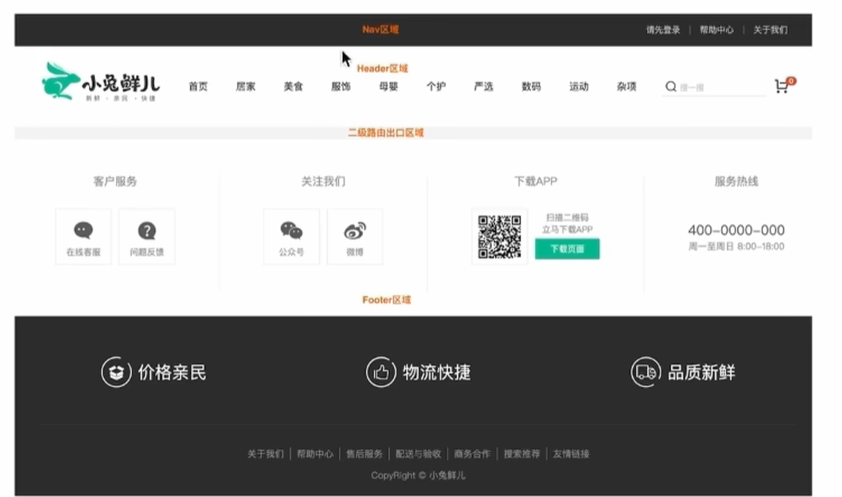](https://xiaobaicai350.github.io/pic/image-20230619105759274.png)

## 组件结构快速搭建

view/Latout/components/LayoutNav.vue

**PLAINTEXT**

|  |
| --- |
| <script setup>  </script>  <template>  <nav class="app-topnav">  <div class="container">  <ul>  <template v-if="true">  <li><a href="javascript:;"><i class="iconfont icon-user"></i>周杰伦</a></li>  <li>  <el-popconfirm title="确认退出吗?" confirm-button-text="确认" cancel-button-text="取消">  <template #reference>  <a href="javascript:;">退出登录</a>  </template>  </el-popconfirm>  </li>  <li><a href="javascript:;">我的订单</a></li>  <li><a href="javascript:;">会员中心</a></li>  </template>  <template v-else>  <li><a href="javascript:;">请先登录</a></li>  <li><a href="javascript:;">帮助中心</a></li>  <li><a href="javascript:;">关于我们</a></li>  </template>  </ul>  </div>  </nav> </template>   <style scoped lang="scss"> .app-topnav {  background: #333;  ul {  display: flex;  height: 53px;  justify-content: flex-end;  align-items: center;  li {  a {  padding: 0 15px;  color: #cdcdcd;  line-height: 1;  display: inline-block;   i {  font-size: 14px;  margin-right: 2px;  }   &:hover {  color: $xtxColor;  }  }   ~li {  a {  border-left: 2px solid #666;  }  }  }  } } </style> |

view/Latout/components/LayoutHeader.vue

**PLAINTEXT**

|  |
| --- |
| <script setup>  </script>  <template>  <header class='app-header'>  <div class="container">  <h1 class="logo">  <RouterLink to="/">小兔鲜</RouterLink>  </h1>  <ul class="app-header-nav">  <li class="home">  <RouterLink to="/">首页</RouterLink>  </li>  <li> <RouterLink to="/">居家</RouterLink> </li>  <li> <RouterLink to="/">美食</RouterLink> </li>  <li> <RouterLink to="/">服饰</RouterLink> </li>  </ul>  <div class="search">  <i class="iconfont icon-search"></i>  <input type="text" placeholder="搜一搜">  </div>  <!-- 头部购物车 -->    </div>  </header> </template>   <style scoped lang='scss'> .app-header {  background: #fff;   .container {  display: flex;  align-items: center;  }   .logo {  width: 200px;   a {  display: block;  height: 132px;  width: 100%;  text-indent: -9999px;  background: url('@/assets/images/logo.png') no-repeat center 18px / contain;  }  }   .app-header-nav {  width: 820px;  display: flex;  padding-left: 40px;  position: relative;  z-index: 998;    li {  margin-right: 40px;  width: 38px;  text-align: center;    a {  font-size: 16px;  line-height: 32px;  height: 32px;  display: inline-block;    &:hover {  color: $xtxColor;  border-bottom: 1px solid $xtxColor;  }  }    .active {  color: $xtxColor;  border-bottom: 1px solid $xtxColor;  }  }  }   .search {  width: 170px;  height: 32px;  position: relative;  border-bottom: 1px solid #e7e7e7;  line-height: 32px;   .icon-search {  font-size: 18px;  margin-left: 5px;  }   input {  width: 140px;  padding-left: 5px;  color: #666;  }  }   .cart {  width: 50px;   .curr {  height: 32px;  line-height: 32px;  text-align: center;  position: relative;  display: block;   .icon-cart {  font-size: 22px;  }   em {  font-style: normal;  position: absolute;  right: 0;  top: 0;  padding: 1px 6px;  line-height: 1;  background: $helpColor;  color: #fff;  font-size: 12px;  border-radius: 10px;  font-family: Arial;  }  }  } } </style> |

view/Latout/components/LayoutFooter.vue

**PLAINTEXT**

|  |
| --- |
| <template>  <footer class="app_footer">  <!-- 联系我们 -->  <div class="contact">  <div class="container">  <dl>  <dt>客户服务</dt>  <dd><i class="iconfont icon-kefu"></i> 在线客服</dd>  <dd><i class="iconfont icon-question"></i> 问题反馈</dd>  </dl>  <dl>  <dt>关注我们</dt>  <dd><i class="iconfont icon-weixin"></i> 公众号</dd>  <dd><i class="iconfont icon-weibo"></i> 微博</dd>  </dl>  <dl>  <dt>下载APP</dt>  <dd class="qrcode"><img src="@/assets/images/qrcode.jpg" /></dd>  <dd class="download">  <span>扫描二维码</span>  <span>立马下载APP</span>  <a href="javascript:;">下载页面</a>  </dd>  </dl>  <dl>  <dt>服务热线</dt>  <dd class="hotline">400-0000-000 <small>周一至周日 8:00-18:00</small></dd>  </dl>  </div>  </div>  <!-- 其它 -->  <div class="extra">  <div class="container">  <div class="slogan">  <a href="javascript:;">  <i class="iconfont icon-footer01"></i>  <span>价格亲民</span>  </a>  <a href="javascript:;">  <i class="iconfont icon-footer02"></i>  <span>物流快捷</span>  </a>  <a href="javascript:;">  <i class="iconfont icon-footer03"></i>  <span>品质新鲜</span>  </a>  </div>  <!-- 版权信息 -->  <div class="copyright">  <p>  <a href="javascript:;">关于我们</a>  <a href="javascript:;">帮助中心</a>  <a href="javascript:;">售后服务</a>  <a href="javascript:;">配送与验收</a>  <a href="javascript:;">商务合作</a>  <a href="javascript:;">搜索推荐</a>  <a href="javascript:;">友情链接</a>  </p>  <p>CopyRight © 小兔鲜儿</p>  </div>  </div>  </div>  </footer> </template>  <style scoped lang='scss'> .app_footer {  overflow: hidden;  background-color: #f5f5f5;  padding-top: 20px;   .contact {  background: #fff;   .container {  padding: 60px 0 40px 25px;  display: flex;  }   dl {  height: 190px;  text-align: center;  padding: 0 72px;  border-right: 1px solid #f2f2f2;  color: #999;   &:first-child {  padding-left: 0;  }   &:last-child {  border-right: none;  padding-right: 0;  }  }   dt {  line-height: 1;  font-size: 18px;  }   dd {  margin: 36px 12px 0 0;  float: left;  width: 92px;  height: 92px;  padding-top: 10px;  border: 1px solid #ededed;   .iconfont {  font-size: 36px;  display: block;  color: #666;  }   &:hover {  .iconfont {  color: $xtxColor;  }  }   &:last-child {  margin-right: 0;  }  }   .qrcode {  width: 92px;  height: 92px;  padding: 7px;  border: 1px solid #ededed;  }   .download {  padding-top: 5px;  font-size: 14px;  width: auto;  height: auto;  border: none;   span {  display: block;  }   a {  display: block;  line-height: 1;  padding: 10px 25px;  margin-top: 5px;  color: #fff;  border-radius: 2px;  background-color: $xtxColor;  }  }   .hotline {  padding-top: 20px;  font-size: 22px;  color: #666;  width: auto;  height: auto;  border: none;   small {  display: block;  font-size: 15px;  color: #999;  }  }  }   .extra {  background-color: #333;  }   .slogan {  height: 178px;  line-height: 58px;  padding: 60px 100px;  border-bottom: 1px solid #434343;  display: flex;  justify-content: space-between;   a {  height: 58px;  line-height: 58px;  color: #fff;  font-size: 28px;   i {  font-size: 50px;  vertical-align: middle;  margin-right: 10px;  font-weight: 100;  }   span {  vertical-align: middle;  text-shadow: 0 0 1px #333;  }  }  }   .copyright {  height: 170px;  padding-top: 40px;  text-align: center;  color: #999;  font-size: 15px;   p {  line-height: 1;  margin-bottom: 20px;  }   a {  color: #999;  line-height: 1;  padding: 0 10px;  border-right: 1px solid #999;   &:last-child {  border-right: none;  }  }  } } </style> |

view/Latout/index.vue

**PLAINTEXT**

|  |
| --- |
| <script setup> import LayoutNav from './components/LayoutNav.vue' import LayoutHeader from './components/LayoutHeader.vue' import LayoutFooter from './components/LayoutFooter.vue' </script>  <template>  <LayoutNav />  <LayoutHeader />  <RouterView />  <LayoutFooter /> </template> |

## 字体图标渲染

字体图标采用的是阿里的字体图标库，样式文件已经准备好，在 index.html文件中引入即可

[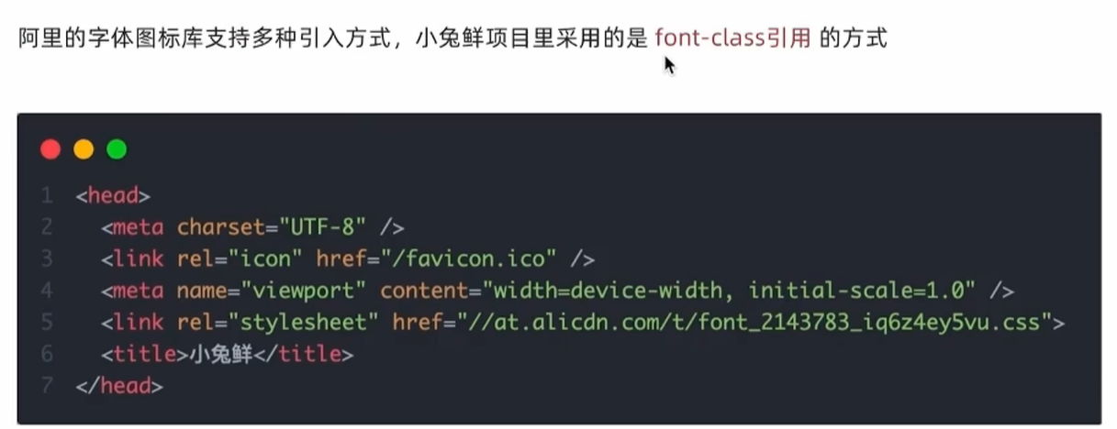](https://xiaobaicai350.github.io/pic/image-20230619110946417.png)

[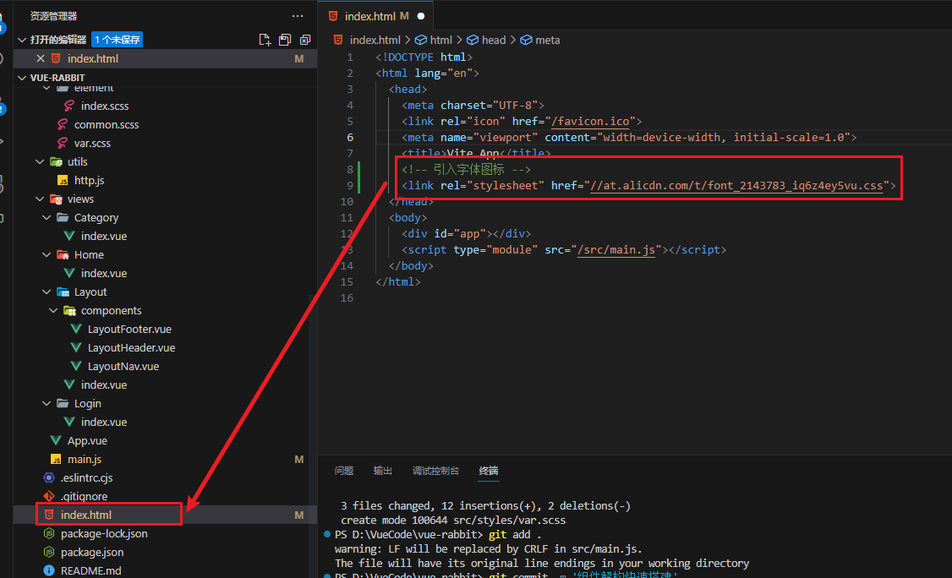](https://raw.githubusercontent.com/Xiaobaicai350/picBed/master/xiaobaicai/image-20230619111332619.png)

**HTML**

|  |
| --- |
| <link rel="stylesheet" href="//at.alicdn.com/t/font_2143783_iq6z4ey5vu.css"> |

效果：

[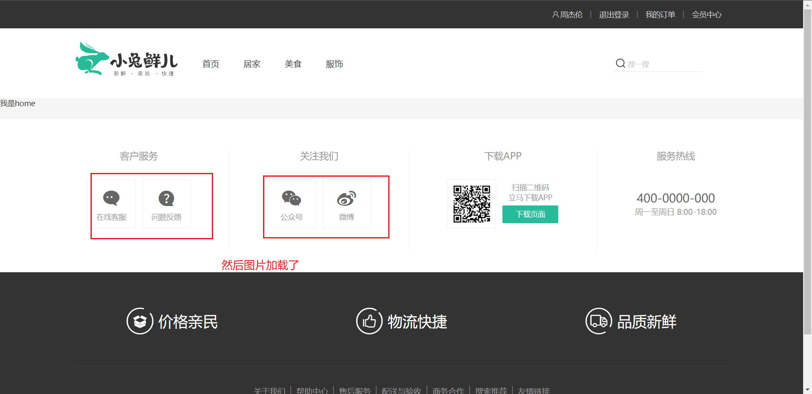](https://raw.githubusercontent.com/Xiaobaicai350/picBed/master/xiaobaicai/image-20230619111415232.png)

## 一级导航渲染

要把上面的导航信息根据后端传过来的数据进行渲染

[](https://raw.githubusercontent.com/Xiaobaicai350/picBed/master/xiaobaicai/1677638045286-b328a3ce-8241-4ce7-9db3-e9c872da5b73.png)  
**实现步骤**

1. 封装接口函数
2. 调用接口函数
3. v-for渲染模版

**代码落地**

apis/layout.js

**JAVASCRIPT**

|  |
| --- |
| import httpInstance from '@/utils/http'  export function getCategoryAPI () {  return httpInstance({  url: '/home/category/head'  }) } |

views/components/LayoutHeader.vue

**PLAINTEXT**

|  |
| --- |
| <script setup> // 引入api import { getCategoryAPI } from "@/apis/layout"; import { onMounted, ref } from "vue";  const categoryList = ref([]); const getCategory = async () => {  const res = await getCategoryAPI();  // 赋值  categoryList.value = res.result; };  onMounted(() => getCategory()); </script>  <template>  <header class="app-header">  <div class="container">  <h1 class="logo">  <RouterLink to="/">小兔鲜</RouterLink>  </h1>  <ul class="app-header-nav">  <!-- 遍历list中的数据，渲染列表 -->  <li class="home" v-for="item in categoryList" :key="item.id">  <RouterLink to="/">{{ item.name }}</RouterLink>  </li>  </ul>  <div class="search">  <i class="iconfont icon-search"></i>  <input type="text" placeholder="搜一搜" />  </div>  <!-- 头部购物车 -->  </div>  </header> </template> |

## 吸顶导航交互实现

需求：浏览器在上下滚动的过程中，如果距离顶部的滚动距离大于78px，吸顶导航就显示，如果小于78px就隐藏

### 1. 准备组件静态结构

view/Layout/components/LayoutFixed.vue

**PLAINTEXT**

|  |
| --- |
| <script setup>  </script>  <template>  <div class="app-header-sticky show">  <div class="container">  <RouterLink class="logo" to="/" />  <!-- 导航区域 -->  <ul class="app-header-nav ">  <li class="home">  <RouterLink to="/">首页</RouterLink>  </li>  <li>  <RouterLink to="/">居家</RouterLink>  </li>  <li>  <RouterLink to="/">美食</RouterLink>  </li>  <li>  <RouterLink to="/">服饰</RouterLink>  </li>  <li>  <RouterLink to="/">母婴</RouterLink>  </li>  <li>  <RouterLink to="/">个护</RouterLink>  </li>  <li>  <RouterLink to="/">严选</RouterLink>  </li>  <li>  <RouterLink to="/">数码</RouterLink>  </li>  <li>  <RouterLink to="/">运动</RouterLink>  </li>  <li>  <RouterLink to="/">杂项</RouterLink>  </li>  </ul>   <div class="right">  <RouterLink to="/">品牌</RouterLink>  <RouterLink to="/">专题</RouterLink>  </div>  </div>  </div> </template>   <style scoped lang='scss'> .app-header-sticky {  width: 100%;  height: 80px;  position: fixed;  left: 0;  top: 0;  z-index: 999;  background-color: #fff;  border-bottom: 1px solid #e4e4e4;  // 此处为关键样式!!!  // 状态一：往上平移自身高度 + 完全透明  transform: translateY(-100%);  opacity: 0;   // 状态二：移除平移 + 完全不透明  &.show {  transition: all 0.3s linear;  transform: none;  opacity: 1;  }   .container {  display: flex;  align-items: center;  }   .logo {  width: 200px;  height: 80px;  background: url("@/assets/images/logo.png") no-repeat right 2px;  background-size: 160px auto;  }   .right {  width: 220px;  display: flex;  text-align: center;  padding-left: 40px;  border-left: 2px solid $xtxColor;   a {  width: 38px;  margin-right: 40px;  font-size: 16px;  line-height: 1;   &:hover {  color: $xtxColor;  }  }  } }  .app-header-nav {  width: 820px;  display: flex;  padding-left: 40px;  position: relative;  z-index: 998;   li {  margin-right: 40px;  width: 38px;  text-align: center;   a {  font-size: 16px;  line-height: 32px;  height: 32px;  display: inline-block;   &:hover {  color: $xtxColor;  border-bottom: 1px solid $xtxColor;  }  }   .active {  color: $xtxColor;  border-bottom: 1px solid $xtxColor;  }  } } </style> |

然后引入到

### 2. 获取滚动距离

安装vueuse

npm i @vueuse/core

用vueuse的函数来实现获取滚动的距离

### 3. 以滚动距离做判断条件控制组件盒子显示隐藏

核心逻辑：根据滚动距离判断当前show类名是否显示，大于78显示，小于78，不显示

view/Layout/components/LayoutFixed.vue

**PLAINTEXT**

|  |
| --- |
| <script setup> // vueUse import { useScroll } from '@vueuse/core' const { y } = useScroll(window) </script>  <template>  <!-- 以滚动距离做判断条件控制组件盒子显示隐藏 -->  <div class="app-header-sticky" :class="{ show: y > 78 }">  <!-- 省略部分代码 -->  </div> </template> |

## Pinia优化重复请求

[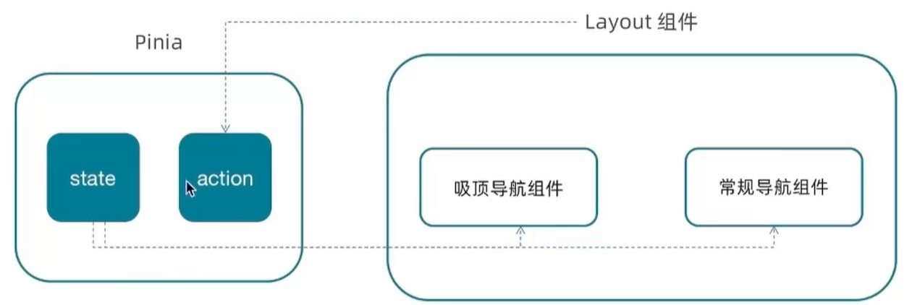](https://xiaobaicai350.github.io/pic/image-20230619133325167.png)

store/category.js

**JAVASCRIPT**

|  |
| --- |
| import { ref } from 'vue' import { defineStore } from 'pinia' import { getCategoryAPI } from '@/apis/layout' export const useCategoryStore = defineStore('category', () => {  // 导航列表的数据管理  // state 导航列表数据  const categoryList = ref([])   // action 获取导航数据的方法  const getCategory = async () => {  const res = await getCategoryAPI()  categoryList.value = res.result  }   return {  categoryList,  getCategory  } }) |

在index页面中调用action初始化数据

[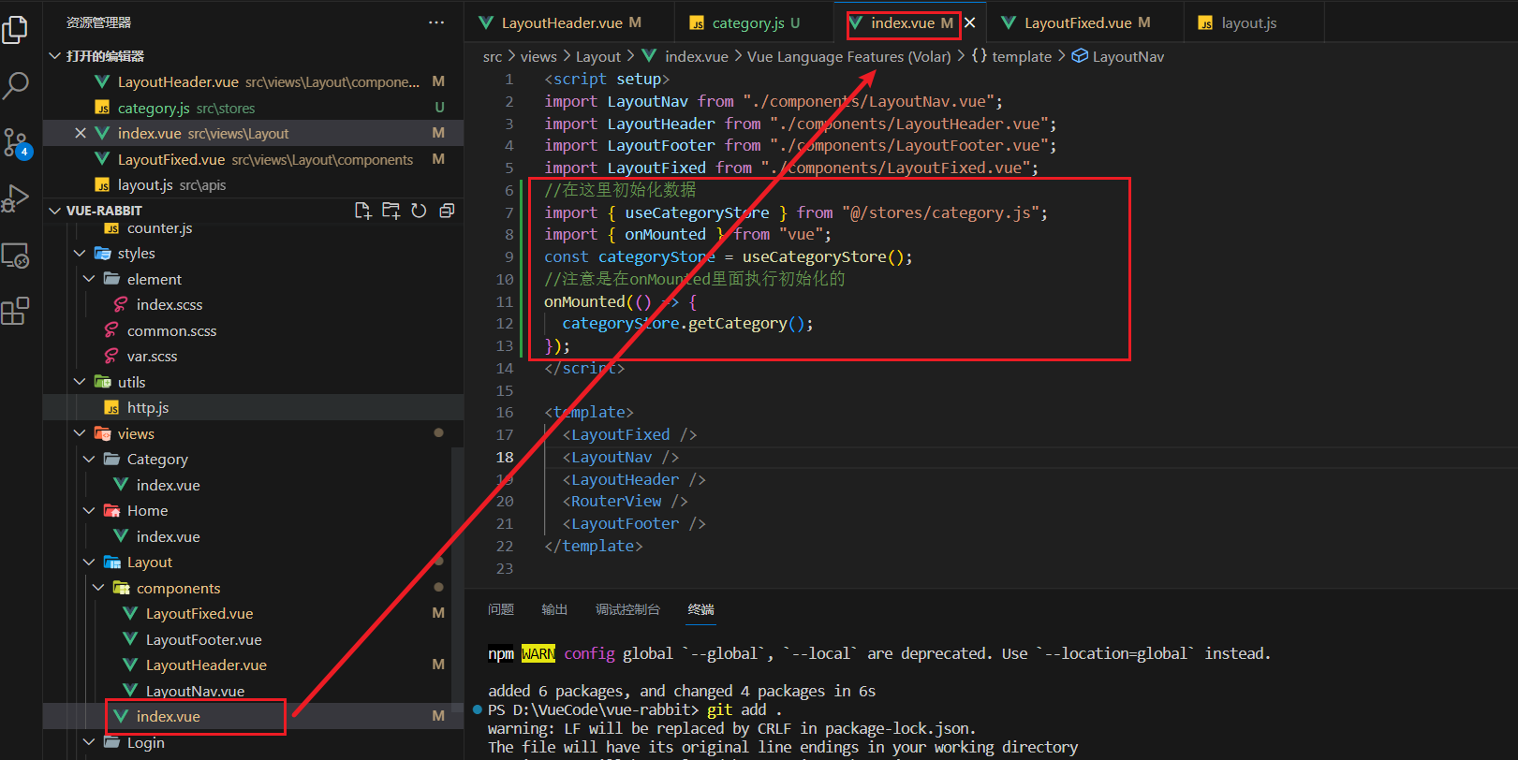](https://xiaobaicai350.github.io/pic/image-20230619135715610.png)

然后就是在两个组件中使用了

[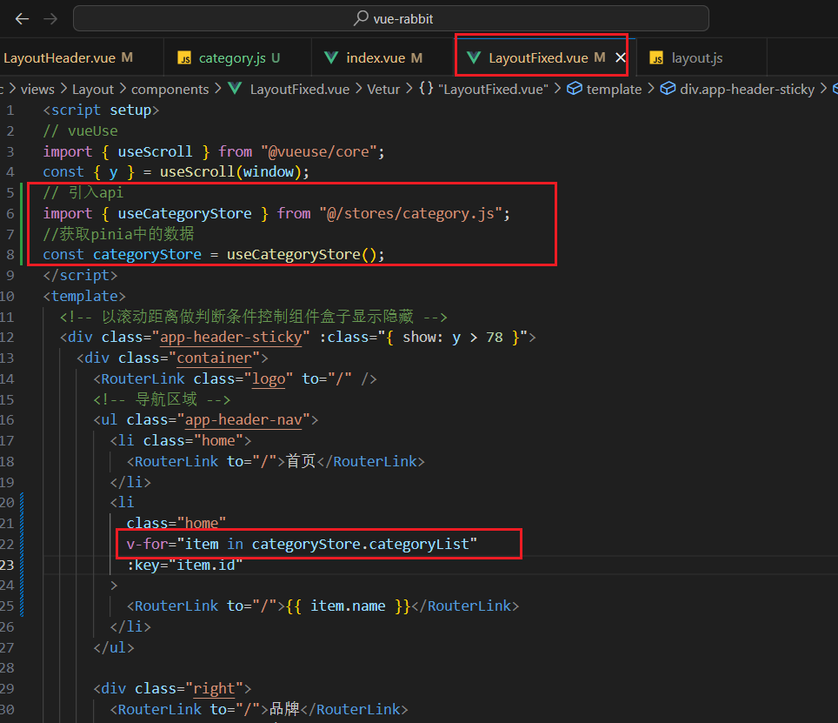](https://xiaobaicai350.github.io/pic/image-20230619135752483.png)

另一个组件同理

# Home页

## 静态结构搭建和分类实现

### 1. 整体结构创建

[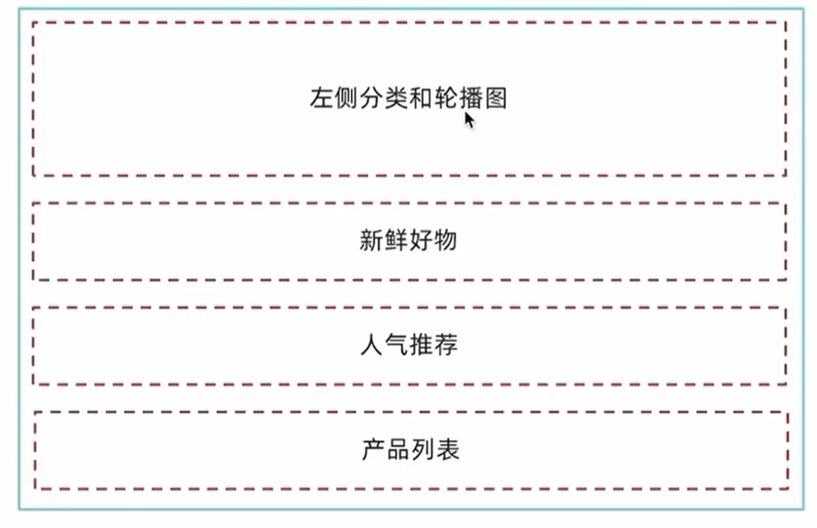](https://xiaobaicai350.github.io/pic/image-20230624194329394.png)

1- 按照结构新增五个组件，准备最简单的模版，分别在Home模块的入口组件中引入

* HomeCategory 轮播图左侧分类
* HomeBanner 轮播图
* HomeNew 新鲜好物
* HomeHot 人气推荐
* HomeProduct 产品列表

**PLAINTEXT**

|  |
| --- |
| <script setup> </script>  <template>  <div> HomeCategory </div> </template> |

剩下的四个省略

2- Home模块入口组件中引入并渲染

views/Home/index.vue

**PLAINTEXT**

|  |
| --- |
| <script setup> import HomeCategory from './components/HomeCategory.vue' import HomeBanner from './components/HomeBanner.vue' import HomeNew from './components/HomeNew.vue' import HomeHot from './components/HomeHot.vue' import homeProduct from './components/HomeProduct.vue' </script>  <template>  <div class="container">  <HomeCategory />  <HomeBanner />  </div>  <HomeNew />  <HomeHot />  <homeProduct /> </template> |

### 2. 分类实现

1- 准备详细模版

HomeCategory.vue

**PLAINTEXT**

|  |
| --- |
| <script setup>  </script>  <template>  <div class="home-category">  <ul class="menu">  <li v-for="item in 9" :key="item">  <RouterLink to="/">居家</RouterLink>  <RouterLink v-for="i in 2" :key="i" to="/">南北干货</RouterLink>  <!-- 弹层layer位置 -->  <div class="layer">  <h4>分类推荐 <small>根据您的购买或浏览记录推荐</small></h4>  <ul>  <li v-for="i in 5" :key="i">  <RouterLink to="/">  <img alt="" />  <div class="info">  <p class="name ellipsis-2">  男士外套  </p>  <p class="desc ellipsis">男士外套，冬季必选</p>  <p class="price"><i>¥</i>200.00</p>  </div>  </RouterLink>  </li>  </ul>  </div>  </li>  </ul>  </div> </template>   <style scoped lang='scss'> .home-category {  width: 250px;  height: 500px;  background: rgba(0, 0, 0, 0.8);  position: relative;  z-index: 99;   .menu {  li {  padding-left: 40px;  height: 55px;  line-height: 55px;   &:hover {  background: $xtxColor;  }   a {  margin-right: 4px;  color: #fff;   &:first-child {  font-size: 16px;  }  }   .layer {  width: 990px;  height: 500px;  background: rgba(255, 255, 255, 0.8);  position: absolute;  left: 250px;  top: 0;  display: none;  padding: 0 15px;   h4 {  font-size: 20px;  font-weight: normal;  line-height: 80px;   small {  font-size: 16px;  color: #666;  }  }   ul {  display: flex;  flex-wrap: wrap;   li {  width: 310px;  height: 120px;  margin-right: 15px;  margin-bottom: 15px;  border: 1px solid #eee;  border-radius: 4px;  background: #fff;   &:nth-child(3n) {  margin-right: 0;  }   a {  display: flex;  width: 100%;  height: 100%;  align-items: center;  padding: 10px;   &:hover {  background: #e3f9f4;  }   img {  width: 95px;  height: 95px;  }   .info {  padding-left: 10px;  line-height: 24px;  overflow: hidden;   .name {  font-size: 16px;  color: #666;  }   .desc {  color: #999;  }   .price {  font-size: 22px;  color: $priceColor;   i {  font-size: 16px;  }  }  }  }  }  }  }   // 关键样式 hover状态下的layer盒子变成block  &:hover {  .layer {  display: block;  }  }  }  } } </style> |

2- 完成代码

[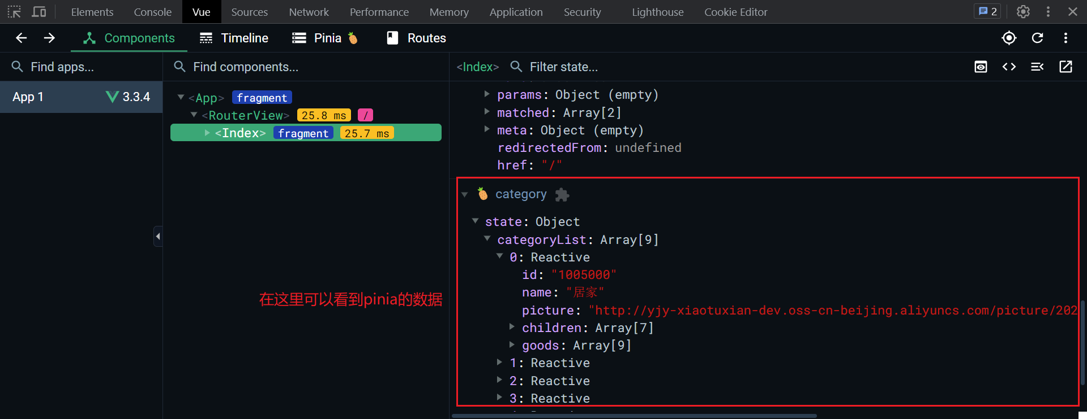](https://xiaobaicai350.github.io/pic/image-20230624201633518.png)

HomeCategory.vue

**PLAINTEXT**

|  |
| --- |
| <script setup> import { useCategoryStore } from "@/stores/category";  const categoryStore = useCategoryStore(); </script>  <template>  <div class="home-category">  <ul class="menu">  <li v-for="item in categoryStore.categoryList" :key="item.id">  <!-- 一级标题 -->  <RouterLink to="/">{{ item.name }}</RouterLink>  <!-- 二级标题，但是只需要显示两个就可以了 -->  <RouterLink v-for="i in item.children.slice(0, 2)" :key="i" to="/">{{  i.name  }}</RouterLink>  <!-- 弹层layer位置 -->  <div class="layer">  <h4>分类推荐 <small>根据您的购买或浏览记录推荐</small></h4>  <ul>  <!-- 遍历goods信息 -->  <li v-for="i in item.goods" :key="i.id">  <RouterLink to="/">  <img :src="i.picture" alt="" />  <div class="info">  <p class="name ellipsis-2">  {{ i.name }}  </p>  <p class="desc ellipsis">{{ i.desc }}</p>  <p class="price"><i>¥</i>{{ i.price }}</p>  </div>  </RouterLink>  </li>  </ul>  </div>  </li>  </ul>  </div> </template> |

## banner轮播图实现

### 1. 熟悉组件

这里直接使用elment-ui的组件进行完成

src\views\Home\components\HomeBanner.vue

**PLAINTEXT**

|  |
| --- |
| <script setup>  </script>    <template>  <div class="home-banner">  <el-carousel height="500px">  <el-carousel-item v-for="item in 4" :key="item">  <img src="http://yjy-xiaotuxian-dev.oss-cn-beijing.aliyuncs.com/picture/2021-04-15/6d202d8e-bb47-4f92-9523-f32ab65754f4.jpg" alt="">  </el-carousel-item>  </el-carousel>  </div> </template>    <style scoped lang='scss'> .home-banner {  width: 1240px;  height: 500px;  position: absolute;  left: 0;  top: 0;  z-index: 98;   img {  width: 100%;  height: 500px;  } } </style> |

### 2. 获取数据渲染组件

1- 封装接口

src\apis\home.js

**JAVASCRIPT**

|  |
| --- |
| /**  * @description: 获取banner图  * @param {*}  * @return {*}  */ import httpInstance from "@/utils/http"; export function getBannerAPI() {  return httpInstance({  url: "home/banner",  }); } |

2- 获取数据渲染模版

src\views\Home\components\HomeBanner.vue

**PLAINTEXT**

|  |
| --- |
| <script setup> import { getBannerAPI } from '@/apis/home' import { onMounted, ref } from 'vue'  const bannerList = ref([])  const getBanner = async () => {  const res = await getBannerAPI()  console.log(res)  bannerList.value = res.result }  onMounted(() => getBanner())  </script>    <template>  <div class="home-banner">  <el-carousel height="500px">  <el-carousel-item v-for="item in bannerList" :key="item.id">  <img :src="item.imgUrl" alt="">  </el-carousel-item>  </el-carousel>  </div> </template> |

## 面板组件封装

[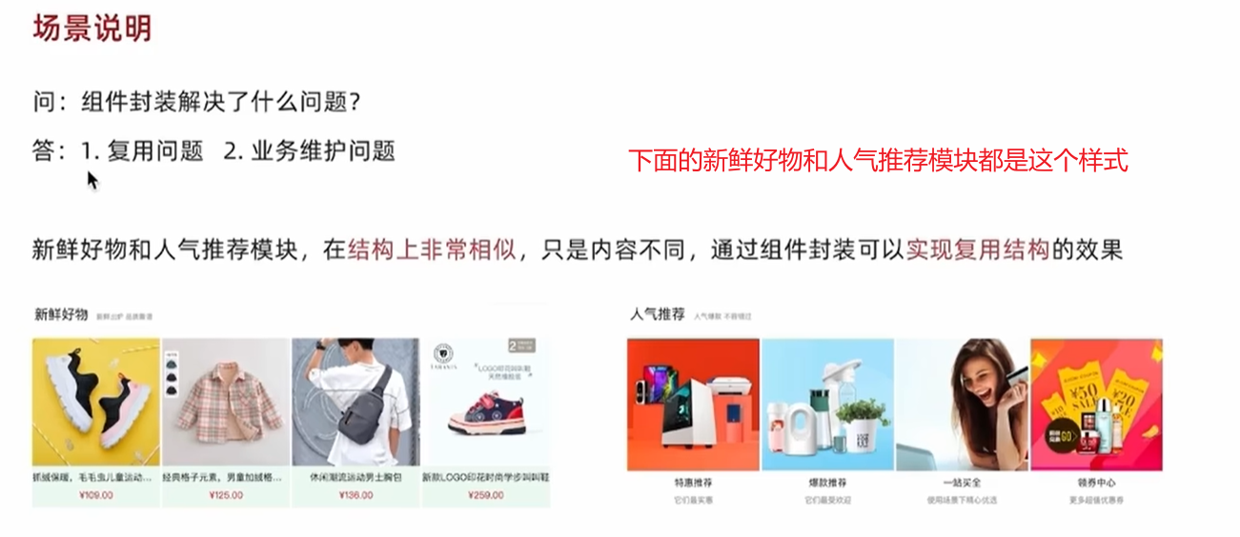](https://xiaobaicai350.github.io/pic/image-20230624203449908.png)

并且我们把需要改变的部分可以抽象成组件参数（插槽/props）

[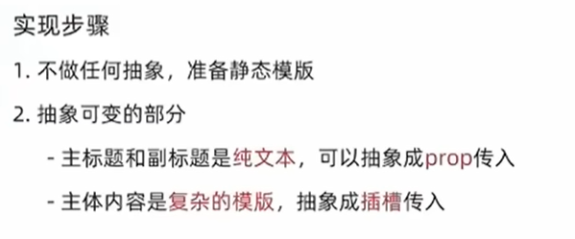](https://xiaobaicai350.github.io/pic/image-20230624203615722.png)

### 1. 纯静态结构

HomePanel.vue

**PLAINTEXT**

|  |
| --- |
| <script setup>  </script>   <template>  <div class="home-panel">  <div class="container">  <div class="head">  <!-- 主标题和副标题 -->  <h3>  新鲜好物<small>新鲜出炉 品质靠谱</small>  </h3>  </div>  <!-- 主体内容区域 -->  <div> 主体内容 </div>  </div>  </div> </template>  <style scoped lang='scss'> .home-panel {  background-color: #fff;   .head {  padding: 40px 0;  display: flex;  align-items: flex-end;   h3 {  flex: 1;  font-size: 32px;  font-weight: normal;  margin-left: 6px;  height: 35px;  line-height: 35px;   small {  font-size: 16px;  color: #999;  margin-left: 20px;  }  }  } } </style> |

### 2. 完整代码

HomePanel.vue

**PLAINTEXT**

|  |
| --- |
| <script setup>  defineProps({  title: {  type: String,  default: ''  },  subTitle: {  type: String,  default: ''  } })  </script>   <template>  <div class="home-panel">  <div class="container">  <div class="head">  <!-- 主标题和副标题 -->  <h3>  {{ title }}  <small>{{ subTitle }}</small>  </h3>  </div>  <!-- 主体内容区域 -->  <slot name="main" />  </div>  </div> </template>   <style scoped lang='scss'> .home-panel {  background-color: #fff;   .head {  padding: 40px 0;  display: flex;  align-items: flex-end;   h3 {  flex: 1;  font-size: 32px;  font-weight: normal;  margin-left: 6px;  height: 35px;  line-height: 35px;   small {  font-size: 16px;  color: #999;  margin-left: 20px;  }  }  } } </style> |

## 新鲜好物实现

### 1. 准备模版

src\views\Home\components\HomeNew.vue

**PLAINTEXT**

|  |
| --- |
| <script setup>  </script>  <template>  <div></div>  <!-- 下面是插槽主体内容模版  <ul class="goods-list">  <li v-for="item in newList" :key="item.id">  <RouterLink to="/">  <img :src="item.picture" alt="" />  <p class="name">{{ item.name }}</p>  <p class="price">&yen;{{ item.price }}</p>  </RouterLink>  </li>  </ul>  --> </template>   <style scoped lang='scss'> .goods-list {  display: flex;  justify-content: space-between;  height: 406px;   li {  width: 306px;  height: 406px;   background: #f0f9f4;  transition: all .5s;   &:hover {  transform: translate3d(0, -3px, 0);  box-shadow: 0 3px 8px rgb(0 0 0 / 20%);  }   img {  width: 306px;  height: 306px;  }   p {  font-size: 22px;  padding-top: 12px;  text-align: center;  text-overflow: ellipsis;  overflow: hidden;  white-space: nowrap;  }   .price {  color: $priceColor;  }  } } </style> |

### 2. 封装接口

home.js

**JAVASCRIPT**

|  |
| --- |
| /**  * @description: 获取新鲜好物  * @param {*}  * @return {*}  */ export const findNewAPI = () => {  return httpInstance({  url:'/home/new'  }) } |

### 3. 获取数据渲染模版

src\views\Home\components\HomeNew.vue

**PLAINTEXT**

|  |
| --- |
| <script setup> import HomePanel from "./HomePanel.vue"; import { findNewAPI } from "@/apis/home"; import { ref } from "vue"; const newList = ref([]); const getNewList = async () => {  const res = await findNewAPI();  newList.value = res.result; };  getNewList(); </script>  <template>  <HomePanel title="新鲜好物" sub-title="新鲜出炉 品质靠谱">  <template #main>  <ul class="goods-list">  <li v-for="item in newList" :key="item.id">  <RouterLink :to="`/detail/${item.id}`">  <img :src="item.picture" alt="" />  <p class="name">{{ item.name }}</p>  <p class="price">&yen;{{ item.price }}</p>  </RouterLink>  </li>  </ul>  </template>  </HomePanel> </template>  <style scoped lang="scss"> .goods-list {  display: flex;  justify-content: space-between;  height: 406px;   li {  width: 306px;  height: 406px;   background: #f0f9f4;  transition: all 0.5s;   &:hover {  transform: translate3d(0, -3px, 0);  box-shadow: 0 3px 8px rgb(0 0 0 / 20%);  }   img {  width: 306px;  height: 306px;  }   p {  font-size: 22px;  padding-top: 12px;  text-align: center;  text-overflow: ellipsis;  overflow: hidden;  white-space: nowrap;  }   .price {  color: $priceColor;  }  } } </style> |

## 人气推荐实现

### 1. 封装接口

src\apis\home.js

**JAVASCRIPT**

|  |
| --- |
| /**  * @description: 获取人气推荐  * @param {*}  * @return {*}  */ export const getHotAPI = () => {  return httpInstance('home/hot', 'get', {}) } |

### 2. 获取数据渲染模版

src\views\Home\components\HomeHot.vue

**PLAINTEXT**

|  |
| --- |
| <script setup> import HomePanel from "./HomePanel.vue"; import { getHotAPI } from "@/apis/home"; import { ref } from "vue"; const hotList = ref([]); const getHotList = async () => {  const res = await getHotAPI();  hotList.value = res.result; }; getHotList(); </script>  <template>  <HomePanel title="人气推荐" sub-title="人气爆款 不容错过">  <template #main>  <ul class="goods-list">  <li v-for="item in hotList" :key="item.id">  <RouterLink to="/">  <img :src="item.picture" alt="" />  <p class="name">{{ item.title }}</p>  <p class="desc">{{ item.alt }}</p>  </RouterLink>  </li>  </ul>  </template>  </HomePanel> </template>  <style scoped lang="scss"> .goods-list {  display: flex;  justify-content: space-between;  height: 426px;   li {  width: 306px;  height: 406px;  transition: all 0.5s;   &:hover {  transform: translate3d(0, -3px, 0);  box-shadow: 0 3px 8px rgb(0 0 0 / 20%);  }   img {  width: 306px;  height: 306px;  }   p {  font-size: 22px;  padding-top: 12px;  text-align: center;  }   .desc {  color: #999;  font-size: 18px;  }  } } </style> |

## 懒加载指令实现

### 1. 封装全局指令

**JAVASCRIPT**

|  |
| --- |
| // 定义懒加载插件 import { useIntersectionObserver } from "@vueuse/core";  export const lazyPlugin = {  install(app) {  // 懒加载指令逻辑  app.directive("img-lazy", {  mounted(el, binding) {  // el: 指令绑定的那个元素 img  // binding: binding.value 指令等于号后面绑定的表达式的值 图片url  console.log(el, binding.value);  const { stop } = useIntersectionObserver(el, ([{ isIntersecting }]) => {  console.log(isIntersecting);  if (isIntersecting) {  // 进入视口区域  el.src = binding.value;  // 停止监听器  stop();  }  });  },  });  }, }; |

### 2. 注册全局指令

**JAVASCRIPT**

|  |
| --- |
| // 全局指令注册 import { lazyPlugin } from "@/directives"; app.use(lazyPlugin); |

### 3.修改HomeHot

**PLAINTEXT**

|  |
| --- |
| <template>  <HomePanel title="人气推荐" sub-title="人气爆款 不容错过">  <template #main>  <ul class="goods-list">  <li v-for="item in hotList" :key="item.id">  <RouterLink to="/">  <!-- 这里使用了懒加载 -->  <img :src="item.picture" alt="" />  <p class="name">{{ item.title }}</p>  <p class="desc">{{ item.alt }}</p>  </RouterLink>  </li>  </ul>  </template>  </HomePanel> </template> |

## Product产品列表实现

### 1. 基础数据渲染

1- 准备静态模版

HomeProduct.vue

**PLAINTEXT**

|  |
| --- |
| <script setup> import HomePanel from './HomePanel.vue'  </script>  <template>  <div class="home-product">  <!-- <HomePanel :title="cate.name" v-for="cate in goodsProduct" :key="cate.id">  <div class="box">  <RouterLink class="cover" to="/">  <img :src="cate.picture" />  <strong class="label">  <span>{{ cate.name }}馆</span>  <span>{{ cate.saleInfo }}</span>  </strong>  </RouterLink>  <ul class="goods-list">  <li v-for="good in cate.goods" :key="good.id">  <RouterLink to="/" class="goods-item">  <img :src="good.picture" alt="" />  <p class="name ellipsis">{{ good.name }}</p>  <p class="desc ellipsis">{{ good.desc }}</p>  <p class="price">&yen;{{ good.price }}</p>  </RouterLink>  </li>  </ul>  </div>  </HomePanel> -->  </div> </template>  <style scoped lang='scss'> .home-product {  background: #fff;  margin-top: 20px;  .sub {  margin-bottom: 2px;   a {  padding: 2px 12px;  font-size: 16px;  border-radius: 4px;   &:hover {  background: $xtxColor;  color: #fff;  }   &:last-child {  margin-right: 80px;  }  }  }   .box {  display: flex;   .cover {  width: 240px;  height: 610px;  margin-right: 10px;  position: relative;   img {  width: 100%;  height: 100%;  }   .label {  width: 188px;  height: 66px;  display: flex;  font-size: 18px;  color: #fff;  line-height: 66px;  font-weight: normal;  position: absolute;  left: 0;  top: 50%;  transform: translate3d(0, -50%, 0);   span {  text-align: center;   &:first-child {  width: 76px;  background: rgba(0, 0, 0, 0.9);  }   &:last-child {  flex: 1;  background: rgba(0, 0, 0, 0.7);  }  }  }  }   .goods-list {  width: 990px;  display: flex;  flex-wrap: wrap;   li {  width: 240px;  height: 300px;  margin-right: 10px;  margin-bottom: 10px;   &:nth-last-child(-n + 4) {  margin-bottom: 0;  }   &:nth-child(4n) {  margin-right: 0;  }  }  }   .goods-item {  display: block;  width: 220px;  padding: 20px 30px;  text-align: center;  transition: all .5s;   &:hover {  transform: translate3d(0, -3px, 0);  box-shadow: 0 3px 8px rgb(0 0 0 / 20%);  }   img {  width: 160px;  height: 160px;  }   p {  padding-top: 10px;  }   .name {  font-size: 16px;  }   .desc {  color: #999;  height: 29px;  }   .price {  color: $priceColor;  font-size: 20px;  }  }  } } </style> |

2- 封装接口

src\apis\home.js

**JAVASCRIPT**

|  |
| --- |
| /**  * @description: 获取所有商品模块  * @param {*}  * @return {*}  */ export const getGoodsAPI = () => {  return httpInstance({  url: '/home/goods'  }) } |

3- 获取并渲染数据

**PLAINTEXT**

|  |
| --- |
| <script setup> import HomePanel from "./HomePanel.vue"; import { getGoodsAPI } from "@/apis/home"; import { ref, onMounted } from "vue"; const goodsProduct = ref([]); const getGoods = async () => {  const { result } = await getGoodsAPI();  goodsProduct.value = result; }; onMounted(() => getGoods()); </script>  <template>  <div class="home-product">  <HomePanel :title="cate.name" v-for="cate in goodsProduct" :key="cate.id">  <template #main>  <div class="box">  <RouterLink class="cover" to="/">  <img :src="cate.picture" />  <strong class="label">  <span>{{ cate.name }}馆</span>  <span>{{ cate.saleInfo }}</span>  </strong>  </RouterLink>  <ul class="goods-list">  <li v-for="goods in cate.goods" :key="goods.id">  <RouterLink to="/" class="goods-item">  <img :src="goods.picture" alt="" />  <p class="name ellipsis">{{ goods.name }}</p>  <p class="desc ellipsis">{{ goods.desc }}</p>  <p class="price">&yen;{{ goods.price }}</p>  </RouterLink>  </li>  </ul>  </div>  </template>  </HomePanel>  </div> </template> |

### 2. 图片懒加载

**HTML**

|  |
| --- |
| <div class="home-product">  <HomePanel :title="cate.name" v-for="cate in goodsProduct" :key="cate.id">  <div class="box">  <RouterLink class="cover" to="/">  <!-- 指令替换 -->  <img v-img-lazy="cate.picture" />  </RouterLink>  <ul class="goods-list">  <li v-for="goods in cate.goods" :key="goods.id">  <RouterLink to="/" class="goods-item">  <!-- 指令替换 -->  <img v-img-lazy="goods.picture" alt="" />  </RouterLink>  </li>  </ul>  </div>  </HomePanel> </div> |

## GoodsItem组件封装

由于下面这个组件经常用，所以我们可以给他封装成一个组件[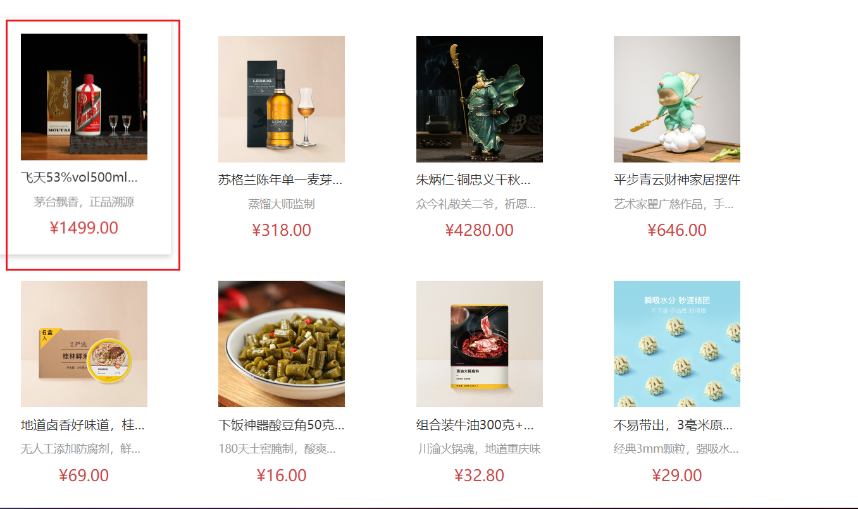](https://xiaobaicai350.github.io/pic/image-20230624214314007.png)

### 1. 封装组件

src\views\Home\components\GoodsItem.vue

**PLAINTEXT**

|  |
| --- |
| <script setup> defineProps({  goods: {  type: Object,  default: () => { }  } }) </script>  <template>  <RouterLink to="/" class="goods-item">  <img :src="goods.picture" alt="" />  <p class="name ellipsis">{{ goods.name }}</p>  <p class="desc ellipsis">{{ goods.desc }}</p>  <p class="price">&yen;{{ goods.price }}</p>  </RouterLink> </template>   <style scoped lang="scss"> .goods-item {  display: block;  width: 220px;  padding: 20px 30px;  text-align: center;  transition: all .5s;   &:hover {  transform: translate3d(0, -3px, 0);  box-shadow: 0 3px 8px rgb(0 0 0 / 20%);  }   img {  width: 160px;  height: 160px;  }   p {  padding-top: 10px;  }   .name {  font-size: 16px;  }   .desc {  color: #999;  height: 29px;  }   .price {  color: $priceColor;  font-size: 20px;  } } </style> |

### 2. 使用组件

src\views\Home\components\GoodsItem.vue

下面就不写导入组件了

**PLAINTEXT**

|  |
| --- |
| <ul class="goods-list">  <li v-for="goods in cate.goods" :key="goods.id">  <GoodsItem :goods="goods" />  </li> </ul> |

# 一级分类页

## 静态结构搭建和路由配置

### 1. 准备分类组件

src\views\Category\index.vue

**PLAINTEXT**

|  |
| --- |
| <script setup>  </script>  <template>  <div class='top-category'>  我是分类  </div> </template> |

### 2. 配置路由

**JAVASCRIPT**

|  |
| --- |
| // createRouter：创建router实例对象 // createWebHistory：创建history模式的路由  import { createRouter, createWebHistory } from "vue-router"; import Login from "@/views/Login/index.vue"; import Layout from "@/views/Layout/index.vue"; import Home from "@/views/Home/index.vue"; import Category from "@/views/Category/index.vue";  const router = createRouter({  history: createWebHistory(import.meta.env.BASE_URL),  // path和component对应关系的位置  routes: [  {  path: "/",  name: "layout",  component: Layout,  children: [  {  path: "",  name: "home",  component: Home,  },  {  path: "category/:id",  name: "category",  component: Category,  },  ],  },  {  path: "/login",  name: "login",  component: Login,  },  ], });  export default router; |

### 3. 配置导航区域链接

LayoutHeader.vue和LayoutFixed.vue

**HTML**

|  |
| --- |
| <li v-for="item in categoryStore.categoryList" :key="item.id">  <RouterLink active-class="active" :to="`/category/${item.id}`">  {{ item.name }}  </RouterLink> </li> |

## 面包屑导航渲染

### 1. 认识组件准备模版

**PLAINTEXT**

|  |
| --- |
| <script setup>  </script>  <template>  <div class="top-category">  <div class="container m-top-20">  <!-- 面包屑 -->  <div class="bread-container">  <el-breadcrumb separator=">">  <el-breadcrumb-item :to="{ path: '/' }">首页</el-breadcrumb-item>  <el-breadcrumb-item>居家</el-breadcrumb-item>  </el-breadcrumb>  </div>  </div>  </div> </template>   <style scoped lang="scss"> .top-category {  h3 {  font-size: 28px;  color: #666;  font-weight: normal;  text-align: center;  line-height: 100px;  }   .sub-list {  margin-top: 20px;  background-color: #fff;   ul {  display: flex;  padding: 0 32px;  flex-wrap: wrap;   li {  width: 168px;  height: 160px;    a {  text-align: center;  display: block;  font-size: 16px;   img {  width: 100px;  height: 100px;  }   p {  line-height: 40px;  }   &:hover {  color: $xtxColor;  }  }  }  }  }   .ref-goods {  background-color: #fff;  margin-top: 20px;  position: relative;   .head {  .xtx-more {  position: absolute;  top: 20px;  right: 20px;  }   .tag {  text-align: center;  color: #999;  font-size: 20px;  position: relative;  top: -20px;  }  }   .body {  display: flex;  justify-content: space-around;  padding: 0 40px 30px;  }  }   .bread-container {  padding: 25px 0;  } } </style> |

### 2. 封装接口

category.js

**JAVASCRIPT**

|  |
| --- |
| import request from "@/utils/http.js";  /**  * @description: 获取分类数据  * @param {*} id 分类id  * @return {*}  */ export const getTopCategoryAPI = (id) => {  return request({  url: "/category",  params: {  id,  },  }); }; |

### 3. 渲染面包屑导航

**PLAINTEXT**

|  |
| --- |
| <script setup> import { ref, onMounted } from "vue"; import { useRoute } from "vue-router"; import { getTopCategoryAPI } from "@/apis/category"; const categoryData = ref({}); // 这里可以获取路由的参数，这里还没引入，注意一下 const route = useRoute(); const getCategory = async () => {  // 如何在setup中获取路由参数 useRoute() -> route 等价于this.$route  const res = await getTopCategoryAPI(route.params.id);  categoryData.value = res.result; }; onMounted(() => {  console.log("这里是category");  getCategory(); }); </script>  <template>  <div class="bread-container">  <el-breadcrumb separator=">">  <el-breadcrumb-item :to="{ path: '/' }">首页</el-breadcrumb-item>  <el-breadcrumb-item>{{ categoryData.name }}</el-breadcrumb-item>  </el-breadcrumb>  </div> </template> |

## 分类Banner渲染

[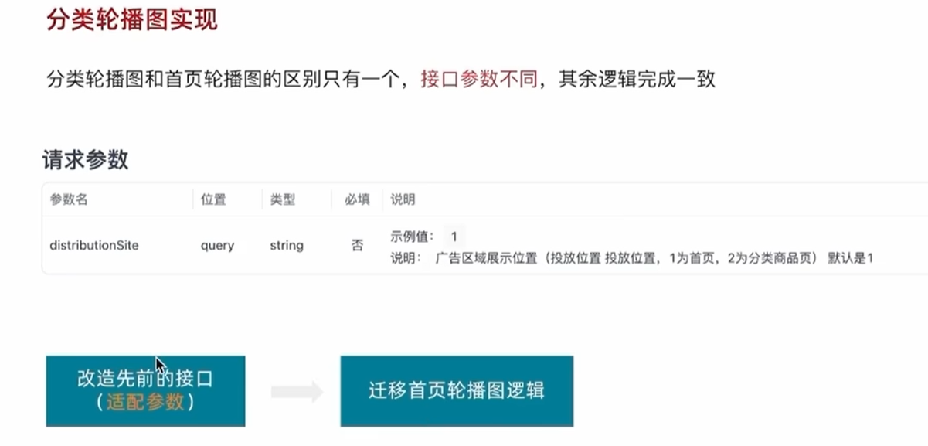](https://xiaobaicai350.github.io/pic/image-20230624222342197.png)

### 1. 适配接口

apis/home.js

**JAVASCRIPT**

|  |
| --- |
| export function getBannerAPI(params = {}) {  // 默认为1 商品为2  const { distributionSite = "1" } = params;  return httpInstance({  url: "/home/banner",  params: {  distributionSite,  },  }); } |

### 2. 迁移首页Banner逻辑

**PLAINTEXT**

|  |
| --- |
| <script setup> // 部分代码省略 import { getBannerAPI } from '@/apis/home'  // 获取banner const bannerList = ref([])  const getBanner = async () => {  const res = await getBannerAPI({  distributionSite: '2'  })  console.log(res)  bannerList.value = res.result }  onMounted(() => getBanner())  </script>  <template>  <div class="top-category">  <div class="container m-top-20">  <!-- 面包屑 -->  <div class="bread-container">  <el-breadcrumb separator=">">  <el-breadcrumb-item :to="{ path: '/' }">首页</el-breadcrumb-item>  <el-breadcrumb-item>{{ categoryData.name }}</el-breadcrumb-item>  </el-breadcrumb>  </div>  <!-- 轮播图 -->  <div class="home-banner">  <el-carousel height="500px">  <el-carousel-item v-for="item in bannerList" :key="item.id">  <img :src="item.imgUrl" alt="">  </el-carousel-item>  </el-carousel>  </div>  </div>  </div> </template>   <style scoped lang="scss"> // 部分代码省略 .home-banner {  width: 1240px;  height: 500px;  margin: 0 auto;  img {  width: 100%;  height: 500px;  } } </style> |

## 导航激活设置分类列表渲染

### 1. 导航激活状态设置

其实就是如果点击导航，然后点击的这个导航就会一直高亮的效果

[](https://xiaobaicai350.github.io/pic/%E5%8A%A8%E7%94%BB-16877541703231.gif)

src\views\Layout\components\LayoutHeader.vue

**PLAINTEXT**

|  |
| --- |
| <!-- 这个active-class="active"的value是一个需要激活的class样式，样式写在了下面 --> <RouterLink active-class="active" :to="`/category/${item.id}`">{{ item.name }}</RouterLink> |

### 2. 分类数据模版

[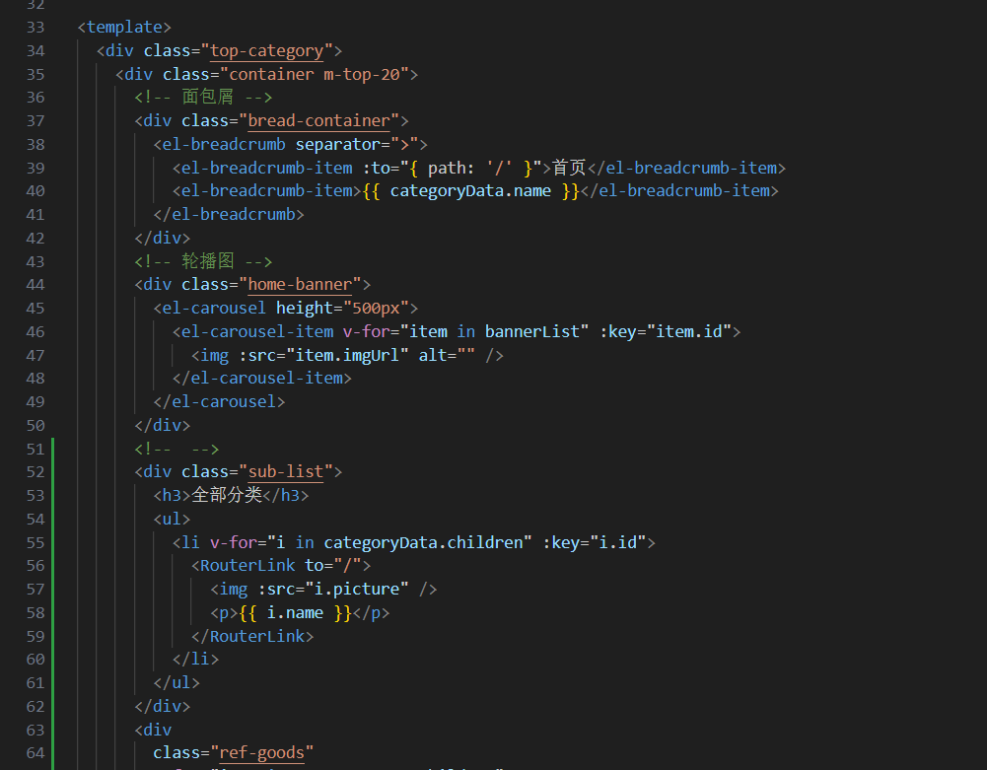](https://xiaobaicai350.github.io/pic/image-20230626124207877.png)

src\views\Category\index.vue

**HTML**

|  |
| --- |
| <div class="sub-list">  <h3>全部分类</h3>  <ul>  <li v-for="i in categoryData.children" :key="i.id">  <RouterLink to="/">  <img :src="i.picture" />  <p>{{ i.name }}</p>  </RouterLink>  </li>  </ul> </div> <div class="ref-goods" v-for="item in categoryData.children" :key="item.id">  <div class="head">  <h3>- {{ item.name }}-</h3>  </div>  <div class="body">  <GoodsItem v-for="good in item.goods" :goods="good" :key="good.id" />  </div> </div> |

## 路由缓存问题解决

[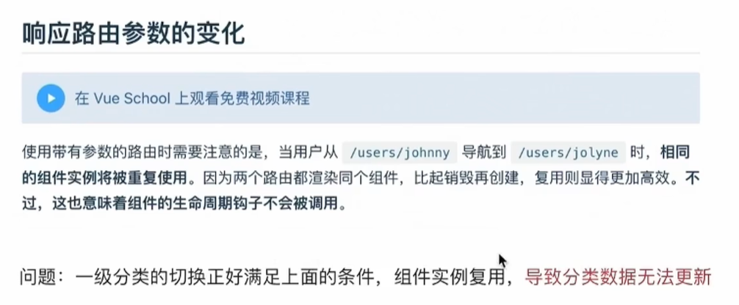](https://xiaobaicai350.github.io/pic/image-20230626124345027.png)

解决方案：

1. 让组件实例不再复用，强制销毁重建
2. 监听路由变化，变化之后执行数据更新操作

具体实现：

### 第一种方法

给 routerv-view 添加key属性，强制不添加缓存，破坏缓存，所以这个方法性能会比较差

[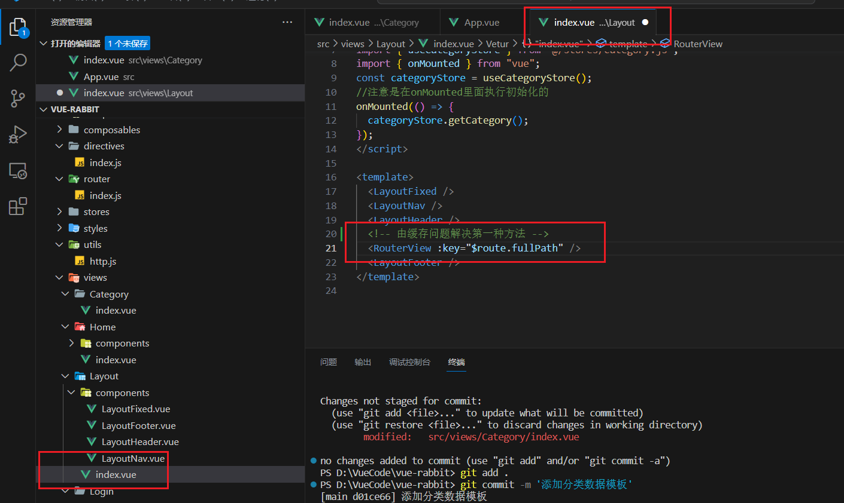](https://xiaobaicai350.github.io/pic/image-20230626125816209.png)

### 第二种方法

使用 onBeforeRouteUpdate钩子函数，做精确更新

[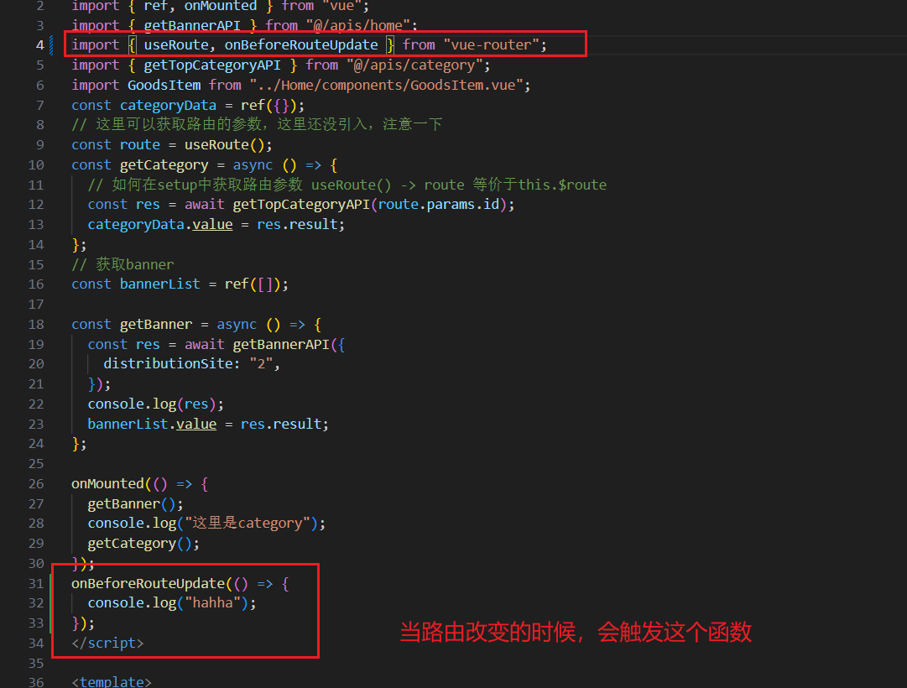](https://xiaobaicai350.github.io/pic/image-20230626131111706.png)

src\views\Category\index.vue

**PLAINTEXT**

|  |
| --- |
| <script setup> import { ref, onMounted } from "vue"; import { getBannerAPI } from "@/apis/home"; import { useRoute, onBeforeRouteUpdate } from "vue-router"; import { getTopCategoryAPI } from "@/apis/category"; import GoodsItem from "../Home/components/GoodsItem.vue"; const categoryData = ref({}); // 这里可以获取路由的参数，这里还没引入，注意一下 const route = useRoute(); // 这里是给id付了一个初始值，是一种高级的写法，如果 const getCategory = async (id = route.params.id) => {  // 如何在setup中获取路由参数 useRoute() -> route 等价于this.$route  const res = await getTopCategoryAPI(id);  categoryData.value = res.result; }; // 获取banner const bannerList = ref([]);  const getBanner = async () => {  const res = await getBannerAPI({  distributionSite: "2",  });  console.log(res);  bannerList.value = res.result; };  onMounted(() => {  getBanner();  console.log("这里是category");  getCategory(); }); // 这里的to对象里面有跳转到指定网址的参数和信息 onBeforeRouteUpdate((to) => {  console.log("hahha路由变化了");  getCategory(to.params.id); }); </script>  <template>  <div class="top-category">  <div class="container m-top-20">  <!-- 面包屑 -->  <div class="bread-container">  <el-breadcrumb separator=">">  <el-breadcrumb-item :to="{ path: '/' }">首页</el-breadcrumb-item>  <el-breadcrumb-item>{{ categoryData.name }}</el-breadcrumb-item>  </el-breadcrumb>  </div>  <!-- 轮播图 -->  <div class="home-banner">  <el-carousel height="500px">  <el-carousel-item v-for="item in bannerList" :key="item.id">  <img :src="item.imgUrl" alt="" />  </el-carousel-item>  </el-carousel>  </div>  <!-- -->  <div class="sub-list">  <h3>全部分类</h3>  <ul>  <li v-for="i in categoryData.children" :key="i.id">  <RouterLink to="/">  <img :src="i.picture" />  <p>{{ i.name }}</p>  </RouterLink>  </li>  </ul>  </div>  <div  class="ref-goods"  v-for="item in categoryData.children"  :key="item.id"  >  <div class="head">  <h3>- {{ item.name }}-</h3>  </div>  <div class="body">  <GoodsItem v-for="good in item.goods" :goods="good" :key="good.id" />  </div>  </div>  </div>  </div> </template>  <style scoped lang="scss"> // 部分代码省略 .home-banner {  width: 1240px;  height: 500px;  margin: 0 auto;  img {  width: 100%;  height: 500px;  } } .top-category {  h3 {  font-size: 28px;  color: #666;  font-weight: normal;  text-align: center;  line-height: 100px;  }   .sub-list {  margin-top: 20px;  background-color: #fff;   ul {  display: flex;  padding: 0 32px;  flex-wrap: wrap;   li {  width: 168px;  height: 160px;   a {  text-align: center;  display: block;  font-size: 16px;   img {  width: 100px;  height: 100px;  }   p {  line-height: 40px;  }   &:hover {  color: $xtxColor;  }  }  }  }  }   .ref-goods {  background-color: #fff;  margin-top: 20px;  position: relative;   .head {  .xtx-more {  position: absolute;  top: 20px;  right: 20px;  }   .tag {  text-align: center;  color: #999;  font-size: 20px;  position: relative;  top: -20px;  }  }   .body {  display: flex;  justify-content: space-around;  padding: 0 40px 30px;  }  }   .bread-container {  padding: 25px 0;  } } </style> |

## 基于业务逻辑的函数拆分

基本思想：把组件内独立的业务逻辑通过 useXXX 函数做封装处理，在组件中做组合使用

[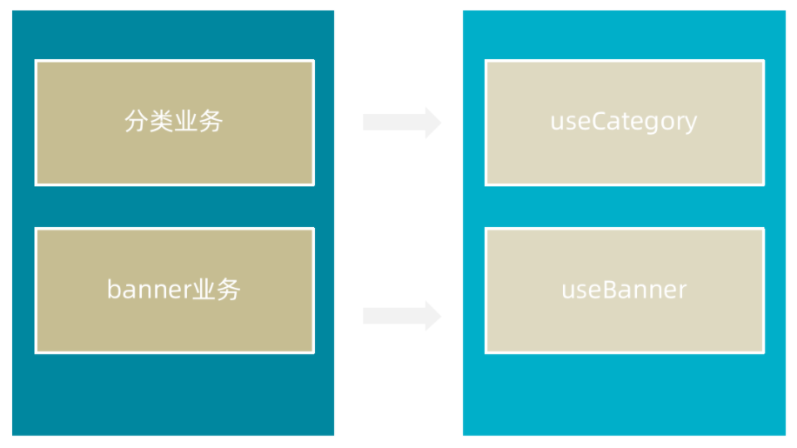](https://xiaobaicai350.github.io/pic/image-20230626132841940.png)

实现步骤：

1. 按照业务 声明以use打头的逻辑函数
2. 把独立的业务逻辑封装到各个函数的内部
3. 函数内部把组件中需要用到的数据或者方法return出去
4. 在组件中调用函数然后把数据或者方法解构赋值进行使用

src\views\Category\composables\useBanner.js

**JAVASCRIPT**

|  |
| --- |
| // 封装分类数据业务相关代码 import { onMounted, ref } from "vue"; import { getTopCategoryAPI } from "@/apis/category"; import { useRoute } from "vue-router"; import { onBeforeRouteUpdate } from "vue-router";  export function useCategory() {  // 获取分类数据  const categoryData = ref({});  const route = useRoute();  const getCategory = async (id = route.params.id) => {  const res = await getTopCategoryAPI(id);  categoryData.value = res.result;  };  onMounted(() => getCategory());   // 目标:路由参数变化的时候 可以把分类数据接口重新发送  onBeforeRouteUpdate((to) => {  // 存在问题：使用最新的路由参数请求最新的分类数据  getCategory(to.params.id);  });  return {  categoryData,  }; } |

src\views\Category\composables\useBanner.js

**JAVASCRIPT**

|  |
| --- |
| // 封装banner轮播图相关的业务代码 import { ref, onMounted } from 'vue' import { getBannerAPI } from '@/apis/home'  export function useBanner () {  const bannerList = ref([])   const getBanner = async () => {  const res = await getBannerAPI({  distributionSite: '2'  })  console.log(res)  bannerList.value = res.result  }   onMounted(() => getBanner())   return {  bannerList  } } |

src\views\Category\index.vue

**PLAINTEXT**

|  |
| --- |
| <script setup>  import { useBanner } from './composables/useBanner' import { useCategory } from './composables/useCategory' const { bannerList } = useBanner() const { categoryData } = useCategory()  </script> |

# 二级分类

## 整体业务认识和路由配置

[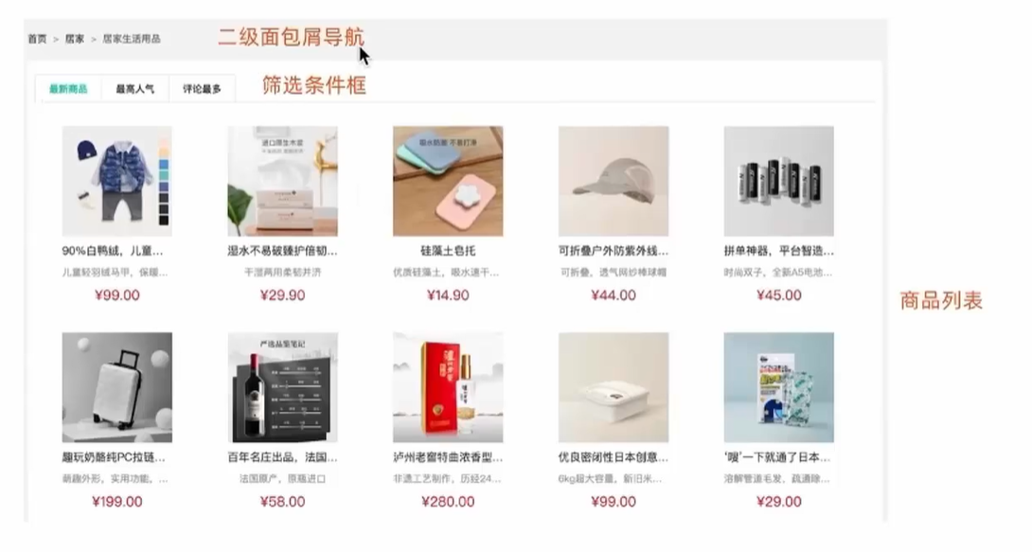](https://xiaobaicai350.github.io/pic/image-20230626134756387.png)

### 1. 准备组件模版

src\views\SubCategory\index.vue

**PLAINTEXT**

|  |
| --- |
| <script setup></script>  <template>  <div class="container">  <!-- 面包屑 -->  <div class="bread-container">  <el-breadcrumb separator=">">  <el-breadcrumb-item :to="{ path: '/' }">首页</el-breadcrumb-item>  <el-breadcrumb-item :to="{ path: '/' }">居家 </el-breadcrumb-item>  <el-breadcrumb-item>居家生活用品</el-breadcrumb-item>  </el-breadcrumb>  </div>  <div class="sub-container">  <el-tabs>  <el-tab-pane label="最新商品" name="publishTime"></el-tab-pane>  <el-tab-pane label="最高人气" name="orderNum"></el-tab-pane>  <el-tab-pane label="评论最多" name="evaluateNum"></el-tab-pane>  </el-tabs>  <div class="body">  <!-- 商品列表-->  </div>  </div>  </div> </template>  <style lang="scss" scoped> .bread-container {  padding: 25px 0;  color: #666; }  .sub-container {  padding: 20px 10px;  background-color: #fff;   .body {  display: flex;  flex-wrap: wrap;  padding: 0 10px;  }   .goods-item {  display: block;  width: 220px;  margin-right: 20px;  padding: 20px 30px;  text-align: center;   img {  width: 160px;  height: 160px;  }   p {  padding-top: 10px;  }   .name {  font-size: 16px;  }   .desc {  color: #999;  height: 29px;  }   .price {  color: $priceColor;  font-size: 20px;  }  }   .pagination-container {  margin-top: 20px;  display: flex;  justify-content: center;  } } </style> |

### 2. 配置路由关系

src\router\index.js

**JAVASCRIPT**

|  |
| --- |
| import { createRouter, createWebHashHistory } from 'vue-router' import Layout from '@/views/Layout/index.vue' import Home from '@/views/Home/index.vue' import Category from '@/views/Category/index.vue' import SubCategory from '@/views/SubCategory/index.vue' const router = createRouter({  history: createWebHashHistory(import.meta.env.BASE_URL),  routes: [  {  path: '/',  name: 'layout',  component: Layout,  children: [  {  path: '',  name: 'home',  component: Home  },  {  path: 'category/:id',  name: 'category',  component: Category  },  {  path: 'category/sub/:id',  name: 'subCategory',  component: SubCategory  },  ]  },  {  path: '/login',  name: 'login',  component: Login  },   ] })  export default router |

### 3. 跳转配置

src\views\Category\index.vue

**HTML**

|  |
| --- |
| <div class="sub-list">  <h3>全部分类</h3>  <ul>  <li v-for="i in categoryData.children" :key="i.id">  <RouterLink :to="`/category/sub/${i.id}`">  <img :src="i.picture" />  <p>{{ i.name }}</p>  </RouterLink>  </li>  </ul> </div> |

## 面包屑导航实现

### 1. 准备接口

src\apis\category.js

**JAVASCRIPT**

|  |
| --- |
| /**  * @description: 获取二级分类列表数据  * @param {*} id 二级分类id   * @return {*}  */  export const getCategoryFilterAPI = (id) => {  return request({  url:'/category/sub/filter',  params:{  id  }  }) } |

### 2. 获取数据渲染模版

src\views\SubCategory\index.vue

**PLAINTEXT**

|  |
| --- |
| <script setup> import { ref, onMounted } from "vue"; import { getCategoryFilterAPI } from "@/apis/category"; import { useRoute } from "vue-router"; // 获取面包屑导航数据 const route = useRoute(); const filterData = ref({}); const getFilterData = async () => {  const res = await getCategoryFilterAPI(route.params.id);  filterData.value = res.result; }; onMounted(() => {  getFilterData(); }); </script>  <template>  <div class="container">  <!-- 面包屑 -->  <div class="bread-container">  <el-breadcrumb separator=">">  <el-breadcrumb-item :to="{ path: '/' }">首页</el-breadcrumb-item>  <el-breadcrumb-item :to="{ path: `/category/${filterData.parentId}` }"  >{{ filterData.parentName }}  </el-breadcrumb-item>  <el-breadcrumb-item>{{ filterData.name }}</el-breadcrumb-item>  </el-breadcrumb>  </div>  <div class="sub-container">  <el-tabs>  <el-tab-pane label="最新商品" name="publishTime"></el-tab-pane>  <el-tab-pane label="最高人气" name="orderNum"></el-tab-pane>  <el-tab-pane label="评论最多" name="evaluateNum"></el-tab-pane>  </el-tabs>  <div class="body">  <!-- 商品列表-->  </div>  </div>  </div> </template> |

## 分类基础列表实现

[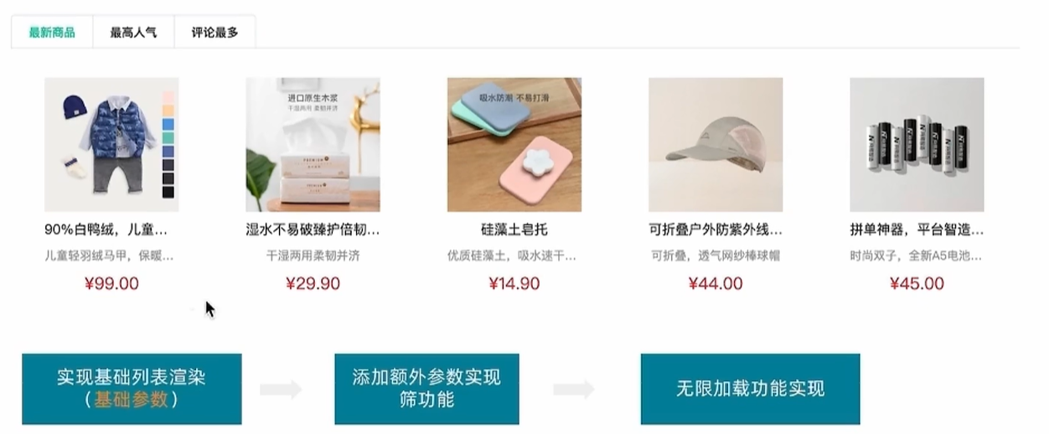](https://xiaobaicai350.github.io/pic/image-20230626143453649.png)

这里我们先实现第一步，也就是得到基础的列表

### 1. 准备接口

@/apis/category.js

**JAVASCRIPT**

|  |
| --- |
| /**  * @description: 获取导航数据  * @data {   categoryId: 1005000 ,  page: 1,  pageSize: 20,  sortField: 'publishTime' | 'orderNum' | 'evaluateNum'  }   * @return {*}  */ export const getSubCategoryAPI = (data) => {  return request({  url:'/category/goods/temporary',  method:'POST',  data  }) } |

### 2. 获取数据列表

src\views\SubCategory\index.vue

**PLAINTEXT**

|  |
| --- |
| <script setup> import GoodsItem from "../Home/components/GoodsItem.vue"; import { getSubCategoryAPI } from "@/apis/category.js"; // 获取基础列表数据渲染 const goodList = ref([]) const reqData = ref({  categoryId: route.params.id,  page: 1,  pageSize: 20,  sortField: 'publishTime' })   const getGoodList = async () => {  const res = await getSubCategoryAPI(reqData.value)  console.log(res)  goodList.value = res.result.items }   onMounted(() => getGoodList())   </script>     <div class="body">  <!-- 商品列表-->  <GoodsItem v-for="goods in goodList" :goods="goods" :key="goods.id" />  </div> |

## 列表筛选实现

思路：tab组件切换时修改reqData中的sortField字段，重新拉取接口列表

src\views\SubCategory\index.vue

**PLAINTEXT**

|  |
| --- |
| <script setup> // tab切换回调 const tabChange = () => {  console.log('tab切换了', reqData.value.sortField)  reqData.value.page = 1  getGoodList() } </script>  <template>  <el-tabs v-model="reqData.sortField" @tab-change="tabChange">  <el-tab-pane label="最新商品" name="publishTime"></el-tab-pane>  <el-tab-pane label="最高人气" name="orderNum"></el-tab-pane>  <el-tab-pane label="评论最多" name="evaluateNum"></el-tab-pane>  </el-tabs> </template> |

## 无限加载实现

基础思路

1. 触底条件满足之后 page++，拉取下一页数据
2. 新老数据做数组拼接
3. 判断是否已经全部加载完毕，停止监听

[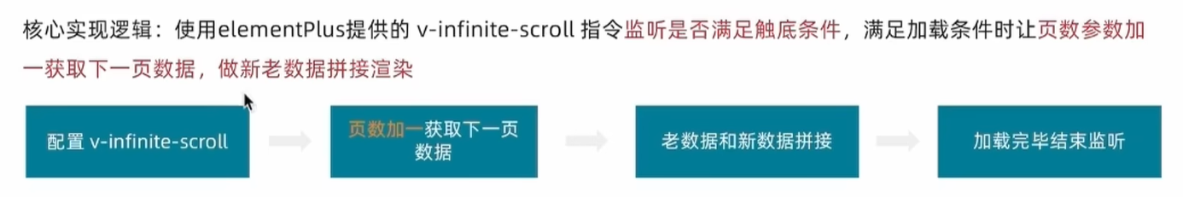](https://xiaobaicai350.github.io/pic/image-20230626165042583.png)

src\views\SubCategory\index.vue

**JAVASCRIPT**

|  |
| --- |
| // 加载更多 const disabled = ref(false) const load = async () => {  console.log('加载更多数据咯')  // 获取下一页的数据  reqData.value.page++  const res = await getSubCategoryAPI(reqData.value)  goodList.value = [...goodList.value, ...res.result.items]  // 加载完毕 停止监听  if (res.result.items.length === 0) {  disabled.value = true  } } |

在页面上监听load方法,并且设置如果到底的话不再加载新数据

**HTML**

|  |
| --- |
| <div class="body" v-infinite-scroll="load" :infinite-scroll-disabled="disabled">  <!-- 商品列表-->  <GoodsItem v-for="goods in goodList" :goods="goods" :key="goods.id" /> </div> |

## 定制路由行为

定制路由行为可以让我们在切换不同路由的时候，可以自动滚动到页面的任何一个部分（比如说顶部），如果不配置默认会停留到原先的位置

配置

[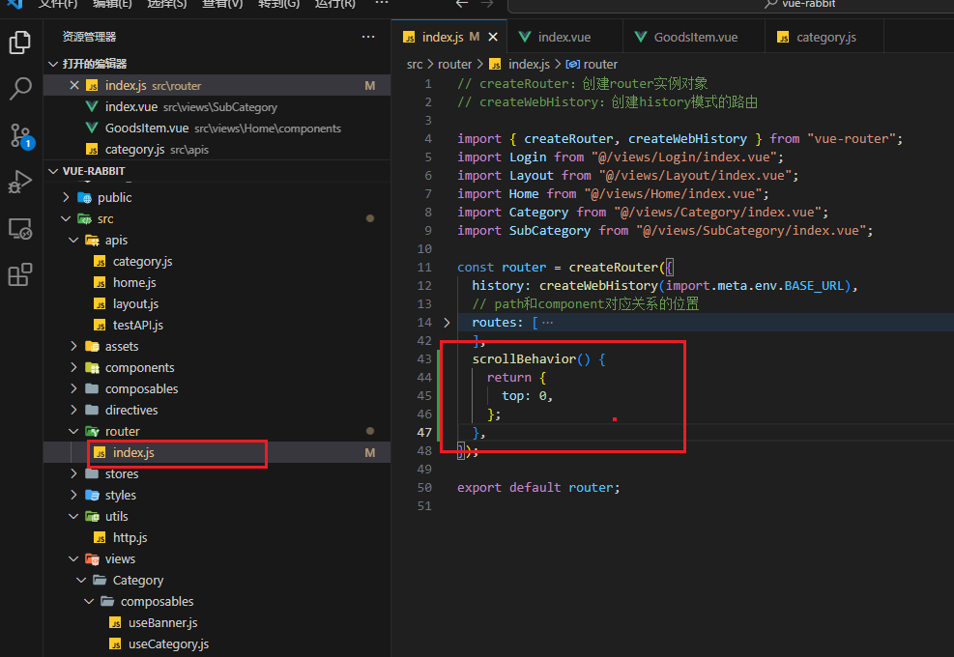](https://xiaobaicai350.github.io/pic/image-20230626171339818.png)

# 新鲜好物商品详情

## 整体认识和路由配置

[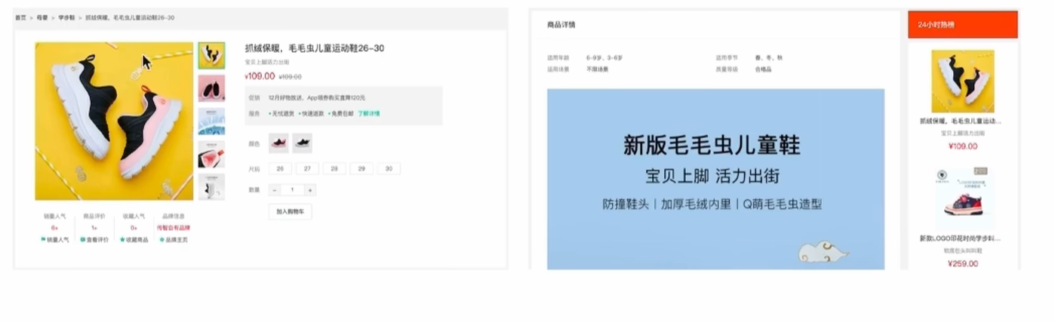](https://xiaobaicai350.github.io/pic/image-20230626171923568.png)

### 1. 准备组件模版

src\views\Detail\index.vue

**PLAINTEXT**

|  |
| --- |
| <script setup>   </script>  <template>  <div class="xtx-goods-page">  <div class="container">  <div class="bread-container">  <el-breadcrumb separator=">">  <el-breadcrumb-item :to="{ path: '/' }">首页</el-breadcrumb-item>  <el-breadcrumb-item :to="{ path: '/' }">母婴  </el-breadcrumb-item>  <el-breadcrumb-item :to="{ path: '/' }">跑步鞋  </el-breadcrumb-item>  <el-breadcrumb-item>抓绒保暖，毛毛虫子儿童运动鞋</el-breadcrumb-item>  </el-breadcrumb>  </div>  <!-- 商品信息 -->  <div class="info-container">  <div>  <div class="goods-info">  <div class="media">  <!-- 图片预览区 -->   <!-- 统计数量 -->  <ul class="goods-sales">  <li>  <p>销量人气</p>  <p> 100+ </p>  <p><i class="iconfont icon-task-filling"></i>销量人气</p>  </li>  <li>  <p>商品评价</p>  <p>200+</p>  <p><i class="iconfont icon-comment-filling"></i>查看评价</p>  </li>  <li>  <p>收藏人气</p>  <p>300+</p>  <p><i class="iconfont icon-favorite-filling"></i>收藏商品</p>  </li>  <li>  <p>品牌信息</p>  <p>400+</p>  <p><i class="iconfont icon-dynamic-filling"></i>品牌主页</p>  </li>  </ul>  </div>  <div class="spec">  <!-- 商品信息区 -->  <p class="g-name"> 抓绒保暖，毛毛虫儿童鞋 </p>  <p class="g-desc">好穿 </p>  <p class="g-price">  <span>200</span>  <span> 100</span>  </p>  <div class="g-service">  <dl>  <dt>促销</dt>  <dd>12月好物放送，App领券购买直降120元</dd>  </dl>  <dl>  <dt>服务</dt>  <dd>  <span>无忧退货</span>  <span>快速退款</span>  <span>免费包邮</span>  <a href="javascript:;">了解详情</a>  </dd>  </dl>  </div>  <!-- sku组件 -->   <!-- 数据组件 -->   <!-- 按钮组件 -->  <div>  <el-button size="large" class="btn">  加入购物车  </el-button>  </div>   </div>  </div>  <div class="goods-footer">  <div class="goods-article">  <!-- 商品详情 -->  <div class="goods-tabs">  <nav>  <a>商品详情</a>  </nav>  <div class="goods-detail">  <!-- 属性 -->  <ul class="attrs">  <li v-for="item in 3" :key="item.value">  <span class="dt">白色</span>  <span class="dd">纯棉</span>  </li>  </ul>  <!-- 图片 -->   </div>  </div>  </div>  <!-- 24热榜+专题推荐 -->  <div class="goods-aside">   </div>  </div>  </div>  </div>  </div>  </div> </template>   <style scoped lang='scss'> .xtx-goods-page {  .goods-info {  min-height: 600px;  background: #fff;  display: flex;   .media {  width: 580px;  height: 600px;  padding: 30px 50px;  }   .spec {  flex: 1;  padding: 30px 30px 30px 0;  }  }   .goods-footer {  display: flex;  margin-top: 20px;   .goods-article {  width: 940px;  margin-right: 20px;  }   .goods-aside {  width: 280px;  min-height: 1000px;  }  }   .goods-tabs {  min-height: 600px;  background: #fff;  }   .goods-warn {  min-height: 600px;  background: #fff;  margin-top: 20px;  }   .number-box {  display: flex;  align-items: center;   .label {  width: 60px;  color: #999;  padding-left: 10px;  }  }   .g-name {  font-size: 22px;  }   .g-desc {  color: #999;  margin-top: 10px;  }   .g-price {  margin-top: 10px;   span {  &::before {  content: "¥";  font-size: 14px;  }   &:first-child {  color: $priceColor;  margin-right: 10px;  font-size: 22px;  }   &:last-child {  color: #999;  text-decoration: line-through;  font-size: 16px;  }  }  }   .g-service {  background: #f5f5f5;  width: 500px;  padding: 20px 10px 0 10px;  margin-top: 10px;   dl {  padding-bottom: 20px;  display: flex;  align-items: center;   dt {  width: 50px;  color: #999;  }   dd {  color: #666;   &:last-child {  span {  margin-right: 10px;   &::before {  content: "•";  color: $xtxColor;  margin-right: 2px;  }  }   a {  color: $xtxColor;  }  }  }  }  }   .goods-sales {  display: flex;  width: 400px;  align-items: center;  text-align: center;  height: 140px;   li {  flex: 1;  position: relative;   ~li::after {  position: absolute;  top: 10px;  left: 0;  height: 60px;  border-left: 1px solid #e4e4e4;  content: "";  }   p {  &:first-child {  color: #999;  }   &:nth-child(2) {  color: $priceColor;  margin-top: 10px;  }   &:last-child {  color: #666;  margin-top: 10px;   i {  color: $xtxColor;  font-size: 14px;  margin-right: 2px;  }   &:hover {  color: $xtxColor;  cursor: pointer;  }  }  }  }  } }  .goods-tabs {  min-height: 600px;  background: #fff;   nav {  height: 70px;  line-height: 70px;  display: flex;  border-bottom: 1px solid #f5f5f5;   a {  padding: 0 40px;  font-size: 18px;  position: relative;   >span {  color: $priceColor;  font-size: 16px;  margin-left: 10px;  }  }  } }  .goods-detail {  padding: 40px;   .attrs {  display: flex;  flex-wrap: wrap;  margin-bottom: 30px;   li {  display: flex;  margin-bottom: 10px;  width: 50%;   .dt {  width: 100px;  color: #999;  }   .dd {  flex: 1;  color: #666;  }  }  }   >img {  width: 100%;  } }  .btn {  margin-top: 20px;  }  .bread-container {  padding: 25px 0; } </style> |

### 2. 配置路由

src\router\index.js

**JAVASCRIPT**

|  |
| --- |
| const router = createRouter({  history: createWebHistory(import.meta.env.BASE_URL),  // path和component对应关系的位置  routes: [  {  path: '/',  component: Layout,  children: [  {  path: '',  component: Home  },  {  path: 'category/:id',  component: Category  },  {  path: 'category/sub/:id',  component: SubCategory  },  {  path: 'detail/:id',  component: Detail  }  ]  },  {  path: '/login',  component: Login  }  ],  // 路由滚动行为定制  scrollBehavior () {  return {  top: 0  }  } }) |

### 3. 绑定模版测试跳转

src\views\Home\components\HomeNew.vue

**HTML**

|  |
| --- |
| <RouterLink :to="`/detail/${item.id}`">  <img :src="item.picture" alt="" />  <p class="name">{{ item.name }}</p>  <p class="price">&yen;{{ item.price }}</p> </RouterLink> |

## 渲染基础数据

### 1. 封装接口

src\apis\category.js

**JAVASCRIPT**

|  |
| --- |
| import request from '@/utils/http'   export const getDetail = (id) => {  return request({  url: '/goods',  params: {  id  }  }) } |

### 2. 获取数据渲染模版

src\views\Detail\index.vue

**PLAINTEXT**

|  |
| --- |
| <script setup> import { getDetail } from '@/apis/detail' import { onMounted, ref } from 'vue' import { useRoute } from 'vue-router' const goods = ref({}) const route = useRoute() const getGoods = async () => {  const res = await getDetail(route.params.id)  goods.value = res.result } onMounted(() => getGoods()) </script>  <template>  <div class="xtx-goods-page">  <div class="container" v-if="goods.details">  <div class="bread-container">  <el-breadcrumb separator=">">  <el-breadcrumb-item :to="{ path: '/' }">首页</el-breadcrumb-item>  <!--   错误原因：goods一开始{} {}.categories -> undefined -> undefined[1]  1. 可选链的语法?.   2. v-if手动控制渲染时机 保证只有数据存在才渲染  -->  <el-breadcrumb-item :to="{ path: `/category/${goods.categories[1].id}` }">{{ goods.categories[1].name }}  </el-breadcrumb-item>  <el-breadcrumb-item :to="{ path: `/category/sub/${goods.categories[0].id}` }">{{  goods.categories[0].name  }}  </el-breadcrumb-item>  <el-breadcrumb-item>抓绒保暖，毛毛虫子儿童运动鞋</el-breadcrumb-item>  </el-breadcrumb>  </div>  <!-- 商品信息 -->  <div class="info-container">  <div>  <div class="goods-info">  <div class="media">  <!-- 图片预览区 -->   <!-- 统计数量 -->  <ul class="goods-sales">  <li>  <p>销量人气</p>  <p> {{ goods.salesCount }}+ </p>  <p><i class="iconfont icon-task-filling"></i>销量人气</p>  </li>  <li>  <p>商品评价</p>  <p>{{ goods.commentCount }}+</p>  <p><i class="iconfont icon-comment-filling"></i>查看评价</p>  </li>  <li>  <p>收藏人气</p>  <p>{{ goods.collectCount }}+</p>  <p><i class="iconfont icon-favorite-filling"></i>收藏商品</p>  </li>  <li>  <p>品牌信息</p>  <p>{{ goods.brand.name }}</p>  <p><i class="iconfont icon-dynamic-filling"></i>品牌主页</p>  </li>  </ul>  </div>  <div class="spec">  <!-- 商品信息区 -->  <p class="g-name"> {{ goods.name }} </p>  <p class="g-desc">{{ goods.desc }} </p>  <p class="g-price">  <span>{{ goods.oldPrice }}</span>  <span> {{ goods.price }}</span>  </p>  <div class="g-service">  <dl>  <dt>促销</dt>  <dd>12月好物放送，App领券购买直降120元</dd>  </dl>  <dl>  <dt>服务</dt>  <dd>  <span>无忧退货</span>  <span>快速退款</span>  <span>免费包邮</span>  <a href="javascript:;">了解详情</a>  </dd>  </dl>  </div>  <!-- sku组件 -->   <!-- 数据组件 -->   <!-- 按钮组件 -->  <div>  <el-button size="large" class="btn">  加入购物车  </el-button>  </div>   </div>  </div>  <div class="goods-footer">  <div class="goods-article">  <!-- 商品详情 -->  <div class="goods-tabs">  <nav>  <a>商品详情</a>  </nav>  <div class="goods-detail">  <!-- 属性 -->  <ul class="attrs">  <li v-for="item in goods.details.properties" :key="item.value">  <span class="dt">{{ item.name }}</span>  <span class="dd">{{ item.value }}</span>  </li>  </ul>  <!-- 图片 -->  <img v-for="img in goods.details.pictures" :src="img" :key="img" alt="">  </div>  </div>  </div>  <!-- 24热榜+专题推荐 -->  <div class="goods-aside">   </div>  </div>  </div>  </div>  </div>  </div> </template> |

## 热榜区域

[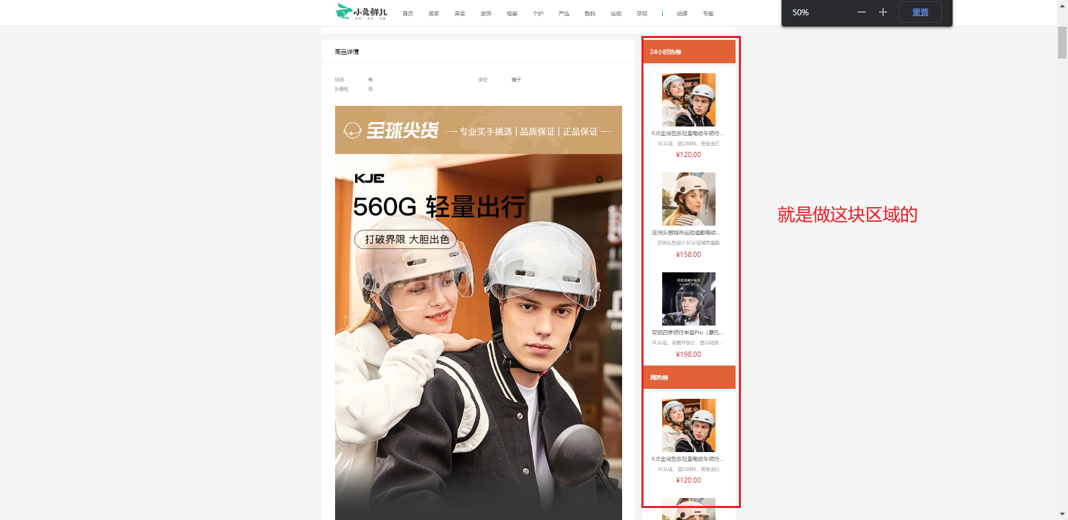](https://xiaobaicai350.github.io/pic/image-20230626223232285.png)

### 1. 渲染基础热榜数据

1- 准备模版

src\views\Detail\index.vue

**PLAINTEXT**

|  |
| --- |
| <script setup>  </script>   <template>  <div class="goods-hot">  <h3>周日榜单</h3>  <!-- 商品区块 -->  <RouterLink to="/" class="goods-item" v-for="item in 3" :key="item.id">  <img :src="item.picture" alt="" />  <p class="name ellipsis">一双男鞋</p>  <p class="desc ellipsis">一双好穿的男鞋</p>  <p class="price">&yen;200.00</p>  </RouterLink>  </div> </template>   <style scoped lang="scss"> .goods-hot {  h3 {  height: 70px;  background: $helpColor;  color: #fff;  font-size: 18px;  line-height: 70px;  padding-left: 25px;  margin-bottom: 10px;  font-weight: normal;  }   .goods-item {  display: block;  padding: 20px 30px;  text-align: center;  background: #fff;   img {  width: 160px;  height: 160px;  }   p {  padding-top: 10px;  }   .name {  font-size: 16px;  }   .desc {  color: #999;  height: 29px;  }   .price {  color: $priceColor;  font-size: 20px;  }  } } </style> |

2- 封装接口

src\apis\detail.js

**JAVASCRIPT**

|  |
| --- |
| /**  * 获取热榜商品  * @param {Number} id - 商品id  * @param {Number} type - 1代表24小时热销榜 2代表周热销榜  * @param {Number} limit - 获取个数  */ export const fetchHotGoodsAPI = ({ id, type, limit = 3 }) => {  return request({  url:'/goods/hot',  params:{  id,   type,   limit  }  }) } |

3- 获取基础数据渲染模版

**PLAINTEXT**

|  |
| --- |
| <script setup> import { ref } from 'vue' import { getHotGoodsAPI } from '@/apis/detail' import { useRoute } from 'vue-router'  const goodList = ref([]) const route = useRoute() const getHotList = async () => {  const res = await getHotGoodsAPI({  id: route.params.id,  type: 1  })  goodList.value = res.result } getHotList()   </script>    <template>  <div class="goods-hot">  <h3> 24小时热榜 </h3>  <!-- 商品区块 -->  <RouterLink :to="`/detail/${item.id}`" class="goods-item" v-for="item in goodList" :key="item.id">  <img :src="item.picture" alt="" />  <p class="name ellipsis">{{ item.name }}</p>  <p class="desc ellipsis">{{ item.desc }}</p>  <p class="price">&yen;{{ item.price }}</p>  </RouterLink>  </div> </template> |

### 2. 适配热榜类型

1- 设计props参数type

src\views\Detail\components\DetailHot.vue

**JSX**

|  |
| --- |
| // type适配不同类型热榜数据 const props = defineProps({  type: {  type: Number, // 1代表24小时热销榜 2代表周热销榜 3代表总热销榜 可以使用type去适配title和数据列表  default: 1  } })    const res = await fetchHotGoodsAPI({  id: route.params.id,  type: props.type }) |

2- 使用组件传入不同的type

src\views\Detail\index.vue

**PLAINTEXT**

|  |
| --- |
| <!-- 24小时热榜 --> <DetailHot :type="1" /> <!-- 周热榜 --> <DetailHot :type="2" /> |

### 3. 适配热榜title

src\views\Detail\components\DetailHot.vue

**JSX**

|  |
| --- |
| const TITLEMAP = {  1: '24小时热榜',  2: '周热榜',  } const title = computed(() => TITLEMAP[props.type]) |

在页面中使用

src\views\Detail\components\DetailHot.vue

**PLAINTEXT**

|  |
| --- |
| <h3>{{ title }}</h3> |

### 4.汇总热榜代码

src\views\Detail\components\DetailHot.vue

**PLAINTEXT**

|  |
| --- |
| <script setup> import { ref, computed } from "vue"; import { fetchHotGoodsAPI } from "@/apis/detail"; import { useRoute } from "vue-router";  const goodList = ref([]); const route = useRoute(); // type适配不同类型热榜数据 const props = defineProps({  type: {  type: Number, // 1代表24小时热销榜 2代表周热销榜 3代表总热销榜 可以使用type去适配title和数据列表  default: 1,  }, });  const getHotList = async () => {  const res = await fetchHotGoodsAPI({  id: route.params.id,  // 这里传入type类型，是为了传参用来区别周榜和日榜  type: props.type,  });  goodList.value = res.result; }; getHotList(); const TITLEMAP = {  1: "24小时热榜",  2: "周热榜", }; const title = computed(() => TITLEMAP[props.type]); </script>  <template>  <div class="goods-hot">  <h3>{{ title }}</h3>  <!-- 商品区块 -->  <RouterLink  :to="`/detail/${item.id}`"  class="goods-item"  v-for="item in goodList"  :key="item.id"  >  <img :src="item.picture" alt="" />  <p class="name ellipsis">{{ item.name }}</p>  <p class="desc ellipsis">{{ item.desc }}</p>  <p class="price">&yen;{{ item.price }}</p>  </RouterLink>  </div> </template> <style scoped lang="scss"> .goods-hot {  h3 {  height: 70px;  background: $helpColor;  color: #fff;  font-size: 18px;  line-height: 70px;  padding-left: 25px;  margin-bottom: 10px;  font-weight: normal;  }   .goods-item {  display: block;  padding: 20px 30px;  text-align: center;  background: #fff;   img {  width: 160px;  height: 160px;  }   p {  padding-top: 10px;  }   .name {  font-size: 16px;  }   .desc {  color: #999;  height: 29px;  }   .price {  color: $priceColor;  font-size: 20px;  }  } } </style> |

## 图片预览组件封装

[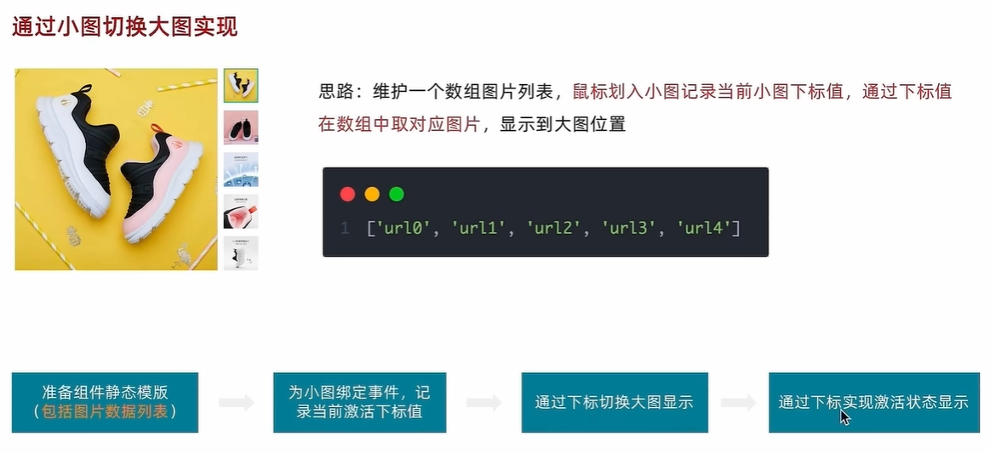](https://xiaobaicai350.github.io/pic/image-20230626223459674.png)

### 1. 小图切换大图显示

1- 准备模版

src\components\ImageView.vue

**PLAINTEXT**

|  |
| --- |
| <script setup> // 图片列表 const imageList = [  "https://yanxuan-item.nosdn.127.net/d917c92e663c5ed0bb577c7ded73e4ec.png",  "https://yanxuan-item.nosdn.127.net/e801b9572f0b0c02a52952b01adab967.jpg",  "https://yanxuan-item.nosdn.127.net/b52c447ad472d51adbdde1a83f550ac2.jpg",  "https://yanxuan-item.nosdn.127.net/f93243224dc37674dfca5874fe089c60.jpg",  "https://yanxuan-item.nosdn.127.net/f881cfe7de9a576aaeea6ee0d1d24823.jpg" ] </script>   <template>  <div class="goods-image">  <!-- 左侧大图-->  <div class="middle" ref="target">  <img :src="imageList[0]" alt="" />  <!-- 蒙层小滑块 -->  <div class="layer" :style="{ left: `0px`, top: `0px` }"></div>  </div>  <!-- 小图列表 -->  <ul class="small">  <li v-for="(img, i) in imageList" :key="i">  <img :src="img" alt="" />  </li>  </ul>  <!-- 放大镜大图 -->  <div class="large" :style="[  {  backgroundImage: `url(${imageList[0]})`,  backgroundPositionX: `0px`,  backgroundPositionY: `0px`,  },  ]" v-show="false"></div>  </div> </template>  <style scoped lang="scss"> .goods-image {  width: 480px;  height: 400px;  position: relative;  display: flex;   .middle {  width: 400px;  height: 400px;  background: #f5f5f5;  }   .large {  position: absolute;  top: 0;  left: 412px;  width: 400px;  height: 400px;  z-index: 500;  box-shadow: 0 0 10px rgba(0, 0, 0, 0.1);  background-repeat: no-repeat;  // 背景图:盒子的大小 = 2:1 将来控制背景图的移动来实现放大的效果查看 background-position  background-size: 800px 800px;  background-color: #f8f8f8;  }   .layer {  width: 200px;  height: 200px;  background: rgba(0, 0, 0, 0.2);  // 绝对定位 然后跟随咱们鼠标控制left和top属性就可以让滑块移动起来  left: 0;  top: 0;  position: absolute;  }   .small {  width: 80px;   li {  width: 68px;  height: 68px;  margin-left: 12px;  margin-bottom: 15px;  cursor: pointer;   &:hover,  &.active {  border: 2px solid $xtxColor;  }  }  } } </style> |

2- 实现逻辑

src\components\ImageView.vue

**PLAINTEXT**

|  |
| --- |
| <script setup> import { ref } from 'vue'  // 实现鼠标移入交互 const curIndex = ref(0) const mouseEnterFn = (i) => curIndex.value = i    </script>   <template>  <div class="goods-image">  <!-- 小图列表 -->  <ul class="small">  <li v-for="(img, i) in imageList"   :key="i"   @mouseenter="mouseEnterFn(i)"   :class="{ active: i === curIndex }">  <img :src="img" alt="" />  </li>  </ul>  </div> </template> |

### 2. 放大镜效果实现

功能拆解：

1. 左侧滑块跟随鼠标移动（这里用到了vueuese）
2. 右侧大图放大效果实现
3. 鼠标移入控制滑块和大图显示隐藏

**PLAINTEXT**

|  |
| --- |
| <script setup> import { ref, watch } from 'vue' import { useMouseInElement } from '@vueuse/core'  // 图片列表 const imageList = [  "https://yanxuan-item.nosdn.127.net/d917c92e663c5ed0bb577c7ded73e4ec.png",  "https://yanxuan-item.nosdn.127.net/e801b9572f0b0c02a52952b01adab967.jpg",  "https://yanxuan-item.nosdn.127.net/b52c447ad472d51adbdde1a83f550ac2.jpg",  "https://yanxuan-item.nosdn.127.net/f93243224dc37674dfca5874fe089c60.jpg",  "https://yanxuan-item.nosdn.127.net/f881cfe7de9a576aaeea6ee0d1d24823.jpg" ]  // 1.小图切换大图显示 const activeIndex = ref(0)  const enterhandler = (i) => {  activeIndex.value = i }  // 2. 获取鼠标相对位置 const target = ref(null) const { elementX, elementY, isOutside } = useMouseInElement(target)  // 3. 控制滑块跟随鼠标移动（监听elementX/Y变化，一旦变化 重新设置left/top） const left = ref(0) const top = ref(0)  const positionX = ref(0) const positionY = ref(0) watch([elementX, elementY, isOutside], () => {  console.log('xy变化了')  // 如果鼠标没有移入到盒子里面 直接不执行后面的逻辑  if (isOutside.value) return  console.log('后续逻辑执行了')  // 有效范围内控制滑块距离  // 横向  if (elementX.value > 100 && elementX.value < 300) {  left.value = elementX.value - 100  }  // 纵向  if (elementY.value > 100 && elementY.value < 300) {  top.value = elementY.value - 100  }   // 处理边界  if (elementX.value > 300) { left.value = 200 }  if (elementX.value < 100) { left.value = 0 }   if (elementY.value > 300) { top.value = 200 }  if (elementY.value < 100) { top.value = 0 }   // 控制大图的显示  positionX.value = -left.value * 2  positionY.value = -top.value * 2  })  </script>   <template>  <div class="goods-image">   <!-- 左侧大图-->  <div class="middle" ref="target">  <img :src="imageList[activeIndex]" alt="" />  <!-- 蒙层小滑块 -->  <div class="layer" v-show="!isOutside" :style="{ left: `${left}px`, top: `${top}px` }"></div>  </div>  <!-- 小图列表 -->  <ul class="small">  <li v-for="(img, i) in imageList" :key="i" @mouseenter="enterhandler(i)" :class="{ active: i === activeIndex }">  <img :src="img" alt="" />  </li>  </ul>  <!-- 放大镜大图 -->  <div class="large" :style="[  {  backgroundImage: `url(${imageList[0]})`,  backgroundPositionX: `${positionX}px`,  backgroundPositionY: `${positionY}px`,  },  ]" v-show="!isOutside"></div>  </div> </template>  <style scoped lang="scss"> .goods-image {  width: 480px;  height: 400px;  position: relative;  display: flex;   .middle {  width: 400px;  height: 400px;  background: #f5f5f5;  }   .large {  position: absolute;  top: 0;  left: 412px;  width: 400px;  height: 400px;  z-index: 500;  box-shadow: 0 0 10px rgba(0, 0, 0, 0.1);  background-repeat: no-repeat;  // 背景图:盒子的大小 = 2:1 将来控制背景图的移动来实现放大的效果查看 background-position  background-size: 800px 800px;  background-color: #f8f8f8;  }   .layer {  width: 200px;  height: 200px;  background: rgba(0, 0, 0, 0.2);  // 绝对定位 然后跟随咱们鼠标控制left和top属性就可以让滑块移动起来  left: 0;  top: 0;  position: absolute;  }   .small {  width: 80px;   li {  width: 68px;  height: 68px;  margin-left: 12px;  margin-bottom: 15px;  cursor: pointer;   &:hover,  &.active {  border: 2px solid $xtxColor;  }  }  } } </style> |

## SKU组件熟悉

## 全局组件统一插件化

存货单位，也翻译为库存单元，是一个会计学名词，定义为库存管理中的最小可用单元，例如纺织品中一个SKU通常表示规格、颜色、款式，而在连锁零售门店中有时称单品为一个SKU

[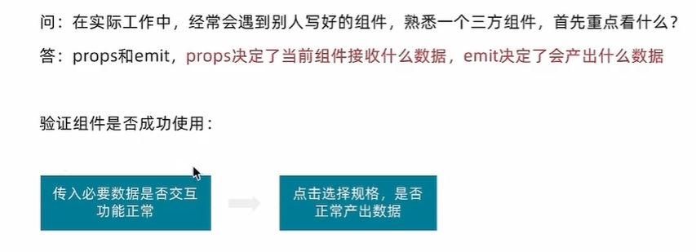](https://xiaobaicai350.github.io/pic/image-20230627140647608.png)

### 1. 插件化开发

**JAVASCRIPT**

|  |
| --- |
| // 把components中的所组件都进行全局化注册 // 通过插件的方式 import ImageView from './ImageView/index.vue' import Sku from './XtxSku/index.vue' export const componentPlugin = {  install (app) {  // app.component('组件名字'，组件配置对象)  app.component('XtxImageView', ImageView)  app.component('XtxSku', Sku)  } } |

### 2. 插件注册

**PLAINTEXT**

|  |
| --- |
| // 引入全局组件插件 import { componentPlugin } from '@/components'  app.use(componentPlugin) |

# 登录页

## 整体认识和路由配置

### 1. 准备模版

src\views\Login\index.vue

**PLAINTEXT**

|  |
| --- |
| <script setup>  </script>   <template>  <div>  <header class="login-header">  <div class="container m-top-20">  <h1 class="logo">  <RouterLink to="/">小兔鲜</RouterLink>  </h1>  <RouterLink class="entry" to="/">  进入网站首页  <i class="iconfont icon-angle-right"></i>  <i class="iconfont icon-angle-right"></i>  </RouterLink>  </div>  </header>  <section class="login-section">  <div class="wrapper">  <nav>  <a href="javascript:;">账户登录</a>  </nav>  <div class="account-box">  <div class="form">  <el-form label-position="right" label-width="60px"  status-icon>  <el-form-item label="账户">  <el-input/>  </el-form-item>  <el-form-item label="密码">  <el-input/>  </el-form-item>  <el-form-item label-width="22px">  <el-checkbox size="large">  我已同意隐私条款和服务条款  </el-checkbox>  </el-form-item>  <el-button size="large" class="subBtn">点击登录</el-button>  </el-form>  </div>  </div>  </div>  </section>   <footer class="login-footer">  <div class="container">  <p>  <a href="javascript:;">关于我们</a>  <a href="javascript:;">帮助中心</a>  <a href="javascript:;">售后服务</a>  <a href="javascript:;">配送与验收</a>  <a href="javascript:;">商务合作</a>  <a href="javascript:;">搜索推荐</a>  <a href="javascript:;">友情链接</a>  </p>  <p>CopyRight &copy; 小兔鲜儿</p>  </div>  </footer>  </div> </template>  <style scoped lang='scss'> .login-header {  background: #fff;  border-bottom: 1px solid #e4e4e4;   .container {  display: flex;  align-items: flex-end;  justify-content: space-between;  }   .logo {  width: 200px;   a {  display: block;  height: 132px;  width: 100%;  text-indent: -9999px;  background: url("@/assets/images/logo.png") no-repeat center 18px / contain;  }  }   .sub {  flex: 1;  font-size: 24px;  font-weight: normal;  margin-bottom: 38px;  margin-left: 20px;  color: #666;  }   .entry {  width: 120px;  margin-bottom: 38px;  font-size: 16px;   i {  font-size: 14px;  color: $xtxColor;  letter-spacing: -5px;  }  } }  .login-section {  background: url('@/assets/images/login-bg.png') no-repeat center / cover;  height: 488px;  position: relative;   .wrapper {  width: 380px;  background: #fff;  position: absolute;  left: 50%;  top: 54px;  transform: translate3d(100px, 0, 0);  box-shadow: 0 0 10px rgba(0, 0, 0, 0.15);   nav {  font-size: 14px;  height: 55px;  margin-bottom: 20px;  border-bottom: 1px solid #f5f5f5;  display: flex;  padding: 0 40px;  text-align: right;  align-items: center;   a {  flex: 1;  line-height: 1;  display: inline-block;  font-size: 18px;  position: relative;  text-align: center;  }  }  } }  .login-footer {  padding: 30px 0 50px;  background: #fff;   p {  text-align: center;  color: #999;  padding-top: 20px;   a {  line-height: 1;  padding: 0 10px;  color: #999;  display: inline-block;   ~a {  border-left: 1px solid #ccc;  }  }  } }  .account-box {  .toggle {  padding: 15px 40px;  text-align: right;   a {  color: $xtxColor;   i {  font-size: 14px;  }  }  }   .form {  padding: 0 20px 20px 20px;   &-item {  margin-bottom: 28px;   .input {  position: relative;  height: 36px;   >i {  width: 34px;  height: 34px;  background: #cfcdcd;  color: #fff;  position: absolute;  left: 1px;  top: 1px;  text-align: center;  line-height: 34px;  font-size: 18px;  }   input {  padding-left: 44px;  border: 1px solid #cfcdcd;  height: 36px;  line-height: 36px;  width: 100%;   &.error {  border-color: $priceColor;  }   &.active,  &:focus {  border-color: $xtxColor;  }  }   .code {  position: absolute;  right: 1px;  top: 1px;  text-align: center;  line-height: 34px;  font-size: 14px;  background: #f5f5f5;  color: #666;  width: 90px;  height: 34px;  cursor: pointer;  }  }   >.error {  position: absolute;  font-size: 12px;  line-height: 28px;  color: $priceColor;   i {  font-size: 14px;  margin-right: 2px;  }  }  }   .agree {  a {  color: #069;  }  }   .btn {  display: block;  width: 100%;  height: 40px;  color: #fff;  text-align: center;  line-height: 40px;  background: $xtxColor;   &.disabled {  background: #cfcdcd;  }  }  }   .action {  padding: 20px 40px;  display: flex;  justify-content: space-between;  align-items: center;   .url {  a {  color: #999;  margin-left: 10px;  }  }  } }  .subBtn {  background: $xtxColor;  width: 100%;  color: #fff; } </style> |

### 2. 配置路由跳转

src\views\Layout\components\LayoutNav.vue

**PLAINTEXT**

|  |
| --- |
| <li><a href="javascript:;" @click="router.push('/login')">请先登录</a></li> |

## 表单校验实现

[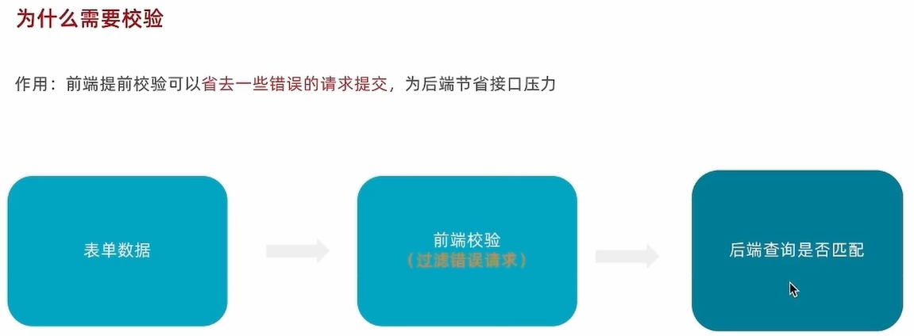](https://xiaobaicai350.github.io/pic/image-20230627144611157.png)

### 1. 校验要求

用户名：不能为空，字段名为 account  
密码：不能为空且为6-14个字符，字段名为 password  
同意协议：必选，字段名为 agree

### 2. 代码实现

[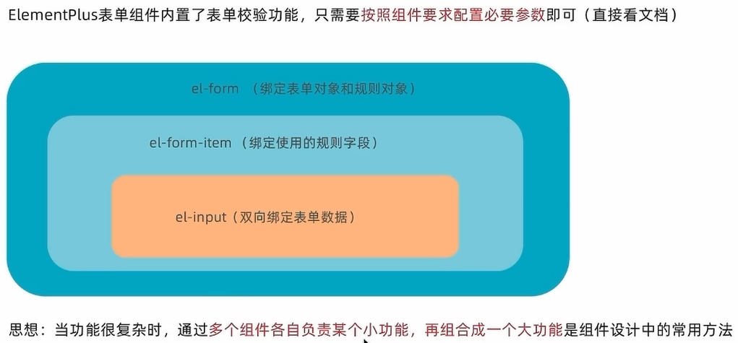](https://xiaobaicai350.github.io/pic/image-20230627144757263.png)

这里用到了自定义校验规则

[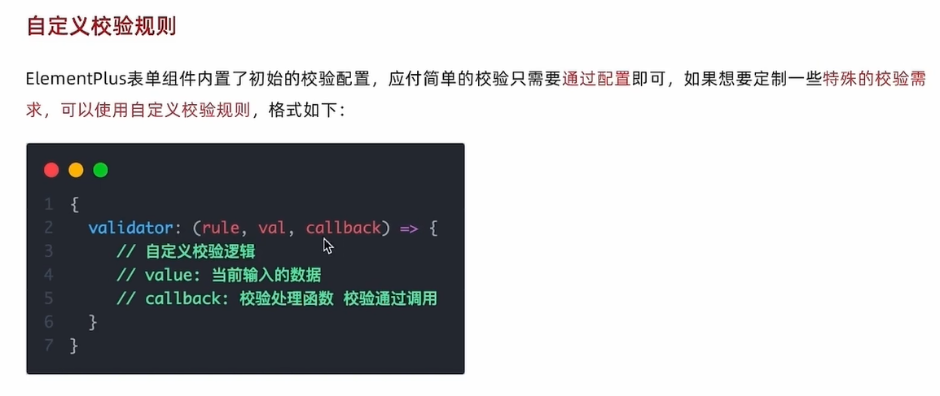](https://xiaobaicai350.github.io/pic/image-20230627145321643.png)

**PLAINTEXT**

|  |
| --- |
| <script setup> import { ref } from 'vue' // 表单数据对象 const userInfo = ref({  account: '1311111111',  password: '123456',  agree: true })  // 规则数据对象 const rules = {  account: [  { required: true, message: '用户名不能为空' }  ],  password: [  { required: true, message: '密码不能为空' },  { min: 6, max: 24, message: '密码长度要求6-14个字符' }  ],  agree: [  {  validator: (rule, val, callback) => {  return val ? callback() : new Error('请先同意协议')  }  }  ] }   </script>   <template>  <div class="form">  <el-form ref="formRef" :model="userInfo" :rules="rules" status-icon>  <el-form-item prop="account" label="账户">  <el-input v-model="userInfo.account" />  </el-form-item>  <el-form-item prop="password" label="密码">  <el-input v-model="userInfo.password" />  </el-form-item>  <el-form-item prop="agree" label-width="22px">  <el-checkbox v-model="userInfo.agree" size="large">  我已同意隐私条款和服务条款  </el-checkbox>  </el-form-item>  <el-button size="large" class="subBtn" @click="doLogin">点击登录</el-button>  </el-form>  </div> </template> |

## 登录基础业务实现

[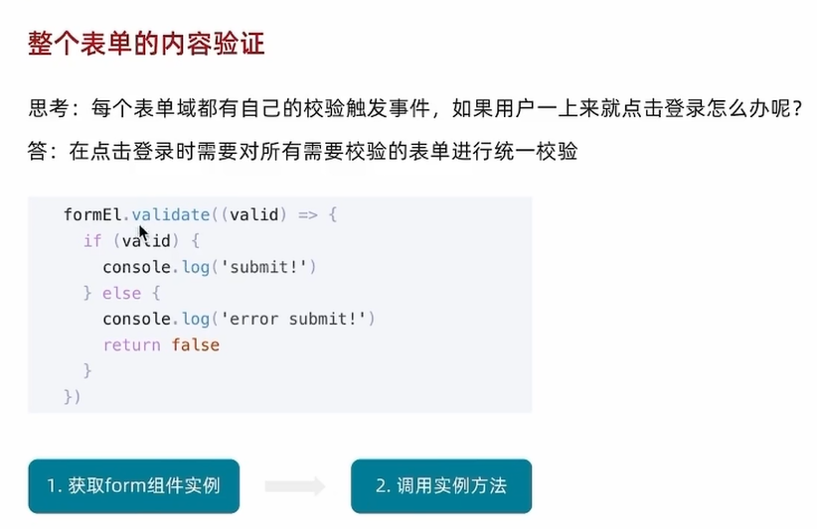](https://xiaobaicai350.github.io/pic/image-20230627150412626.png)

基础思想

1. 调用登录接口获取用户信息
2. 提示用户当前是否成功
3. 跳转到首页

封装接口

src\apis\user.js

**JS**

|  |
| --- |
| // 封装所有和用户相关的接口函数 import request from "@/utils/http";  export const loginAPI = ({ account, password }) => {  return request({  url: "/login",  method: "POST",  data: {  account,  password,  },  }); }; |

src\views\Login\index.vue

**JSX**

|  |
| --- |
| import { ElMessage } from "element-plus"; import "element-plus/theme-chalk/el-message.css"; import { useRouter } from "vue-router"; import { loginAPI } from "@/apis/user.js"; const router = useRouter();  const formRef = ref(null); const doLogin = () => {  const { account, password } = userInfo.value;  // 调用实例方法  formRef.value.validate(async (valid) => {  // valid: 所有表单都通过校验 才为true  console.log(valid);  // 以valid做为判断条件 如果通过校验才执行登录逻辑  if (valid) {  // TODO LOGIN  await loginAPI({ account, password });  // 这里其实很奇怪，不知道为什么登录出错就不执行这个了  // 1. 提示用户  ElMessage({ type: "success", message: "登录成功" });  // 2. 跳转首页  router.replace({ path: "/" });  }  }); }; |

这里其实我有点不理解，这里如果登录失败就不会执行后面的语句，然后就会执行拦截器里面的语句了

src\utils\http.js

**JS**

|  |
| --- |
| // axios响应式拦截器 httpInstance.interceptors.response.use(  (res) => res.data,  (e) => {  // 这里通过拦截器的方式，来发送提示信息，  // 这个response是拦截到响应码不是200了就会执行这个  ElMessage({  type: "warning",  message: e.response.data.message,  });  return Promise.reject(e);  } ); |

## Pinia管理用户数据

基本思想：Pinia负责用户数据相关的state和action，组件中只负责触发action函数并传递参数

src\stores\user.js

**JAVASCRIPT**

|  |
| --- |
| // 管理用户数据相关  import { defineStore } from 'pinia' import { ref } from 'vue' import { loginAPI } from '@/apis/user'  export const useUserStore = defineStore('user', () => {  // 1. 定义管理用户数据的state  const userInfo = ref({})  // 2. 定义获取接口数据的action函数  const getUserInfo = async ({ account, password }) => {  const res = await loginAPI({ account, password })  userInfo.value = res.result  }  // 3. 以对象的格式把state和action return  return {  getUserInfo  } }, {  persist: true, }) |

使用pinia替换原来的api形式

src\views\Login\index.vue

**JS**

|  |
| --- |
| import { ElMessage } from "element-plus"; import "element-plus/theme-chalk/el-message.css"; import { useRouter } from "vue-router"; import { useUserStore } from "@/stores/user.js"; const router = useRouter(); const userStore = useUserStore(); const formRef = ref(null); const doLogin = () => {  const { account, password } = userInfo.value;  // 调用实例方法  formRef.value.validate(async (valid) => {  // valid: 所有表单都通过校验 才为true  console.log(valid);  // 以valid做为判断条件 如果通过校验才执行登录逻辑  if (valid) {  // TODO LOGIN  await userStore.getUserInfo({ account, password });  // 这里其实很奇怪，不知道为什么登录出错就不执行这个了  // 1. 提示用户  ElMessage({ type: "success", message: "登录成功" });  // 2. 跳转首页  router.replace({ path: "/" });  }  }); }; |

### 持久化用户数据

[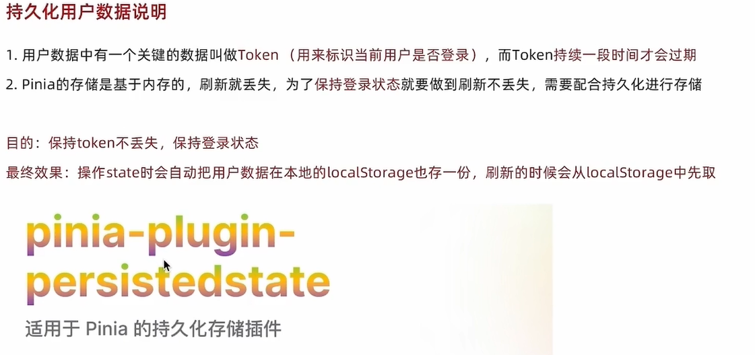](https://xiaobaicai350.github.io/pic/image-20230701193844143.png)

这个pinia的插件也是把token存储到localstorage中。只是更方便一些

[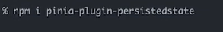](https://xiaobaicai350.github.io/pic/image-20230701193914896.png)

[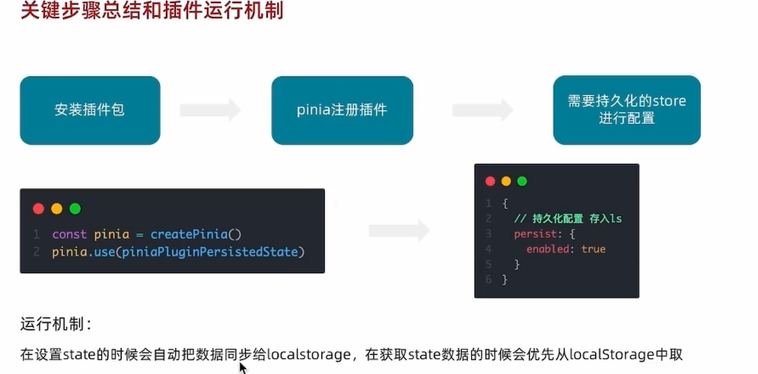](https://xiaobaicai350.github.io/pic/image-20230701194419890.png)

## 请求拦截器携带token

[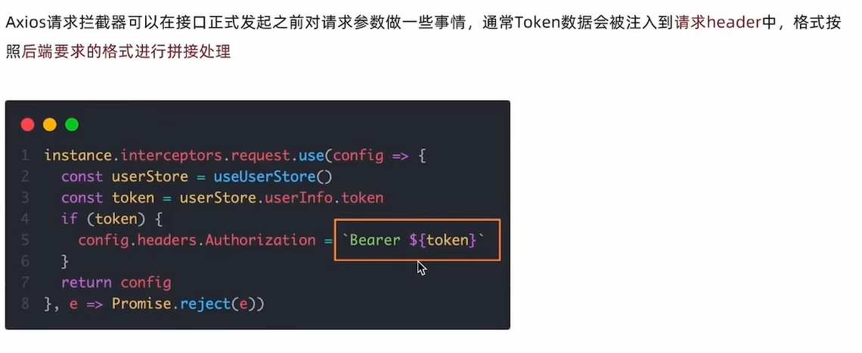](https://xiaobaicai350.github.io/pic/image-20230701195811256.png)

基础思想：很多接口如果想要获取数据必须要带着有效的Token信息才可以，拦截器中做一次，用到axios实例的其他都可以拿到

**JAVASCRIPT**

|  |
| --- |
| // axios请求拦截器 httpInstance.interceptors.request.use(config => {  // 1. 从pinia获取token数据  const userStore = useUserStore()  // 2. 按照后端的要求拼接token数据  const token = userStore.userInfo.token  if (token) {  config.headers.Authorization = `Bearer ${token}`  }  return config }, e => Promise.reject(e)) |

## 退出登录实现

基础思想：

1. 清除用户信息
2. 跳转到登录页

1- 新增清除用户信息action

**JAVASCRIPT**

|  |
| --- |
| // 退出时清除用户信息  const clearUserInfo = () => {  userInfo.value = {}  } |

2- 组件中执行业务逻辑

**PLAINTEXT**

|  |
| --- |
| <script setup> import { useUserStore } from '@/stores/userStore' import { useRouter } from 'vue-router' const userStore = useUserStore() const router = useRouter() const confirm = () => {  console.log('用户要退出登录了')  // 退出登录业务逻辑实现  // 1.清除用户信息 触发action  userStore.clearUserInfo()  // 2.跳转到登录页  router.push('/login') } </script> |

# 购物车

[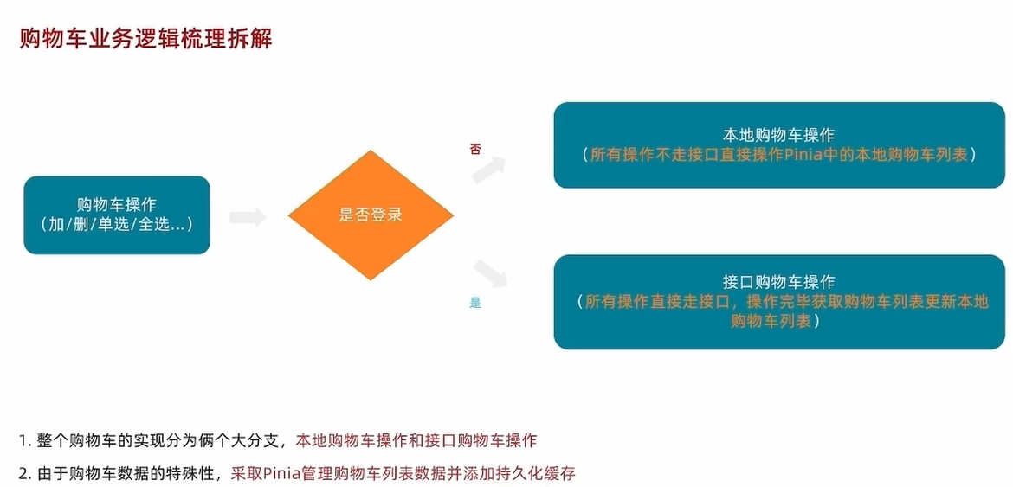](https://xiaobaicai350.github.io/pic/image-20230701202406372.png)

## 本地购物车

### 1. 添加购物车

基础思想：如果已经添加过相同的商品，就在其数量count上加一，如果没有添加过，就直接push到购物车列表中

**JAVASCRIPT**

|  |
| --- |
| // 封装购物车模块  import { defineStore } from 'pinia' import { ref } from 'vue'   export const useCartStore = defineStore('cart', () => {  // 1. 定义state - cartList  const cartList = ref([])  // 2. 定义action - addCart  const addCart = (goods) => {  console.log('添加', goods)  // 添加购物车操作  // 已添加过 - count + 1  // 没有添加过 - 直接push  // 思路：通过匹配传递过来的商品对象中的skuId能不能在cartList中找到，找到了就是添加过  const item = cartList.value.find((item) => goods.skuId === item.skuId)  if (item) {  // 找到了  item.count++  } else {  // 没找到  cartList.value.push(goods)  }  }  return {  cartList,  addCart  } }, {  persist: true, }) |

### 2. 头部购物车

#### 2.1. 头部购物车组件模版

**PLAINTEXT**

|  |
| --- |
| <script setup>  </script>  <template>  <div class="cart">  <a class="curr" href="javascript:;">  <i class="iconfont icon-cart"></i><em>2</em>  </a>  <div class="layer">  <div class="list">  <!--  <div class="item" v-for="i in cartList" :key="i">  <RouterLink to="">  <img :src="i.picture" alt="" />  <div class="center">  <p class="name ellipsis-2">  {{ i.name }}  </p>  <p class="attr ellipsis">{{ i.attrsText }}</p>  </div>  <div class="right">  <p class="price">&yen;{{ i.price }}</p>  <p class="count">x{{ i.count }}</p>  </div>  </RouterLink>  <i class="iconfont icon-close-new" @click="store.delCart(i.skuId)"></i>  </div>  -->  </div>  <div class="foot">  <div class="total">  <p>共 10 件商品</p>  <p>&yen; 100.00 </p>  </div>  <el-button size="large" type="primary" >去购物车结算</el-button>  </div>  </div> </div> </template>  <style scoped lang="scss"> .cart {  width: 50px;  position: relative;  z-index: 600;   .curr {  height: 32px;  line-height: 32px;  text-align: center;  position: relative;  display: block;   .icon-cart {  font-size: 22px;  }   em {  font-style: normal;  position: absolute;  right: 0;  top: 0;  padding: 1px 6px;  line-height: 1;  background: $helpColor;  color: #fff;  font-size: 12px;  border-radius: 10px;  font-family: Arial;  }  }   &:hover {  .layer {  opacity: 1;  transform: none;  }  }   .layer {  opacity: 0;  transition: all 0.4s 0.2s;  transform: translateY(-200px) scale(1, 0);  width: 400px;  height: 400px;  position: absolute;  top: 50px;  right: 0;  box-shadow: 0 0 10px rgba(0, 0, 0, 0.2);  background: #fff;  border-radius: 4px;  padding-top: 10px;   &::before {  content: "";  position: absolute;  right: 14px;  top: -10px;  width: 20px;  height: 20px;  background: #fff;  transform: scale(0.6, 1) rotate(45deg);  box-shadow: -3px -3px 5px rgba(0, 0, 0, 0.1);  }   .foot {  position: absolute;  left: 0;  bottom: 0;  height: 70px;  width: 100%;  padding: 10px;  display: flex;  justify-content: space-between;  background: #f8f8f8;  align-items: center;   .total {  padding-left: 10px;  color: #999;   p {  &:last-child {  font-size: 18px;  color: $priceColor;  }  }  }  }  }   .list {  height: 310px;  overflow: auto;  padding: 0 10px;   &::-webkit-scrollbar {  width: 10px;  height: 10px;  }   &::-webkit-scrollbar-track {  background: #f8f8f8;  border-radius: 2px;  }   &::-webkit-scrollbar-thumb {  background: #eee;  border-radius: 10px;  }   &::-webkit-scrollbar-thumb:hover {  background: #ccc;  }   .item {  border-bottom: 1px solid #f5f5f5;  padding: 10px 0;  position: relative;   i {  position: absolute;  bottom: 38px;  right: 0;  opacity: 0;  color: #666;  transition: all 0.5s;  }   &:hover {  i {  opacity: 1;  cursor: pointer;  }  }   a {  display: flex;  align-items: center;   img {  height: 80px;  width: 80px;  }   .center {  padding: 0 10px;  width: 200px;   .name {  font-size: 16px;  }   .attr {  color: #999;  padding-top: 5px;  }  }   .right {  width: 100px;  padding-right: 20px;  text-align: center;   .price {  font-size: 16px;  color: $priceColor;  }   .count {  color: #999;  margin-top: 5px;  font-size: 16px;  }  }  }  }  } } </style> |

#### 2.2 渲染头部购物车数据

**PLAINTEXT**

|  |
| --- |
| <script setup> import { useCartStore } from '@/stores/cartStore' const cartStore = useCartStore()  </script>  <template>  <div class="cart">  <a class="curr" href="javascript:;">  <i class="iconfont icon-cart"></i><em>{{ cartStore.cartList.length }}</em>  </a>  <div class="layer">  <div class="list">   <div class="item" v-for="i in cartStore.cartList" :key="i">  <RouterLink to="">  <img :src="i.picture" alt="" />  <div class="center">  <p class="name ellipsis-2">  {{ i.name }}  </p>  <p class="attr ellipsis">{{ i.attrsText }}</p>  </div>  <div class="right">  <p class="price">&yen;{{ i.price }}</p>  <p class="count">x{{ i.count }}</p>  </div>  </RouterLink>  <i class="iconfont icon-close-new" @click="cartStore.delCart(i.skuId)"></i>  </div>   </div>  <div class="foot">  <div class="total">  <p>共 {{ cartStore.allCount }} 件商品</p>  <p>&yen; {{ cartStore.allPrice.toFixed(2) }} </p>  </div>  <el-button size="large" type="primary" @click="$router.push('/cartlist')">去购物车结算</el-button>  </div>  </div> </div> </template> |

#### 2.3 删除功能实现

1- 添加删除action函数

**JAVASCRIPT**

|  |
| --- |
| // 删除购物车 const delCart = async (skuId) => {  // 思路：  // 1. 找到要删除项的下标值 - splice  // 2. 使用数组的过滤方法 - filter  const idx = cartList.value.findIndex((item) => skuId === item.skuId)  cartList.value.splice(idx, 1) } |

2- 组件触发action函数并传递参数

**PLAINTEXT**

|  |
| --- |
| <i class="iconfont icon-close-new" @click="cartStore.delCart(i.skuId)"></i> |

### 3. 列表购物车-基础内容渲染

#### 3.1. 准备模版

**PLAINTEXT**

|  |
| --- |
| <script setup> const cartList = [] </script>  <template>  <div class="xtx-cart-page">  <div class="container m-top-20">  <div class="cart">  <table>  <thead>  <tr>  <th width="120">  <el-checkbox/>  </th>  <th width="400">商品信息</th>  <th width="220">单价</th>  <th width="180">数量</th>  <th width="180">小计</th>  <th width="140">操作</th>  </tr>  </thead>  <!-- 商品列表 -->  <tbody>  <tr v-for="i in cartList" :key="i.id">  <td>  <el-checkbox />  </td>  <td>  <div class="goods">  <RouterLink to="/"><img :src="i.picture" alt="" /></RouterLink>  <div>  <p class="name ellipsis">  {{ i.name }}  </p>  </div>  </div>  </td>  <td class="tc">  <p>&yen;{{ i.price }}</p>  </td>  <td class="tc">  <el-input-number v-model="i.count" />  </td>  <td class="tc">  <p class="f16 red">&yen;{{ (i.price * i.count).toFixed(2) }}</p>  </td>  <td class="tc">  <p>  <el-popconfirm title="确认删除吗?" confirm-button-text="确认" cancel-button-text="取消" @confirm="delCart(i)">  <template #reference>  <a href="javascript:;">删除</a>  </template>  </el-popconfirm>  </p>  </td>  </tr>  <tr v-if="cartList.length === 0">  <td colspan="6">  <div class="cart-none">  <el-empty description="购物车列表为空">  <el-button type="primary">随便逛逛</el-button>  </el-empty>  </div>  </td>  </tr>  </tbody>   </table>  </div>  <!-- 操作栏 -->  <div class="action">  <div class="batch">  共 10 件商品，已选择 2 件，商品合计：  <span class="red">¥ 200.00 </span>  </div>  <div class="total">  <el-button size="large" type="primary" >下单结算</el-button>  </div>  </div>  </div>  </div> </template>  <style scoped lang="scss"> .xtx-cart-page {  margin-top: 20px;   .cart {  background: #fff;  color: #666;   table {  border-spacing: 0;  border-collapse: collapse;  line-height: 24px;   th,  td {  padding: 10px;  border-bottom: 1px solid #f5f5f5;   &:first-child {  text-align: left;  padding-left: 30px;  color: #999;  }  }   th {  font-size: 16px;  font-weight: normal;  line-height: 50px;  }  }  }   .cart-none {  text-align: center;  padding: 120px 0;  background: #fff;   p {  color: #999;  padding: 20px 0;  }  }   .tc {  text-align: center;   a {  color: $xtxColor;  }   .xtx-numbox {  margin: 0 auto;  width: 120px;  }  }   .red {  color: $priceColor;  }   .green {  color: $xtxColor;  }   .f16 {  font-size: 16px;  }   .goods {  display: flex;  align-items: center;   img {  width: 100px;  height: 100px;  }   >div {  width: 280px;  font-size: 16px;  padding-left: 10px;   .attr {  font-size: 14px;  color: #999;  }  }  }   .action {  display: flex;  background: #fff;  margin-top: 20px;  height: 80px;  align-items: center;  font-size: 16px;  justify-content: space-between;  padding: 0 30px;   .xtx-checkbox {  color: #999;  }   .batch {  a {  margin-left: 20px;  }  }   .red {  font-size: 18px;  margin-right: 20px;  font-weight: bold;  }  }   .tit {  color: #666;  font-size: 16px;  font-weight: normal;  line-height: 50px;  }  } </style> |

#### 3.2. 绑定路由

**JAVASCRIPT**

|  |
| --- |
| import CartList from '@/views/CartList/index.vue'  {  path: 'cartlist',  component: CartList } |

#### 3.3. 渲染列表

**PLAINTEXT**

|  |
| --- |
| <script setup> import { useCartStore } from '@/stores/cartStore' const cartStore = useCartStore() </script>  <template>  <div class="xtx-cart-page">  <div class="container m-top-20">  <div class="cart">  <table>  <thead>  <tr>  <th width="120">  <el-checkbox />  </th>  <th width="400">商品信息</th>  <th width="220">单价</th>  <th width="180">数量</th>  <th width="180">小计</th>  <th width="140">操作</th>  </tr>  </thead>  <!-- 商品列表 -->  <tbody>  <tr v-for="i in cartStore.cartList" :key="i.id">  <td>  <!-- 单选框 -->  <el-checkbox/>  </td>  <td>  <div class="goods">  <RouterLink to="/"><img :src="i.picture" alt="" /></RouterLink>  <div>  <p class="name ellipsis">  {{ i.name }}  </p>  </div>  </div>  </td>  <td class="tc">  <p>&yen;{{ i.price }}</p>  </td>  <td class="tc">  <el-input-number v-model="i.count" />  </td>  <td class="tc">  <p class="f16 red">&yen;{{ (i.price * i.count).toFixed(2) }}</p>  </td>  <td class="tc">  <p>  <el-popconfirm title="确认删除吗?" confirm-button-text="确认" cancel-button-text="取消" @confirm="delCart(i)">  <template #reference>  <a href="javascript:;">删除</a>  </template>  </el-popconfirm>  </p>  </td>  </tr>  <tr v-if="cartStore.cartList.length === 0">  <td colspan="6">  <div class="cart-none">  <el-empty description="购物车列表为空">  <el-button type="primary">随便逛逛</el-button>  </el-empty>  </div>  </td>  </tr>  </tbody>   </table>  </div>  <!-- 操作栏 -->  <div class="action">  <div class="batch">  共 10 件商品，已选择 2 件，商品合计：  <span class="red">¥ 200.00 </span>  </div>  <div class="total">  <el-button size="large" type="primary" >下单结算</el-button>  </div>  </div>  </div>  </div> </template> |

### 4. 列表购物车-单选功能实现

基本思想：通过skuId找到要进行单选操作的商品，把控制是否选中的selected字段修改为当前单选框的状态

1- 添加单选action

**JAVASCRIPT**

|  |
| --- |
| // 单选功能 const singleCheck = (skuId, selected) => {  // 通过skuId找到要修改的那一项 然后把它的selected修改为传过来的selected  const item = cartList.value.find((item) => item.skuId === skuId)  item.selected = selected } |

2- 触发action函数

**PLAINTEXT**

|  |
| --- |
| <script setup> // 单选回调 const singleCheck = (i, selected) => {  console.log(i, selected)  // store cartList 数组 无法知道要修改谁的选中状态？  // 除了selected补充一个用来筛选的参数 - skuId  cartStore.singleCheck(i.skuId, selected) } </script>    <template>  <td>  <!-- 单选框 -->  <el-checkbox :model-value="i.selected" @change="(selected) => singleCheck(i, selected)" />  </td> </template> |

### 5. 列表购物车-全选功能实现

基础思想：

1. 全选状态决定单选框状态 - 遍历cartList把每一项的selected都设置为何全选框状态一致
2. 单选框状态决定全选状态 - 只有所有单选框的selected都为true, 全选框才为true

1- store中定义action和计算属性

**JAVASCRIPT**

|  |
| --- |
| // 全选功能action const allCheck = (selected) => {  // 把cartList中的每一项的selected都设置为当前的全选框状态  cartList.value.forEach(item => item.selected = selected) }   // 是否全选计算属性 const isAll = computed(() => cartList.value.every((item) => item.selected)) |

2- 组件中触发aciton和使用计算属性

**PLAINTEXT**

|  |
| --- |
| <script setup> const allCheck = (selected) => {  cartStore.allCheck(selected) }  </script>    <template>  <!-- 全选框 -->  <el-checkbox :model-value="cartStore.isAll" @change="allCheck" /> </template> |

### 6. 列表购物车-统计数据功能实现

**JAVASCRIPT**

|  |
| --- |
| // 3. 已选择数量 const selectedCount = computed(() => cartList.value.filter(item => item.selected).reduce((a, c) => a + c.count, 0)) // 4. 已选择商品价钱合计 const selectedPrice = computed(() => cartList.value.filter(item => item.selected).reduce((a, c) => a + c.count * c.price, 0)) |

## 接口购物车

#### 1. 加入购物车

1-接口封装

**JAVASCRIPT**

|  |
| --- |
| // 加入购物车 export const insertCartAPI = ({ skuId, count }) => {  return request({  url: '/member/cart',  method: 'POST',  data: {  skuId,  count  }  }) } |

2- action中适配登录和非登录

**JAVASCRIPT**

|  |
| --- |
| import { defineStore } from 'pinia' import { useUserStore } from './userStore' import { insertCartAPI } from '@/apis/cart' export const useCartStore = defineStore('cart', () => {  const userStore = useUserStore()  const isLogin = computed(() => userStore.userInfo.token)   const addCart = async (goods) => {  const { skuId, count } = goods  // 登录  if (isLogin.value) {  // 登录之后的加入购车逻辑  await insertCartAPI({ skuId, count })  updateNewList()  } else {  // 未登录  const item = cartList.value.find((item) => goods.skuId === item.skuId)  if (item) {  // 找到了  item.count++  } else {  // 没找到  cartList.value.push(goods)  }  }  } }, {  persist: true, }) |

#### 2. 删除购物车

1- 封装接口

**JAVASCRIPT**

|  |
| --- |
| // 删除购物车 export const delCartAPI = (ids) => {  return request({  url: '/member/cart',  method: 'DELETE',  data: {  ids  }  }) } |

2- action中适配登录和非登录

**JAVASCRIPT**

|  |
| --- |
| // 删除购物车 const delCart = async (skuId) => {  if (isLogin.value) {  // 调用接口实现接口购物车中的删除功能  await delCartAPI([skuId])  updateNewList()  } else {  // 思路：  // 1. 找到要删除项的下标值 - splice  // 2. 使用数组的过滤方法 - filter  const idx = cartList.value.findIndex((item) => skuId === item.skuId)  cartList.value.splice(idx, 1)  } } |

# 订单页

## 路由配置和基础数据渲染

### 1. 准备组件模版

**PLAINTEXT**

|  |
| --- |
| <script setup> const checkInfo = {} // 订单对象 const curAddress = {} // 地址对象  </script>  <template>  <div class="xtx-pay-checkout-page">  <div class="container">  <div class="wrapper">  <!-- 收货地址 -->  <h3 class="box-title">收货地址</h3>  <div class="box-body">  <div class="address">  <div class="text">  <div class="none" v-if="!curAddress">您需要先添加收货地址才可提交订单。</div>  <ul v-else>  <li><span>收<i />货<i />人：</span>{{ curAddress.receiver }}</li>  <li><span>联系方式：</span>{{ curAddress.contact }}</li>  <li><span>收货地址：</span>{{ curAddress.fullLocation }} {{ curAddress.address }}</li>  </ul>  </div>  <div class="action">  <el-button size="large" @click="toggleFlag = true">切换地址</el-button>  <el-button size="large" @click="addFlag = true">添加地址</el-button>  </div>  </div>  </div>  <!-- 商品信息 -->  <h3 class="box-title">商品信息</h3>  <div class="box-body">  <table class="goods">  <thead>  <tr>  <th width="520">商品信息</th>  <th width="170">单价</th>  <th width="170">数量</th>  <th width="170">小计</th>  <th width="170">实付</th>  </tr>  </thead>  <tbody>  <tr v-for="i in checkInfo.goods" :key="i.id">  <td>  <a href="javascript:;" class="info">  <img :src="i.picture" alt="">  <div class="right">  <p>{{ i.name }}</p>  <p>{{ i.attrsText }}</p>  </div>  </a>  </td>  <td>&yen;{{ i.price }}</td>  <td>{{ i.price }}</td>  <td>&yen;{{ i.totalPrice }}</td>  <td>&yen;{{ i.totalPayPrice }}</td>  </tr>  </tbody>  </table>  </div>  <!-- 配送时间 -->  <h3 class="box-title">配送时间</h3>  <div class="box-body">  <a class="my-btn active" href="javascript:;">不限送货时间：周一至周日</a>  <a class="my-btn" href="javascript:;">工作日送货：周一至周五</a>  <a class="my-btn" href="javascript:;">双休日、假日送货：周六至周日</a>  </div>  <!-- 支付方式 -->  <h3 class="box-title">支付方式</h3>  <div class="box-body">  <a class="my-btn active" href="javascript:;">在线支付</a>  <a class="my-btn" href="javascript:;">货到付款</a>  <span style="color:#999">货到付款需付5元手续费</span>  </div>  <!-- 金额明细 -->  <h3 class="box-title">金额明细</h3>  <div class="box-body">  <div class="total">  <dl>  <dt>商品件数：</dt>  <dd>{{ checkInfo.summary?.goodsCount }}件</dd>  </dl>  <dl>  <dt>商品总价：</dt>  <dd>¥{{ checkInfo.summary?.totalPrice.toFixed(2) }}</dd>  </dl>  <dl>  <dt>运<i></i>费：</dt>  <dd>¥{{ checkInfo.summary?.postFee.toFixed(2) }}</dd>  </dl>  <dl>  <dt>应付总额：</dt>  <dd class="price">{{ checkInfo.summary?.totalPayPrice.toFixed(2) }}</dd>  </dl>  </div>  </div>  <!-- 提交订单 -->  <div class="submit">  <el-button type="primary" size="large" >提交订单</el-button>  </div>  </div>  </div>  </div>  <!-- 切换地址 -->  <!-- 添加地址 --> </template>  <style scoped lang="scss"> .xtx-pay-checkout-page {  margin-top: 20px;   .wrapper {  background: #fff;  padding: 0 20px;   .box-title {  font-size: 16px;  font-weight: normal;  padding-left: 10px;  line-height: 70px;  border-bottom: 1px solid #f5f5f5;  }   .box-body {  padding: 20px 0;  }  } }  .address {  border: 1px solid #f5f5f5;  display: flex;  align-items: center;   .text {  flex: 1;  min-height: 90px;  display: flex;  align-items: center;   .none {  line-height: 90px;  color: #999;  text-align: center;  width: 100%;  }   >ul {  flex: 1;  padding: 20px;   li {  line-height: 30px;   span {  color: #999;  margin-right: 5px;   >i {  width: 0.5em;  display: inline-block;  }  }  }  }   >a {  color: $xtxColor;  width: 160px;  text-align: center;  height: 90px;  line-height: 90px;  border-right: 1px solid #f5f5f5;  }  }   .action {  width: 420px;  text-align: center;   .btn {  width: 140px;  height: 46px;  line-height: 44px;  font-size: 14px;   &:first-child {  margin-right: 10px;  }  }  } }  .goods {  width: 100%;  border-collapse: collapse;  border-spacing: 0;   .info {  display: flex;  text-align: left;   img {  width: 70px;  height: 70px;  margin-right: 20px;  }   .right {  line-height: 24px;   p {  &:last-child {  color: #999;  }  }  }  }   tr {  th {  background: #f5f5f5;  font-weight: normal;  }   td,  th {  text-align: center;  padding: 20px;  border-bottom: 1px solid #f5f5f5;   &:first-child {  border-left: 1px solid #f5f5f5;  }   &:last-child {  border-right: 1px solid #f5f5f5;  }  }  } }  .my-btn {  width: 228px;  height: 50px;  border: 1px solid #e4e4e4;  text-align: center;  line-height: 48px;  margin-right: 25px;  color: #666666;  display: inline-block;   &.active,  &:hover {  border-color: $xtxColor;  } }  .total {  dl {  display: flex;  justify-content: flex-end;  line-height: 50px;   dt {  i {  display: inline-block;  width: 2em;  }  }   dd {  width: 240px;  text-align: right;  padding-right: 70px;   &.price {  font-size: 20px;  color: $priceColor;  }  }  } }  .submit {  text-align: right;  padding: 60px;  border-top: 1px solid #f5f5f5; }  .addressWrapper {  max-height: 500px;  overflow-y: auto; }  .text {  flex: 1;  min-height: 90px;  display: flex;  align-items: center;   &.item {  border: 1px solid #f5f5f5;  margin-bottom: 10px;  cursor: pointer;   &.active,  &:hover {  border-color: $xtxColor;  background: lighten($xtxColor, 50%);  }   >ul {  padding: 10px;  font-size: 14px;  line-height: 30px;  }  } } </style> |

### 2. 配置路由

### 3. 封装接口

**JAVASCRIPT**

|  |
| --- |
| import request from '@/utils/request' /**  * 获取结算信息  */ export const getCheckoutInfoAPI = () => {  return request({  url:'/member/order/pre'  }) } |

### 4. 渲染数据

## 切换地址-打开弹框交互

### 1. 准备弹框模版

**HTML**

|  |
| --- |
| <el-dialog title="切换收货地址" width="30%" center>  <div class="addressWrapper">  <div class="text item" v-for="item in checkInfo.userAddresses" :key="item.id">  <ul>  <li><span>收<i />货<i />人：</span>{{ item.receiver }} </li>  <li><span>联系方式：</span>{{ item.contact }}</li>  <li><span>收货地址：</span>{{ item.fullLocation + item.address }}</li>  </ul>  </div>  </div>  <template #footer>  <span class="dialog-footer">  <el-button>取消</el-button>  <el-button type="primary">确定</el-button>  </span>  </template> </el-dialog> |

### 2. 控制弹框打开

**PLAINTEXT**

|  |
| --- |
| const showDialog = ref(false)  <el-button size="large" @click="showDialog = true">切换地址</el-button>  <el-dialog v-model="showDialog" title="切换收货地址" width="30%" center>  <!-- 省略 --> </el-dialog> |

## 切换地址-地址切换交互

基础思想：记录当前点击项，通过动态class判断当前div是否有激活类名

**PLAINTEXT**

|  |
| --- |
| <script setup> // 切换地址 const activeAddress = ref({}) const switchAddress = (item) => {  activeAddress.value = item } </script>  <template> <div class="text item"   :class="{ active: activeAddress.id === item.id }"   @click="switchAddress(item)"  :key="item.id">  <!-- 省略... --> </div> </template> |

## 创建订单生成订单ID

### 1. 准备支付页组件并绑定路由

**PLAINTEXT**

|  |
| --- |
| <script setup> const payInfo = {} </script>   <template>  <div class="xtx-pay-page">  <div class="container">  <!-- 付款信息 -->  <div class="pay-info">  <span class="icon iconfont icon-queren2"></span>  <div class="tip">  <p>订单提交成功！请尽快完成支付。</p>  <p>支付还剩 <span>24分30秒</span>, 超时后将取消订单</p>  </div>  <div class="amount">  <span>应付总额：</span>  <span>¥{{ payInfo.payMoney?.toFixed(2) }}</span>  </div>  </div>  <!-- 付款方式 -->  <div class="pay-type">  <p class="head">选择以下支付方式付款</p>  <div class="item">  <p>支付平台</p>  <a class="btn wx" href="javascript:;"></a>  <a class="btn alipay" :href="payUrl"></a>  </div>  <div class="item">  <p>支付方式</p>  <a class="btn" href="javascript:;">招商银行</a>  <a class="btn" href="javascript:;">工商银行</a>  <a class="btn" href="javascript:;">建设银行</a>  <a class="btn" href="javascript:;">农业银行</a>  <a class="btn" href="javascript:;">交通银行</a>  </div>  </div>  </div>  </div> </template>  <style scoped lang="scss"> .xtx-pay-page {  margin-top: 20px; }  .pay-info {   background: #fff;  display: flex;  align-items: center;  height: 240px;  padding: 0 80px;   .icon {  font-size: 80px;  color: #1dc779;  }   .tip {  padding-left: 10px;  flex: 1;   p {  &:first-child {  font-size: 20px;  margin-bottom: 5px;  }   &:last-child {  color: #999;  font-size: 16px;  }  }  }   .amount {  span {  &:first-child {  font-size: 16px;  color: #999;  }   &:last-child {  color: $priceColor;  font-size: 20px;  }  }  } }  .pay-type {  margin-top: 20px;  background-color: #fff;  padding-bottom: 70px;   p {  line-height: 70px;  height: 70px;  padding-left: 30px;  font-size: 16px;   &.head {  border-bottom: 1px solid #f5f5f5;  }  }   .btn {  width: 150px;  height: 50px;  border: 1px solid #e4e4e4;  text-align: center;  line-height: 48px;  margin-left: 30px;  color: #666666;  display: inline-block;   &.active,  &:hover {  border-color: $xtxColor;  }   &.alipay {  background: url(https://cdn.cnbj1.fds.api.mi-img.com/mi-mall/7b6b02396368c9314528c0bbd85a2e06.png) no-repeat center / contain;  }   &.wx {  background: url(https://cdn.cnbj1.fds.api.mi-img.com/mi-mall/c66f98cff8649bd5ba722c2e8067c6ca.jpg) no-repeat center / contain;  }  } } </style> |

### 2. 准备生成订单接口

**JAVASCRIPT**

|  |
| --- |
| // 创建订单 export const createOrderAPI = (data) => {  return request({  url: '/member/order',  method: 'POST',  data  }) } |

### 3. 调用接口携带id跳转路由

**PLAINTEXT**

|  |
| --- |
| <script setup> import { createOrderAPI } from '@/apis/checkout'  // 创建订单 const createOrder = async () => {  const res = await createOrderAPI({  deliveryTimeType: 1,  payType: 1,  payChannel: 1,  buyerMessage: '',  goods: checkInfo.value.goods.map(item => {  return {  skuId: item.skuId,  count: item.count  }  }),  addressId: curAddress.value.id  })  const orderId = res.result.id  router.push({  path: '/pay',  query: {  id: orderId  }  }) }  </script>  <template>  <!-- 提交订单 -->  <div class="submit">  <el-button @click="createOrder" type="primary" size="large">提交订单</el-button>  </div> </template> |

# 支付页

# [image.png](https://raw.githubusercontent.com/Xiaobaicai350/picBed/master/xiaobaicai/1677761581263-68132341-71bc-44ad-87f1-a6f312237313.png)

## 基础数据渲染

### 1. 准备接口

**JAVASCRIPT**

|  |
| --- |
| import request from '@/utils/http'  export const getOrderAPI = (id) => {  return request({  url: `/member/order/${id}`  }) } |

### 2. 获取数据渲染内容

**PLAINTEXT**

|  |
| --- |
| <script setup> import { getOrderAPI } from '@/apis/pay' import { onMounted, ref } from 'vue' import { useRoute } from 'vue-router' // 获取订单数据 const route = useRoute() const payInfo = ref({}) const getPayInfo = async () => {  const res = await getOrderAPI(route.query.id)  payInfo.value = res.result } onMounted(() => getPayInfo())  </script>   <template>  <div class="xtx-pay-page">  <div class="container">  <!-- 付款信息 -->  <div class="pay-info">  <span class="icon iconfont icon-queren2"></span>  <div class="tip">  <p>订单提交成功！请尽快完成支付。</p>  <p>支付还剩 <span>{{ formatTime }}</span>, 超时后将取消订单</p>  </div>  <div class="amount">  <span>应付总额：</span>  <span>¥{{ payInfo.payMoney?.toFixed(2) }}</span>  </div>  </div>  <!-- 付款方式 -->  <div class="pay-type">  <p class="head">选择以下支付方式付款</p>  <div class="item">  <p>支付平台</p>  <a class="btn wx" href="javascript:;"></a>  <a class="btn alipay" :href="payUrl"></a>  </div>  <div class="item">  <p>支付方式</p>  <a class="btn" href="javascript:;">招商银行</a>  <a class="btn" href="javascript:;">工商银行</a>  <a class="btn" href="javascript:;">建设银行</a>  <a class="btn" href="javascript:;">农业银行</a>  <a class="btn" href="javascript:;">交通银行</a>  </div>  </div>  </div>  </div> </template> |

## 支付功能实现

[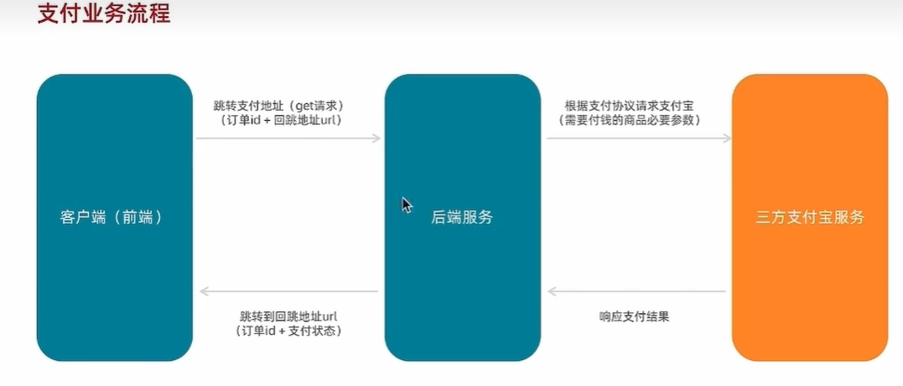](https://xiaobaicai350.github.io/pic/image-20230702140123956.png)

### 1. 支付携带参数

**JAVASCRIPT**

|  |
| --- |
| // 支付地址 const baseURL = 'http://pcapi-xiaotuxian-front-devtest.itheima.net/' const backURL = 'http://127.0.0.1:5173/paycallback' const redirectUrl = encodeURIComponent(backURL) const payUrl = `${baseURL}pay/aliPay?orderId=${route.query.id}&redirect=${redirectUrl}` |

### 2. 支付宝沙箱账号信息

| **账号** | [**jfjbwb4477@sandbox.com**](mailto:jfjbwb4477@sandbox.com) |
| --- | --- |
| 登录密码 | 111111 |
| 支付密码 | 111111 |

## 支付结果页展示

### 1. 准备模版

**PLAINTEXT**

|  |
| --- |
| <script setup>  </script>   <template>  <div class="xtx-pay-page">  <div class="container">  <!-- 支付结果 -->  <div class="pay-result">  <span class="iconfont icon-queren2 green"></span>  <span class="iconfont icon-shanchu red"></span>  <p class="tit">支付成功</p>  <p class="tip">我们将尽快为您发货，收货期间请保持手机畅通</p>  <p>支付方式：<span>支付宝</span></p>  <p>支付金额：<span>¥200.00</span></p>  <div class="btn">  <el-button type="primary" style="margin-right:20px">查看订单</el-button>  <el-button>进入首页</el-button>  </div>  <p class="alert">  <span class="iconfont icon-tip"></span>  温馨提示：小兔鲜儿不会以订单异常、系统升级为由要求您点击任何网址链接进行退款操作，保护资产、谨慎操作。  </p>  </div>  </div>  </div> </template>  <style scoped lang="scss"> .pay-result {  padding: 100px 0;  background: #fff;  text-align: center;  margin-top: 20px;   >.iconfont {  font-size: 100px;  }   .green {  color: #1dc779;  }   .red {  color: $priceColor;  }   .tit {  font-size: 24px;  }   .tip {  color: #999;  }   p {  line-height: 40px;  font-size: 16px;  }   .btn {  margin-top: 50px;  }   .alert {  font-size: 12px;  color: #999;  margin-top: 50px;  } } </style> |

### 2. 绑定路由

**JAVASCRIPT**

|  |
| --- |
| {  path: 'paycallback', // 注意路径，必须是paycallback  component: PayBack }, |

### 3. 渲染数据

**PLAINTEXT**

|  |
| --- |
| <script setup> import { getOrderAPI } from '@/apis/pay' import { onMounted, ref } from 'vue' import { useRoute } from 'vue-router' const route = useRoute() const orderInfo = ref({})  const getOrderInfo = async () => {  const res = await getOrderAPI(route.query.orderId)  orderInfo.value = res.result }  onMounted(() => getOrderInfo())  </script>   <template>  <div class="xtx-pay-page">  <div class="container">  <!-- 支付结果 -->  <div class="pay-result">  <!-- 路由参数获取到的是字符串而不是布尔值 -->  <span class="iconfont icon-queren2 green" v-if="$route.query.payResult === 'true'"></span>  <span class="iconfont icon-shanchu red" v-else></span>  <p class="tit">支付{{ $route.query.payResult === 'true' ? '成功' : '失败' }}</p>  <p class="tip">我们将尽快为您发货，收货期间请保持手机畅通</p>  <p>支付方式：<span>支付宝</span></p>  <p>支付金额：<span>¥{{ orderInfo.payMoney?.toFixed(2) }}</span></p>  <div class="btn">  <el-button type="primary" style="margin-right:20px">查看订单</el-button>  <el-button>进入首页</el-button>  </div>  <p class="alert">  <span class="iconfont icon-tip"></span>  温馨提示：小兔鲜儿不会以订单异常、系统升级为由要求您点击任何网址链接进行退款操作，保护资产、谨慎操作。  </p>  </div>  </div>  </div> </template> |

## 倒计时逻辑函数封装

**JAVASCRIPT**

|  |
| --- |
| // 封装倒计时逻辑函数 import { computed, onUnmounted, ref } from 'vue' import dayjs from 'dayjs' export const useCountDown = () => {  // 1. 响应式的数据  let timer = null  const time = ref(0)  // 格式化时间 为 xx分xx秒  const formatTime = computed(() => dayjs.unix(time.value).format('mm分ss秒'))  // 2. 开启倒计时的函数  const start = (currentTime) => {  // 开始倒计时的逻辑  // 核心逻辑的编写：每隔1s就减一  time.value = currentTime  timer = setInterval(() => {  time.value--  }, 1000)  }  // 组件销毁时清除定时器  onUnmounted(() => {  timer && clearInterval(timer)  })  return {  formatTime,  start  } } |

# 会员中心

## 路由配置

### 1. 准备路由模版

**PLAINTEXT**

|  |
| --- |
| <script setup> </script>  <template>  <div class="container">  <div class="xtx-member-aside">  <div class="user-manage">  <h4>我的账户</h4>  <div class="links">  <RouterLink to="/member/user">个人中心</RouterLink>  </div>  <h4>交易管理</h4>  <div class="links">  <RouterLink to="/member/order">我的订单</RouterLink>  </div>  </div>  </div>  <div class="article">  <!-- 三级路由的挂载点 -->  <!-- <RouterView /> -->  </div>  </div> </template>  <style scoped lang="scss"> .container {  display: flex;  padding-top: 20px;   .xtx-member-aside {  width: 220px;  margin-right: 20px;  border-radius: 2px;  background-color: #fff;   .user-manage {  background-color: #fff;   h4 {  font-size: 18px;  font-weight: 400;  padding: 20px 52px 5px;  border-top: 1px solid #f6f6f6;  }   .links {  padding: 0 52px 10px;  }   a {  display: block;  line-height: 1;  padding: 15px 0;  font-size: 14px;  color: #666;  position: relative;   &:hover {  color: $xtxColor;  }   &.active,  &.router-link-exact-active {  color: $xtxColor;   &:before {  display: block;  }  }   &:before {  content: '';  display: none;  width: 6px;  height: 6px;  border-radius: 50%;  position: absolute;  top: 19px;  left: -16px;  background-color: $xtxColor;  }  }  }  }   .article {  width: 1000px;  background-color: #fff;  } } </style> |

### 2. 配置路由

**JAVASCRIPT**

|  |
| --- |
| import Member from '@/views/Member/index.vue'   {  path: '/member',  component: Member, } |

### 3. 准备个人信息和我的订单路由组件

**PLAINTEXT**

|  |
| --- |
| <script setup> const userStore = {} </script>  <template>  <div class="home-overview">  <!-- 用户信息 -->  <div class="user-meta">  <div class="avatar">  <img :src="userStore.userInfo?.avatar" />  </div>  <h4>{{ userStore.userInfo?.account }}</h4>  </div>  <div class="item">  <a href="javascript:;">  <span class="iconfont icon-hy"></span>  <p>会员中心</p>  </a>  <a href="javascript:;">  <span class="iconfont icon-aq"></span>  <p>安全设置</p>  </a>  <a href="javascript:;">  <span class="iconfont icon-dw"></span>  <p>地址管理</p>  </a>  </div>  </div>  <div class="like-container">  <div class="home-panel">  <div class="header">  <h4 data-v-bcb266e0="">猜你喜欢</h4>  </div>  <div class="goods-list">  <!-- <GoodsItem v-for="good in likeList" :key="good.id" :good="good" /> -->  </div>  </div>  </div> </template>  <style scoped lang="scss"> .home-overview {  height: 132px;  background: url(@/assets/images/center-bg.png) no-repeat center / cover;  display: flex;   .user-meta {  flex: 1;  display: flex;  align-items: center;   .avatar {  width: 85px;  height: 85px;  border-radius: 50%;  overflow: hidden;  margin-left: 60px;   img {  width: 100%;  height: 100%;  }  }   h4 {  padding-left: 26px;  font-size: 18px;  font-weight: normal;  color: white;  }  }   .item {  flex: 1;  display: flex;  align-items: center;  justify-content: space-around;   &:first-child {  border-right: 1px solid #f4f4f4;  }   a {  color: white;  font-size: 16px;  text-align: center;   .iconfont {  font-size: 32px;  }   p {  line-height: 32px;  }  }  } }  .like-container {  margin-top: 20px;  border-radius: 4px;  background-color: #fff; }  .home-panel {  background-color: #fff;  padding: 0 20px;  margin-top: 20px;  height: 400px;   .header {  height: 66px;  border-bottom: 1px solid #f5f5f5;  padding: 18px 0;  display: flex;  justify-content: space-between;  align-items: baseline;   h4 {  font-size: 22px;  font-weight: 400;  }   }   .goods-list {  display: flex;  justify-content: space-around;  } } </style> |

**PLAINTEXT**

|  |
| --- |
| <script setup> // tab列表 const tabTypes = [  { name: "all", label: "全部订单" },  { name: "unpay", label: "待付款" },  { name: "deliver", label: "待发货" },  { name: "receive", label: "待收货" },  { name: "comment", label: "待评价" },  { name: "complete", label: "已完成" },  { name: "cancel", label: "已取消" } ] // 订单列表 const orderList = []  </script>  <template>  <div class="order-container">  <el-tabs>  <!-- tab切换 -->  <el-tab-pane v-for="item in tabTypes" :key="item.name" :label="item.label" />   <div class="main-container">  <div class="holder-container" v-if="orderList.length === 0">  <el-empty description="暂无订单数据" />  </div>  <div v-else>  <!-- 订单列表 -->  <div class="order-item" v-for="order in orderList" :key="order.id">  <div class="head">  <span>下单时间：{{ order.createTime }}</span>  <span>订单编号：{{ order.id }}</span>  <!-- 未付款，倒计时时间还有 -->  <span class="down-time" v-if="order.orderState === 1">  <i class="iconfont icon-down-time"></i>  <b>付款截止: {{order.countdown}}</b>  </span>  </div>  <div class="body">  <div class="column goods">  <ul>  <li v-for="item in order.skus" :key="item.id">  <a class="image" href="javascript:;">  <img :src="item.image" alt="" />  </a>  <div class="info">  <p class="name ellipsis-2">  {{ item.name }}  </p>  <p class="attr ellipsis">  <span>{{ item.attrsText }}</span>  </p>  </div>  <div class="price">¥{{ item.realPay?.toFixed(2) }}</div>  <div class="count">x{{ item.quantity }}</div>  </li>  </ul>  </div>  <div class="column state">  <p>{{ order.orderState }}</p>  <p v-if="order.orderState === 3">  <a href="javascript:;" class="green">查看物流</a>  </p>  <p v-if="order.orderState === 4">  <a href="javascript:;" class="green">评价商品</a>  </p>  <p v-if="order.orderState === 5">  <a href="javascript:;" class="green">查看评价</a>  </p>  </div>  <div class="column amount">  <p class="red">¥{{ order.payMoney?.toFixed(2) }}</p>  <p>（含运费：¥{{ order.postFee?.toFixed(2) }}）</p>  <p>在线支付</p>  </div>  <div class="column action">  <el-button v-if="order.orderState === 1" type="primary"  size="small">  立即付款  </el-button>  <el-button v-if="order.orderState === 3" type="primary" size="small">  确认收货  </el-button>  <p><a href="javascript:;">查看详情</a></p>  <p v-if="[2, 3, 4, 5].includes(order.orderState)">  <a href="javascript:;">再次购买</a>  </p>  <p v-if="[4, 5].includes(order.orderState)">  <a href="javascript:;">申请售后</a>  </p>  <p v-if="order.orderState === 1"><a href="javascript:;">取消订单</a></p>  </div>  </div>  </div>  <!-- 分页 -->  <div class="pagination-container">  <el-pagination background layout="prev, pager, next" />  </div>  </div>  </div>   </el-tabs>  </div>  </template>  <style scoped lang="scss"> .order-container {  padding: 10px 20px;   .pagination-container {  display: flex;  justify-content: center;  }   .main-container {  min-height: 500px;   .holder-container {  min-height: 500px;  display: flex;  justify-content: center;  align-items: center;  }  } }  .order-item {  margin-bottom: 20px;  border: 1px solid #f5f5f5;   .head {  height: 50px;  line-height: 50px;  background: #f5f5f5;  padding: 0 20px;  overflow: hidden;   span {  margin-right: 20px;   &.down-time {  margin-right: 0;  float: right;   i {  vertical-align: middle;  margin-right: 3px;  }   b {  vertical-align: middle;  font-weight: normal;  }  }  }   .del {  margin-right: 0;  float: right;  color: #999;  }  }   .body {  display: flex;  align-items: stretch;   .column {  border-left: 1px solid #f5f5f5;  text-align: center;  padding: 20px;   >p {  padding-top: 10px;  }   &:first-child {  border-left: none;  }   &.goods {  flex: 1;  padding: 0;  align-self: center;   ul {  li {  border-bottom: 1px solid #f5f5f5;  padding: 10px;  display: flex;   &:last-child {  border-bottom: none;  }   .image {  width: 70px;  height: 70px;  border: 1px solid #f5f5f5;  }   .info {  width: 220px;  text-align: left;  padding: 0 10px;   p {  margin-bottom: 5px;   &.name {  height: 38px;  }   &.attr {  color: #999;  font-size: 12px;   span {  margin-right: 5px;  }  }  }  }   .price {  width: 100px;  }   .count {  width: 80px;  }  }  }  }   &.state {  width: 120px;   .green {  color: $xtxColor;  }  }   &.amount {  width: 200px;   .red {  color: $priceColor;  }  }   &.action {  width: 140px;   a {  display: block;   &:hover {  color: $xtxColor;  }  }  }  }  } } </style> |

### 4. 配置三级路由

**JAVASCRIPT**

|  |
| --- |
| import MemberInfo from '@/views/Member/components/UserInfo.vue' import MemberOrder from '@/views/Member/components/UserOrder.vue'   {  path: '/member',  component: Member,  children: [  {  path: '',  component: MemberInfo  },  {  path: 'order',  component: MemberOrder  }  ] } |

## 个人中心信息渲染

### 1. 使用Pinia数据渲染个人信息

**PLAINTEXT**

|  |
| --- |
| <script setup> // 导入userStore import { useUserStore } from '@/stores/userStore' const userStore = useUserStore() </script>  <template>  <!-- 用户信息 -->  <div class="user-meta">  <div class="avatar">  <img :src="userStore.userInfo?.avatar" />  </div>  <h4>{{ userStore.userInfo?.account }}</h4>  </div> </template> |

### 2. 封装猜你喜欢接口

**JAVASCRIPT**

|  |
| --- |
| export const getLikeListAPI = ({ limit = 4 }) => {  return request({  url:'/goods/relevant',  params: {  limit   }  }) } |

### 3. 渲染猜你喜欢数据

**PLAINTEXT**

|  |
| --- |
| <script setup> import { onMounted, ref } from 'vue' // 导入GoodsItem组件 import GoodsItem from '@/views/Home/components/GoodsItem.vue' // 获取猜你喜欢列表 const likeList = ref([]) const getLikeList = async () => {  const res = await getLikeListAPI({ limit: 4 })  likeList.value = res.result }  onMounted(() => getLikeList()) </script>  <template>  <div class="goods-list">  <GoodsItem v-for="good in likeList" :key="good.id" :goods="good" />  </div> </template> |

## 我的订单

### 1. 基础列表渲染

**JAVASCRIPT**

|  |
| --- |
| /* params: {  orderState:0,  page:1,  pageSize:2 } */   export const getUserOrder = (params) => {  return request({  url:'/member/order',  method:'GET',  params  }) } |

**PLAINTEXT**

|  |
| --- |
| <script setup> import { getUserOrder } from '@/apis/order' import { onMounted, ref } from 'vue'  // 获取订单列表 const orderList = ref([]) const params = ref({  orderState: 0,  page: 1,  pageSize: 2 }) const getOrderList = async () => {  const res = await getUserOrder(params.value)  orderList.value = res.result.items  total.value = res.result.counts } onMounted(() => getOrderList()) </script> |

### 2. tab切换实现

**PLAINTEXT**

|  |
| --- |
| <script setup> // tab列表 const tabTypes = [  { name: "all", label: "全部订单" },  { name: "unpay", label: "待付款" },  { name: "deliver", label: "待发货" },  { name: "receive", label: "待收货" },  { name: "comment", label: "待评价" },  { name: "complete", label: "已完成" },  { name: "cancel", label: "已取消" } ]  // tab切换 const tabChange = (type) => {  params.value.orderState = type  getOrderList() }  </script>  <template>  <el-tabs @tab-change="tabChange">  <!-- 省略... -->  </el-tabs> </template> |

### 3. 分页逻实现

页数 = 总条数 / 每页条数

**PLAINTEXT**

|  |
| --- |
| <script setup> // 补充总条数 const total = ref(0) const getOrderList = async () => {  const res = await getUserOrder(params.value)  // 存入总条数  total.value = res.result.counts } // 页数切换 const pageChange = (page) => {  params.value.page = page  getOrderList() } </script>  <template>  <el-pagination   :total="total"   @current-change="pageChange"   :page-size="params.pageSize"   background  layout="prev, pager, next" /> </template> |

## 细节优化

### 1. 默认三级路由设置

**JAVASCRIPT**

|  |
| --- |
| {  path: 'member',  component: Member,  children: [  {  path: '', // 置空path  component: UserInfo  },  {  path: 'order',  component: UserOrder  }  ] } |

### 2. 订单状态显示适配

**PLAINTEXT**

|  |
| --- |
| <script setup>  // 创建格式化函数  const fomartPayState = (payState) => {  const stateMap = {  1: '待付款',  2: '待发货',  3: '待收货',  4: '待评价',  5: '已完成',  6: '已取消'  }  return stateMap[payState]  } </script>   <template>  <!-- 调用函数适配显示 -->  <p>{{ fomartPayState(order.orderState)}}</p> </template> |

# 拓展部分

## Sku组件封装

### 1. 准备模版渲染规格数据

使用Vite快速创建一个Vue项目，在项目中添加请求插件axios，然后新增一个SKU组件，在根组件中把它渲染出来，下面是规格内容的基础模板

**PLAINTEXT**

|  |
| --- |
| <script setup> import { onMounted, ref } from 'vue' import axios from 'axios' // 商品数据 const goods = ref({}) const getGoods = async () => {  // 1135076 初始化就有无库存的规格  // 1369155859933827074 更新之后有无库存项（蓝色-20cm-中国）  const res = await axios.get('http://pcapi-xiaotuxian-front-devtest.itheima.net/goods?id=1369155859933827074')  goods.value = res.data.result } onMounted(() => getGoods())  </script>  <template>  <div class="goods-sku">  <dl v-for="item in goods.specs" :key="item.id">  <dt>{{ item.name }}</dt>  <dd>  <template v-for="val in item.values" :key="val.name">  <!-- 图片类型规格 -->  <img v-if="val.picture" :src="val.picture" :title="val.name">  <!-- 文字类型规格 -->  <span v-else>{{ val.name }}</span>  </template>  </dd>  </dl>  </div> </template>  <style scoped lang="scss"> @mixin sku-state-mixin {  border: 1px solid #e4e4e4;  margin-right: 10px;  cursor: pointer;   &.selected {  border-color: #27ba9b;  }   &.disabled {  opacity: 0.6;  border-style: dashed;  cursor: not-allowed;  } }  .goods-sku {  padding-left: 10px;  padding-top: 20px;   dl {  display: flex;  padding-bottom: 20px;  align-items: center;   dt {  width: 50px;  color: #999;  }   dd {  flex: 1;  color: #666;   >img {  width: 50px;  height: 50px;  margin-bottom: 4px;  @include sku-state-mixin;  }   >span {  display: inline-block;  height: 30px;  line-height: 28px;  padding: 0 20px;  margin-bottom: 4px;  @include sku-state-mixin;  }  }  } } </style> |

### 2. 选中和取消选中实现

基本思路：

1. 每一个规格按钮都拥有自己的选中状态数据-selected，true为选中，false为取消选中
2. 配合动态class，把选中状态selected作为判断条件，true让active类名显示，false让active类名不显示
3. 点击的是未选中，把同一个规格的其他取消选中，当前点击项选中；点击的是已选中，直接取消

**PLAINTEXT**

|  |
| --- |
| <script setup> // 省略代码  // 选中和取消选中实现 const changeSku = (item, val) => {  // 点击的是未选中，把同一个规格的其他取消选中，当前点击项选中，点击的是已选中，直接取消  if (val.selected) {  val.selected = false  } else {  item.values.forEach(valItem => valItem.selected = false)  val.selected = true  } }  </script>  <template>  <div class="goods-sku">  <dl v-for="item in goods.specs" :key="item.id">  <dt>{{ item.name }}</dt>  <dd>  <template v-for="val in item.values" :key="val.name">  <img v-if="val.picture"   @click="changeSku(item, val)"   :class="{ selected: val.selected }"   :src="val.picture"  :title="val.name">  <span v-else   @click="changeSku(val)"   :class="{ selected: val.selected }">{{ val.name }}</span>  </template>  </dd>  </dl>  </div> </template> |

### 3. 规格禁用功能实现

#### 整体思路 分析

#### 生成路径字典

幂集算法

**JAVASCRIPT**

|  |
| --- |
| export default function bwPowerSet (originalSet) {  const subSets = []   // We will have 2^n possible combinations (where n is a length of original set).  // It is because for every element of original set we will decide whether to include  // it or not (2 options for each set element).  const numberOfCombinations = 2 ** originalSet.length   // Each number in binary representation in a range from 0 to 2^n does exactly what we need:  // it shows by its bits (0 or 1) whether to include related element from the set or not.  // For example, for the set {1, 2, 3} the binary number of 0b010 would mean that we need to  // include only "2" to the current set.  for (let combinationIndex = 0; combinationIndex < numberOfCombinations; combinationIndex += 1) {  const subSet = []   for (let setElementIndex = 0; setElementIndex < originalSet.length; setElementIndex += 1) {  // Decide whether we need to include current element into the subset or not.  if (combinationIndex & (1 << setElementIndex)) {  subSet.push(originalSet[setElementIndex])  }  }   // Add current subset to the list of all subsets.  subSets.push(subSet)  }   return subSets } |

**JAVASCRIPT**

|  |
| --- |
| // 创建生成路径字典对象函数 const getPathMap = (goods) => {  const pathMap = {}  // 1. 得到所有有效的Sku集合   const effectiveSkus = goods.skus.filter(sku => sku.inventory > 0)  // 2. 根据有效的Sku集合使用powerSet算法得到所有子集 [1,2] => [[1], [2], [1,2]]  effectiveSkus.forEach(sku => {  // 2.1 获取可选规格值数组  const selectedValArr = sku.specs.map(val => val.valueName)  // 2.2 获取可选值数组的子集  const valueArrPowerSet = powerSet(selectedValArr)  // 3. 根据子集生成路径字典对象  // 3.1 遍历子集 往pathMap中插入数据  valueArrPowerSet.forEach(arr => {  // 根据Arr得到字符串的key，约定使用-分割 ['蓝色'，'美国'] => '蓝色-美国'  const key = arr.join('-')  // 给pathMap设置数据  if (pathMap[key]) {  pathMap[key].push(sku.id)  } else {  pathMap[key] = [sku.id]  }  })  })  return pathMap }  // 数据获取完毕生成路径字典 let pathMap = {} const getGoods = async () => {  // 1135076 初始化就有无库存的规格  // 1369155859933827074 更新之后有无库存项（蓝色-20cm-中国）  const res = await axios.get('http://pcapi-xiaotuxian-front-devtest.itheima.net/goods?id=1135076')  goods.value = res.data.result  pathMap = getPathMap(goods.value)  // 初始化更新按钮状态  initDisabledState(goods.value.specs, pathMap) } |

#### 根据路径字典设置初始化状态

思路：判断规格的name属性是否能在有效路径字典中找到，如果找不到就禁用

**JSX**

|  |
| --- |
| // 1. 定义初始化函数 // specs：商品源数据 pathMap：路径字典 const initDisabledState = (specs, pathMap) => {  // 约定：每一个按钮的状态由自身的disabled进行控制  specs.forEach(item => {  item.values.forEach(val => {  // 路径字典中查找是否有数据 有-可以点击 没有-禁用  val.disabled = !pathMap[val.name]  })  }) }  // 2. 在数据返回后进行初始化处理 let patchMap = {} const getGoods = async () => {  // 1135076 初始化就有无库存的规格  // 1369155859933827074 更新之后有无库存项（蓝色-20cm-中国）  const res = await axios.get('http://pcapi-xiaotuxian-front-devtest.itheima.net/goods?id=1135076')  goods.value = res.data.result  pathMap = getPathMap(goods.value)  // 初始化更新按钮状态  initDisabledState(goods.value.specs, pathMap) }  // 3. 适配模板显示 <img :class="{ selected: val.selected, disabled: val.disabled }"/> <span :class="{ selected: val.selected, disabled: val.disabled }">{{val.name }}</span> |

#### 根据路径字典设置组合状态

思路：

1. 根据当前选中规格，生成顺序规格数组 => [‘黑色’, undefined, undefined ]
2. 遍历每一个规格按钮

如何规格按钮已经选中，忽略判断  
如果规格按钮未选中，拿着按钮的name值按顺序套入匹配数组对应的位置，最后过滤掉没有值的选项，通过-进行拼接成字符串key, 去路径字典中查找，没有找到则把当前规格按钮禁用

**JAVASCRIPT**

|  |
| --- |
| // 获取选中匹配数组 ['黑色',undefined,undefined] const getSelectedValues = (specs) => {  const arr = []  specs.forEach(spec => {  const selectedVal = spec.values.find(value => value.selected)  arr.push(selectedVal ? selectedVal.name : undefined)  })  return arr }  const updateDisabledState = (specs, pathMap) => {  // 约定：每一个按钮的状态由自身的disabled进行控制  specs.forEach((item, i) => {  const selectedValues = getSelectedValues(specs)  item.values.forEach(val => {  if (val.selected) return  const _seletedValues = [...selectedValues]  _seletedValues[i] = val.name  const key = _seletedValues.filter(value => value).join('*')  // 路径字典中查找是否有数据 有-可以点击 没有-禁用  val.disabled = !pathMap[key]  })  })  } |

### 4. 产出Prop数据

**JAVASCRIPT**

|  |
| --- |
| const changeSku = (item, val) => {  // 省略...  // 产出SKU对象数据  const index = getSelectedValues(goods.value.specs).findIndex(item => item === undefined)  if (index > -1) {  console.log('找到了，信息不完整')  } else {  console.log('没有找到，信息完整，可以产出')  // 获取sku对象  const key = getSelectedValues(goods.value.specs).join('*')  const skuIds = pathMap[key]  console.log(skuIds)  // 以skuId作为匹配项去goods.value.skus数组中找  const skuObj = goods.value.skus.find(item => item.id === skuIds[0])  console.log('sku对象为', skuObj)  } } |

**文章作者:**[小白菜](http://example.com/)

**文章链接:**<http://example.com/2023/06/18/%E5%B0%8F%E5%85%94%E9%B2%9C%E9%A1%B9%E7%9B%AE/>

**版权声明:**本博客所有文章除特别声明外，均采用 [CC BY-NC-SA 4.0](https://creativecommons.org/licenses/by-nc-sa/4.0/) 许可协议。转载请注明来自 [是小白菜哦](http://example.com/)！

[前端项目](https://xiaobaicai350.github.io/tags/%E5%89%8D%E7%AB%AF%E9%A1%B9%E7%9B%AE/)

[[](https://xiaobaicai350.github.io/2023/06/19/%E7%AE%97%E6%B3%95%E8%AE%BE%E8%AE%A1%E4%B8%8E%E5%88%86%E6%9E%90%E5%A4%8D%E4%B9%A0/)](https://xiaobaicai350.github.io/2023/06/19/%E7%AE%97%E6%B3%95%E8%AE%BE%E8%AE%A1%E4%B8%8E%E5%88%86%E6%9E%90%E5%A4%8D%E4%B9%A0/)

[上一篇](https://xiaobaicai350.github.io/2023/06/19/%E7%AE%97%E6%B3%95%E8%AE%BE%E8%AE%A1%E4%B8%8E%E5%88%86%E6%9E%90%E5%A4%8D%E4%B9%A0/)

[算法设计与分析复习](https://xiaobaicai350.github.io/2023/06/19/%E7%AE%97%E6%B3%95%E8%AE%BE%E8%AE%A1%E4%B8%8E%E5%88%86%E6%9E%90%E5%A4%8D%E4%B9%A0/)

[[](https://xiaobaicai350.github.io/2023/06/15/%E8%8B%B1%E8%AF%AD%E4%BD%9C%E6%96%87%E6%A8%A1%E6%9D%BF/)](https://xiaobaicai350.github.io/2023/06/15/%E8%8B%B1%E8%AF%AD%E4%BD%9C%E6%96%87%E6%A8%A1%E6%9D%BF/)

[下一篇](https://xiaobaicai350.github.io/2023/06/15/%E8%8B%B1%E8%AF%AD%E4%BD%9C%E6%96%87%E6%A8%A1%E6%9D%BF/)

[英语作文模板](https://xiaobaicai350.github.io/2023/06/15/%E8%8B%B1%E8%AF%AD%E4%BD%9C%E6%96%87%E6%A8%A1%E6%9D%BF/)



小白菜

头发多多

[文章](https://xiaobaicai350.github.io/archives/)

[73](https://xiaobaicai350.github.io/archives/)

[标签](https://xiaobaicai350.github.io/tags/)

[22](https://xiaobaicai350.github.io/tags/)

[分类](https://xiaobaicai350.github.io/categories/)

[0](https://xiaobaicai350.github.io/categories/)

[Follow Me](https://github.com/Xiaobaicai350)

公告

阳光斑斓 微风含香 爱与四季 皆是向往 

目录*33*

1. [1. Vue3入门](https://xiaobaicai350.github.io/2023/06/18/%E5%B0%8F%E5%85%94%E9%B2%9C%E9%A1%B9%E7%9B%AE/#Vue3%E5%85%A5%E9%97%A8)
2. [2. Pinia入门](https://xiaobaicai350.github.io/2023/06/18/%E5%B0%8F%E5%85%94%E9%B2%9C%E9%A1%B9%E7%9B%AE/#Pinia%E5%85%A5%E9%97%A8)
3. [3. 项目起步](https://xiaobaicai350.github.io/2023/06/18/%E5%B0%8F%E5%85%94%E9%B2%9C%E9%A1%B9%E7%9B%AE/#%E9%A1%B9%E7%9B%AE%E8%B5%B7%E6%AD%A5)
4. [4. Layout页](https://xiaobaicai350.github.io/2023/06/18/%E5%B0%8F%E5%85%94%E9%B2%9C%E9%A1%B9%E7%9B%AE/#Layout%E9%A1%B5)
5. [5. Home页](https://xiaobaicai350.github.io/2023/06/18/%E5%B0%8F%E5%85%94%E9%B2%9C%E9%A1%B9%E7%9B%AE/#Home%E9%A1%B5)
   1. [5.1. 静态结构搭建和分类实现](https://xiaobaicai350.github.io/2023/06/18/%E5%B0%8F%E5%85%94%E9%B2%9C%E9%A1%B9%E7%9B%AE/#%E9%9D%99%E6%80%81%E7%BB%93%E6%9E%84%E6%90%AD%E5%BB%BA%E5%92%8C%E5%88%86%E7%B1%BB%E5%AE%9E%E7%8E%B0)
      1. [5.1.1. 1. 整体结构创建](https://xiaobaicai350.github.io/2023/06/18/%E5%B0%8F%E5%85%94%E9%B2%9C%E9%A1%B9%E7%9B%AE/#1-%E6%95%B4%E4%BD%93%E7%BB%93%E6%9E%84%E5%88%9B%E5%BB%BA)
      2. [5.1.2. 2. 分类实现](https://xiaobaicai350.github.io/2023/06/18/%E5%B0%8F%E5%85%94%E9%B2%9C%E9%A1%B9%E7%9B%AE/#2-%E5%88%86%E7%B1%BB%E5%AE%9E%E7%8E%B0)
   2. [5.2. banner轮播图实现](https://xiaobaicai350.github.io/2023/06/18/%E5%B0%8F%E5%85%94%E9%B2%9C%E9%A1%B9%E7%9B%AE/#banner%E8%BD%AE%E6%92%AD%E5%9B%BE%E5%AE%9E%E7%8E%B0)
      1. [5.2.1. 1. 熟悉组件](https://xiaobaicai350.github.io/2023/06/18/%E5%B0%8F%E5%85%94%E9%B2%9C%E9%A1%B9%E7%9B%AE/#1-%E7%86%9F%E6%82%89%E7%BB%84%E4%BB%B6)
      2. [5.2.2. 2. 获取数据渲染组件](https://xiaobaicai350.github.io/2023/06/18/%E5%B0%8F%E5%85%94%E9%B2%9C%E9%A1%B9%E7%9B%AE/#2-%E8%8E%B7%E5%8F%96%E6%95%B0%E6%8D%AE%E6%B8%B2%E6%9F%93%E7%BB%84%E4%BB%B6)
   3. [5.3. 面板组件封装](https://xiaobaicai350.github.io/2023/06/18/%E5%B0%8F%E5%85%94%E9%B2%9C%E9%A1%B9%E7%9B%AE/#%E9%9D%A2%E6%9D%BF%E7%BB%84%E4%BB%B6%E5%B0%81%E8%A3%85)
      1. [5.3.1. 1. 纯静态结构](https://xiaobaicai350.github.io/2023/06/18/%E5%B0%8F%E5%85%94%E9%B2%9C%E9%A1%B9%E7%9B%AE/#1-%E7%BA%AF%E9%9D%99%E6%80%81%E7%BB%93%E6%9E%84)
      2. [5.3.2. 2. 完整代码](https://xiaobaicai350.github.io/2023/06/18/%E5%B0%8F%E5%85%94%E9%B2%9C%E9%A1%B9%E7%9B%AE/#2-%E5%AE%8C%E6%95%B4%E4%BB%A3%E7%A0%81)
   4. [5.4. 新鲜好物实现](https://xiaobaicai350.github.io/2023/06/18/%E5%B0%8F%E5%85%94%E9%B2%9C%E9%A1%B9%E7%9B%AE/#%E6%96%B0%E9%B2%9C%E5%A5%BD%E7%89%A9%E5%AE%9E%E7%8E%B0)
      1. [5.4.1. 1. 准备模版](https://xiaobaicai350.github.io/2023/06/18/%E5%B0%8F%E5%85%94%E9%B2%9C%E9%A1%B9%E7%9B%AE/#1-%E5%87%86%E5%A4%87%E6%A8%A1%E7%89%88)
      2. [5.4.2. 2. 封装接口](https://xiaobaicai350.github.io/2023/06/18/%E5%B0%8F%E5%85%94%E9%B2%9C%E9%A1%B9%E7%9B%AE/#2-%E5%B0%81%E8%A3%85%E6%8E%A5%E5%8F%A3)
      3. [5.4.3. 3. 获取数据渲染模版](https://xiaobaicai350.github.io/2023/06/18/%E5%B0%8F%E5%85%94%E9%B2%9C%E9%A1%B9%E7%9B%AE/#3-%E8%8E%B7%E5%8F%96%E6%95%B0%E6%8D%AE%E6%B8%B2%E6%9F%93%E6%A8%A1%E7%89%88)
   5. [5.5. 人气推荐实现](https://xiaobaicai350.github.io/2023/06/18/%E5%B0%8F%E5%85%94%E9%B2%9C%E9%A1%B9%E7%9B%AE/#%E4%BA%BA%E6%B0%94%E6%8E%A8%E8%8D%90%E5%AE%9E%E7%8E%B0)
      1. [5.5.1. 1. 封装接口](https://xiaobaicai350.github.io/2023/06/18/%E5%B0%8F%E5%85%94%E9%B2%9C%E9%A1%B9%E7%9B%AE/#1-%E5%B0%81%E8%A3%85%E6%8E%A5%E5%8F%A3)
      2. [5.5.2. 2. 获取数据渲染模版](https://xiaobaicai350.github.io/2023/06/18/%E5%B0%8F%E5%85%94%E9%B2%9C%E9%A1%B9%E7%9B%AE/#2-%E8%8E%B7%E5%8F%96%E6%95%B0%E6%8D%AE%E6%B8%B2%E6%9F%93%E6%A8%A1%E7%89%88)
   6. [5.6. 懒加载指令实现](https://xiaobaicai350.github.io/2023/06/18/%E5%B0%8F%E5%85%94%E9%B2%9C%E9%A1%B9%E7%9B%AE/#%E6%87%92%E5%8A%A0%E8%BD%BD%E6%8C%87%E4%BB%A4%E5%AE%9E%E7%8E%B0)
      1. [5.6.1. 1. 封装全局指令](https://xiaobaicai350.github.io/2023/06/18/%E5%B0%8F%E5%85%94%E9%B2%9C%E9%A1%B9%E7%9B%AE/#1-%E5%B0%81%E8%A3%85%E5%85%A8%E5%B1%80%E6%8C%87%E4%BB%A4)
      2. [5.6.2. 2. 注册全局指令](https://xiaobaicai350.github.io/2023/06/18/%E5%B0%8F%E5%85%94%E9%B2%9C%E9%A1%B9%E7%9B%AE/#2-%E6%B3%A8%E5%86%8C%E5%85%A8%E5%B1%80%E6%8C%87%E4%BB%A4)
      3. [5.6.3. 3.修改HomeHot](https://xiaobaicai350.github.io/2023/06/18/%E5%B0%8F%E5%85%94%E9%B2%9C%E9%A1%B9%E7%9B%AE/#3-%E4%BF%AE%E6%94%B9HomeHot)
   7. [5.7. Product产品列表实现](https://xiaobaicai350.github.io/2023/06/18/%E5%B0%8F%E5%85%94%E9%B2%9C%E9%A1%B9%E7%9B%AE/#Product%E4%BA%A7%E5%93%81%E5%88%97%E8%A1%A8%E5%AE%9E%E7%8E%B0)
      1. [5.7.1. 1. 基础数据渲染](https://xiaobaicai350.github.io/2023/06/18/%E5%B0%8F%E5%85%94%E9%B2%9C%E9%A1%B9%E7%9B%AE/#1-%E5%9F%BA%E7%A1%80%E6%95%B0%E6%8D%AE%E6%B8%B2%E6%9F%93)
      2. [5.7.2. 2. 图片懒加载](https://xiaobaicai350.github.io/2023/06/18/%E5%B0%8F%E5%85%94%E9%B2%9C%E9%A1%B9%E7%9B%AE/#2-%E5%9B%BE%E7%89%87%E6%87%92%E5%8A%A0%E8%BD%BD)
   8. [5.8. GoodsItem组件封装](https://xiaobaicai350.github.io/2023/06/18/%E5%B0%8F%E5%85%94%E9%B2%9C%E9%A1%B9%E7%9B%AE/#GoodsItem%E7%BB%84%E4%BB%B6%E5%B0%81%E8%A3%85)
      1. [5.8.1. 1. 封装组件](https://xiaobaicai350.github.io/2023/06/18/%E5%B0%8F%E5%85%94%E9%B2%9C%E9%A1%B9%E7%9B%AE/#1-%E5%B0%81%E8%A3%85%E7%BB%84%E4%BB%B6)
      2. [5.8.2. 2. 使用组件](https://xiaobaicai350.github.io/2023/06/18/%E5%B0%8F%E5%85%94%E9%B2%9C%E9%A1%B9%E7%9B%AE/#2-%E4%BD%BF%E7%94%A8%E7%BB%84%E4%BB%B6)
6. [6. 一级分类页](https://xiaobaicai350.github.io/2023/06/18/%E5%B0%8F%E5%85%94%E9%B2%9C%E9%A1%B9%E7%9B%AE/#%E4%B8%80%E7%BA%A7%E5%88%86%E7%B1%BB%E9%A1%B5)
7. [7. 二级分类](https://xiaobaicai350.github.io/2023/06/18/%E5%B0%8F%E5%85%94%E9%B2%9C%E9%A1%B9%E7%9B%AE/#%E4%BA%8C%E7%BA%A7%E5%88%86%E7%B1%BB)
8. [8. 新鲜好物商品详情](https://xiaobaicai350.github.io/2023/06/18/%E5%B0%8F%E5%85%94%E9%B2%9C%E9%A1%B9%E7%9B%AE/#%E6%96%B0%E9%B2%9C%E5%A5%BD%E7%89%A9%E5%95%86%E5%93%81%E8%AF%A6%E6%83%85)
9. [9. 登录页](https://xiaobaicai350.github.io/2023/06/18/%E5%B0%8F%E5%85%94%E9%B2%9C%E9%A1%B9%E7%9B%AE/#%E7%99%BB%E5%BD%95%E9%A1%B5)
10. [10. 购物车](https://xiaobaicai350.github.io/2023/06/18/%E5%B0%8F%E5%85%94%E9%B2%9C%E9%A1%B9%E7%9B%AE/#%E8%B4%AD%E7%89%A9%E8%BD%A6)

• [11. 订单页](https://xiaobaicai350.github.io/2023/06/18/%E5%B0%8F%E5%85%94%E9%B2%9C%E9%A1%B9%E7%9B%AE/#%E8%AE%A2%E5%8D%95%E9%A1%B5)

• [12. 支付页](https://xiaobaicai350.github.io/2023/06/18/%E5%B0%8F%E5%85%94%E9%B2%9C%E9%A1%B9%E7%9B%AE/#%E6%94%AF%E4%BB%98%E9%A1%B5)

• 13.

• [14. 会员中心](https://xiaobaicai350.github.io/2023/06/18/%E5%B0%8F%E5%85%94%E9%B2%9C%E9%A1%B9%E7%9B%AE/#%E4%BC%9A%E5%91%98%E4%B8%AD%E5%BF%83)

• [15.](https://xiaobaicai350.github.io/2023/06/18/%E5%B0%8F%E5%85%94%E9%B2%9C%E9%A1%B9%E7%9B%AE/#-1)

• [16. 拓展部分](https://xiaobaicai350.github.io/2023/06/18/%E5%B0%8F%E5%85%94%E9%B2%9C%E9%A1%B9%E7%9B%AE/#%E6%8B%93%E5%B1%95%E9%83%A8%E5%88%86)

最新文章

[12306](https://xiaobaicai350.github.io/2024/04/06/12306/)2024-04-06

[JUC中的原子类](https://xiaobaicai350.github.io/2023/08/21/JUC%E4%B8%AD%E7%9A%84%E5%8E%9F%E5%AD%90%E7%B1%BB/)2023-08-21

[深入理解ReentrantLock](https://xiaobaicai350.github.io/2023/08/20/%E6%B7%B1%E5%85%A5%E7%90%86%E8%A7%A3ReentrantLock/)2023-08-20

[线程八锁](https://xiaobaicai350.github.io/2023/08/19/%E7%BA%BF%E7%A8%8B%E5%85%AB%E9%94%81/)2023-08-19

[Java集合详解](https://xiaobaicai350.github.io/2023/08/18/Java%E9%9B%86%E5%90%88%E8%AF%A6%E8%A7%A3/)2023-08-18

©2022 - 2024 By 小白菜

框架 [Hexo](https://hexo.io/)|主题 [Butterfly](https://github.com/jerryc127/hexo-theme-butterfly)

欢迎来到小白菜的blog~

看板娘

你都复制了些什么呀，转载要记得加上出处哦！